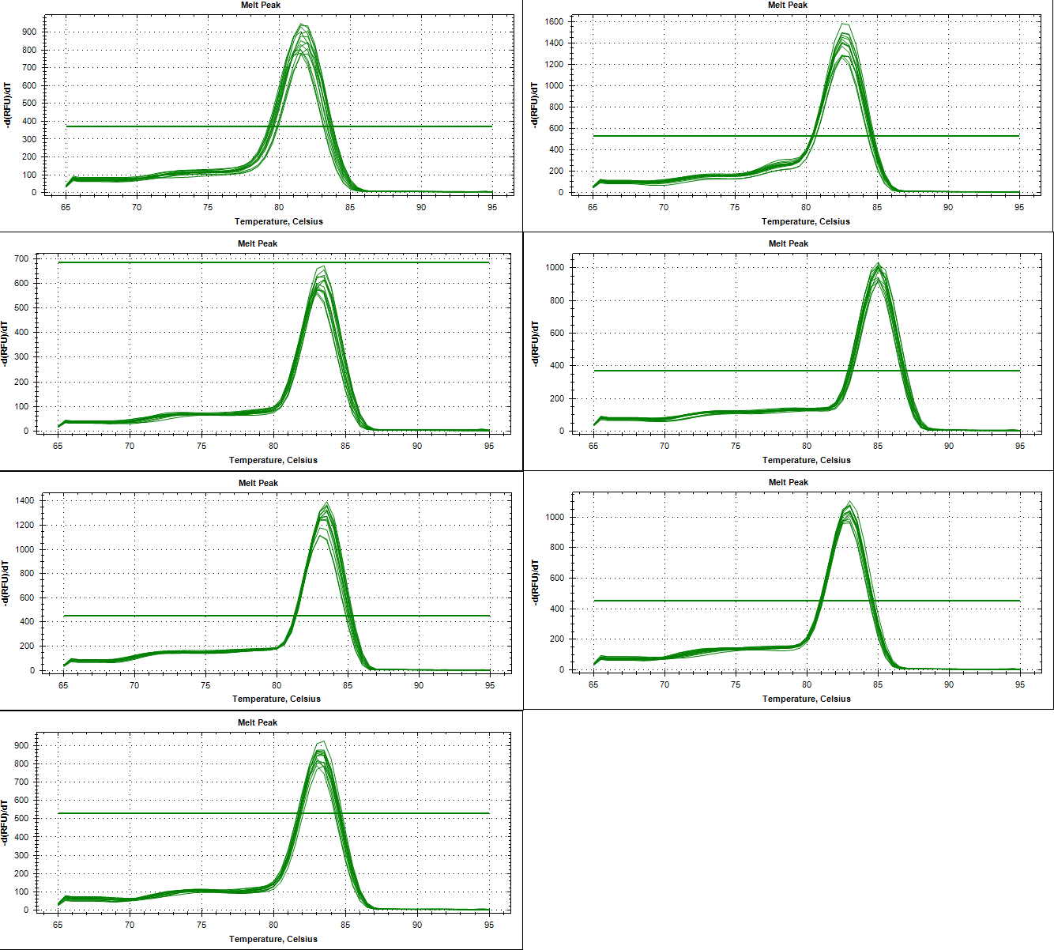
Supplemental Fig. S1 Dissociation curves of the seven candidate reference genes

