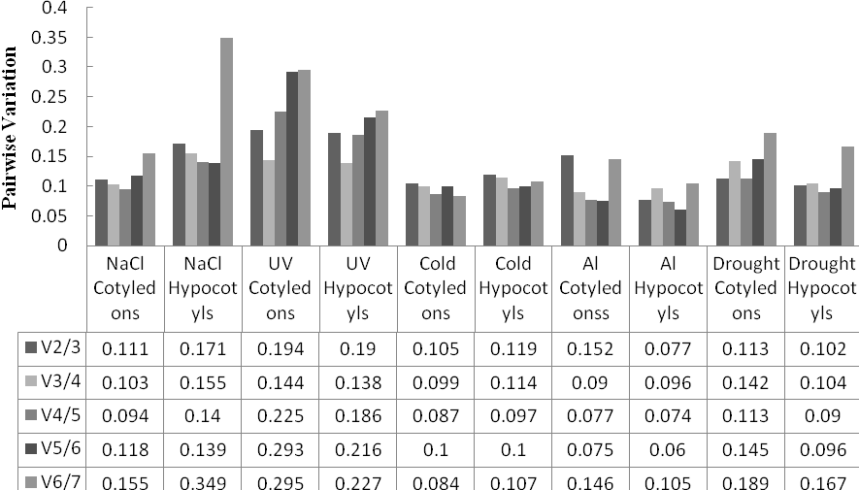
Supplemental Fig. S2 Optimal number of reference genes required for accurate normalization in the hypocotyls and cotyledons of tartary buckwheat

