Montreal Cognitive Assessment (MoCA)
NO:_______ Gender:_______ Age:__________
Education Background:____________

Visual Space and Executive Function
1.Alternate Connection Experiment  戊  甲  乙  2  1  5  丁  丙  4  3  开始  结束 | 2. Replicating Cube
3.Draw a Clock at 11:10 | 4.Nominate
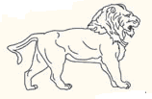
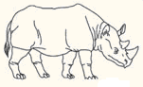
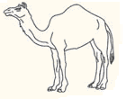

Attention | Repeat the following figures  (count one per second). |  |  |  | Count in order |  |  | 21854
 |  |  |  |  | Count backwards |  |  | 742
 | Every time when it appears 1, knock the desk once |  |  | 52139411806215194511141905112
 | 100 minus 7 in succession | 93 | 86 | 79 |  | 72 | 65
Memorize | Read the following terms,and then repeat the above process two times,finally recollect after five minutes. |  | Face | Velvet | Church | Chrysanthemum | Redness
 |  | 1st
 |  | 2nd

language | Repetition:  I just know that it is Zhang Liang who comes to help today.  When dog is at the room, cat always hide under the sofa.
 | Fluency: Speak animals as much as you can in one minute. ________(N≥11 animals)

Abstraction | Similarity in terms:  - Banana-orange=fruit  - Train-bicycle  - Watch-ruler

Postpone recollection | No tips while recollecting | Face | Velvet | Church | Chrysanthemum | Redness
 | Tips in classification
 | Tips in multiple choices

Orientation | Date | Month | Year | Week | Site | City

