Supplementary Information
Table 1. Dimensions and descriptions of the pits encountered in the study by different species.

Species | Dig dimensions (length x width x depth) (cm) | Mean dig volume (cm³) | Description | Photo
Bettong | 4.9 x 3.9 x 3.1 | 35.9 | Small discrete pit with spoil heap on one side, sometimes into the roots of grasses or shrubs | 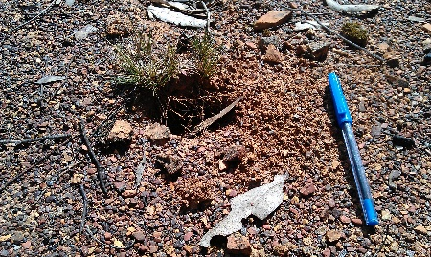
Rabbit | 10.0 x 6.1 x 2.2 | 89.3 | Wide shallow, smooth depression, with spoil heap on one side, often with faeces present | 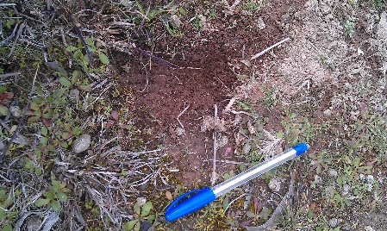
Chough | 2.9 x 2.1 x 2.3 | 14.4 | Narrow deep pit with soil scattered in all directions. No spoil heap | 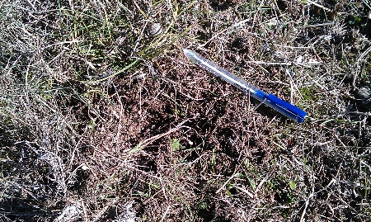
Cockatoo | 6.0 x 2.0 x 2.5 | 31.6 | Long deep gouge with balls of soil cast aside | 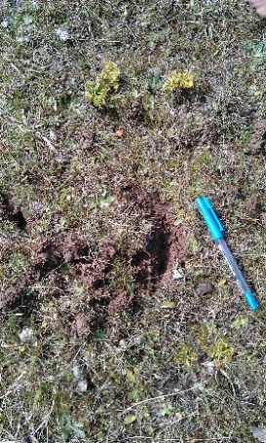
Echidna | 11.4 x 8.1 x 3.8 | 224.1 | Large untidy pit with soil pushed forward into mounds, no neat spoil heap | 