Supplementary information

Figure S3

Dose dependent and strain-dependent anti-obesity effects of Lactobacillus sakei in a diet induced obese murine model
Yosep Ji^{1*}, Young Mee Chung^{2*}, Soyoung Park^{1*}, Dahye Jeong², Bongjoon Kim², Wilhelm H. Holzapfel¹
¹Department of Advanced Green Energy and Environment, Handong Global University, Pohang, Gyungbuk 37554, South Korea;
²Beneficial microbes center, CJ Foods R&D, CJ CheilJedang Corporation, Suwon-si, South Korea

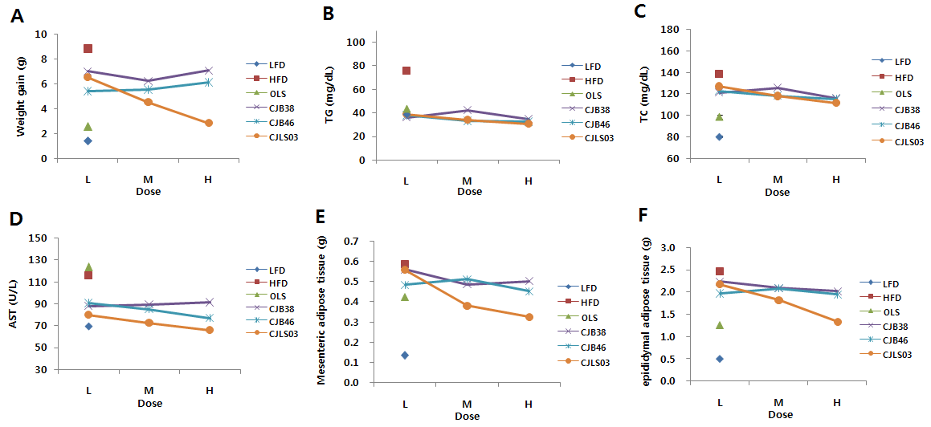

Supplementary Figure S3 Dose dependent anti-obesity effects of CJLS03 with regard to weight gain, serum biomarkers and adipose tissue weight. All data were measured at the end of the experimental period (at 48 days) and RE expressed as mean value (n=10). LFD, normal diet (low-fat diet); HFD, high-fat diet; OLS, Orlistat 40 mg/kg. L (high-dose), 1 X 10¹⁰ CFU/mL; M (medium-dose), 1 X 10⁹ CFU/mL; L (low-dose), 1 X 10⁸ CFU/mL. TG, serum triglycerides; TC, total cholesterol; AST, aspartate transaminase.

