Supplementary information

Figure S4

Dose dependent and strain-dependent anti-obesity effects of Lactobacillus sakei in a diet induced obese murine model
Yosep Ji^{1*}, Young Mee Chung^{2*}, Soyoung Park^{1*}, Dahye Jeong², Bongjoon Kim², Wilhelm H. Holzapfel¹
¹Department of Advanced Green Energy and Environment, Handong Global University, Pohang, Gyungbuk 37554, South Korea;
²Beneficial microbes center, CJ Foods R&D, CJ CheilJedang Corporation, Suwon-si, South Korea

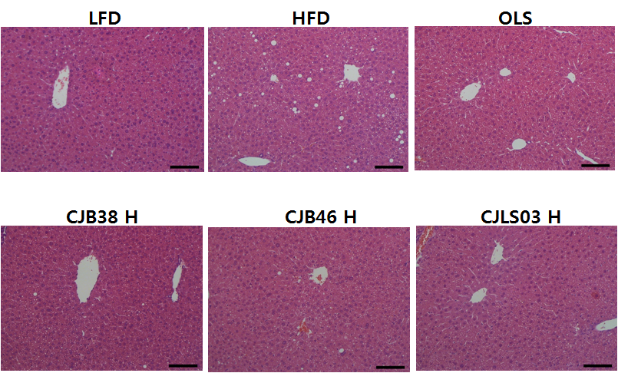

Supplementary Figure S4. Histological analyses of hepatic lipid accumulation. Representative HE-stained liver sections are shown (magnification, 200X). Mice fed a high-fat diet showed considerable hepatic lipid accumulation compared with normal pellet diet. Moderate vacuolations around the portal triad are shown in the HFD-fed mouse. LFD, normal diet (low-fat diet); HFD, high-fat diet; OLS, Orlistat 40 mg/kg; CJB38H, CJB46H, and CJLS03H received 1 X 10¹⁰ CFUs respectively of the L. sakei strains CJB38, CJB46, and CJLS03.

