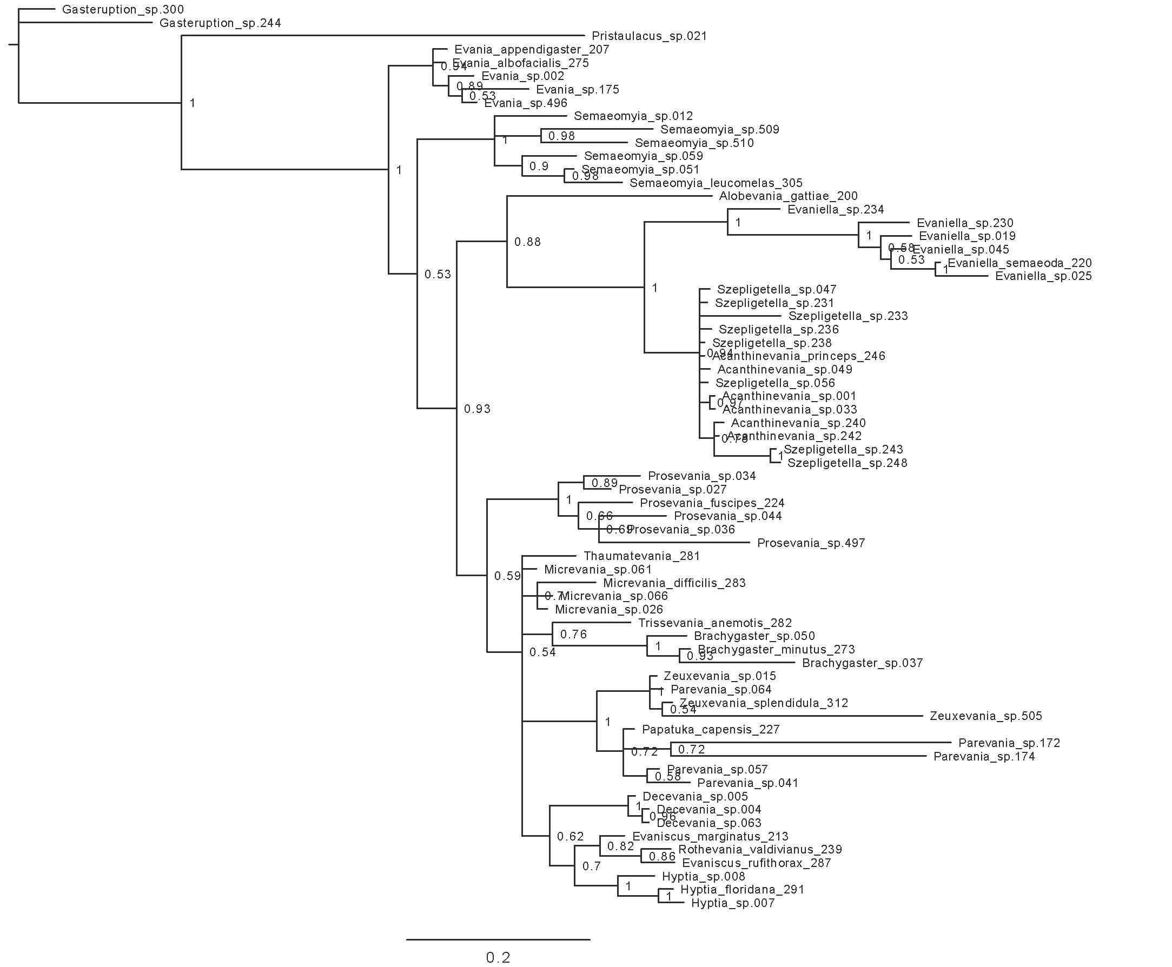

Figure S1. Bayesian analysis of 28S rDNA gene for Evaniidae. Posterior probabilities are listed beside the node.

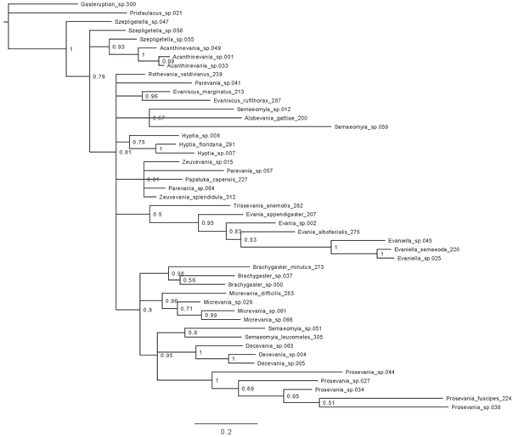Figure S2. Bayesian analysis of 16S rDNA gene for Evaniidae. Posterior probabilities are listed beside the node.

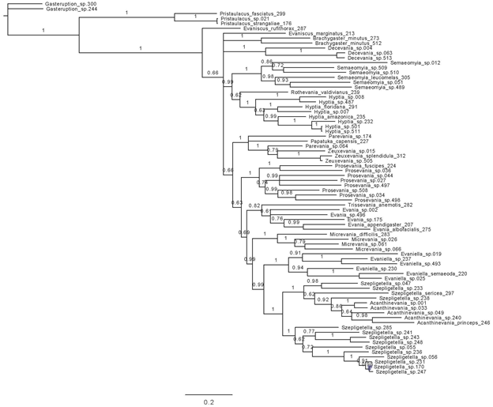Figure S3. Bayesian analysis of COI gene for Evaniidae. Posterior probabilities are listed beside the node.

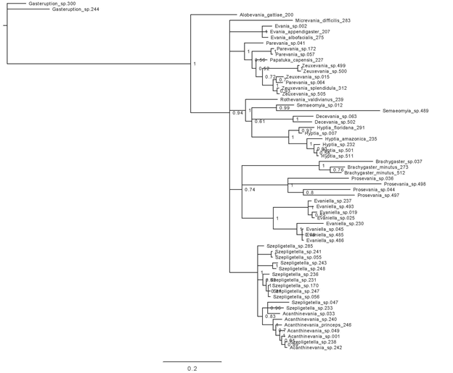Figure S4. Bayesian analysis of CAD1 gene for Evaniidae. Posterior probabilities are listed beside the node.

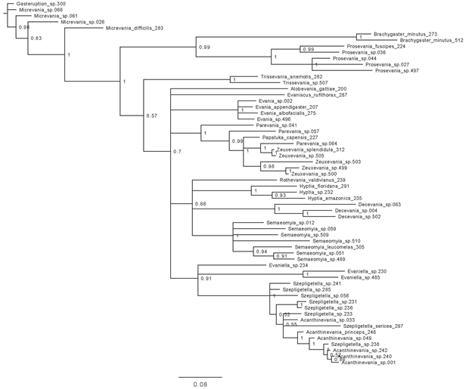Figure S5. Bayesian analysis of CAD2 gene for Evaniidae. Posterior probabilities are listed beside the node.

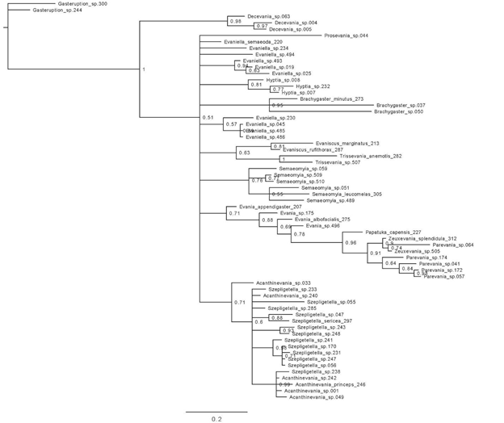Figure S6. Bayesian analysis of RPS23 gene for Evaniidae. Posterior probabilities are listed beside the node.

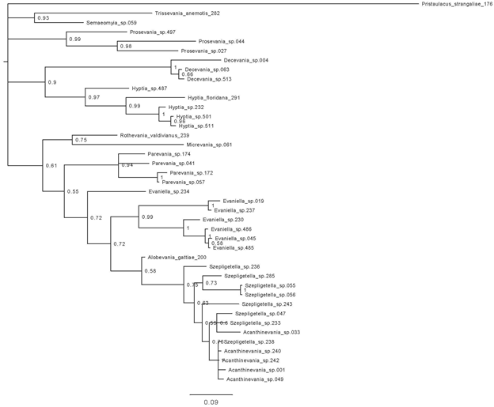Figure S7. Bayesian analysis of AM2 gene for Evaniidae. Posterior probabilities are listed beside the node.

