pH | 5,8 | 6,0 | 6,1 | 6,2 | 6,3 | 6,4 | 6,5
-BAPN | 10569 | 11068 | 12037 | 16301 | 11455 | 9024 | 8394
+BAPN | 7325 | 6920 | 6770 | 7010 | 5479 | 4528 | 4521
∆ | 3244 | 4148 | 5267 | 9291 | 5976 | 4496 | 3873

Effect of different pH values on refolding of HTU-LOX. Arbitrary units of HTU-LOX activity, measured after dialysis at different pH. BAPN – 3-aminopropionitrile.

Cu²⁺ concentration, mcM | --- | 0.1 | 1 | 10
- BAPN | 18288 | 28023 | 35576 | 30847
+ BAPN | 3144 | 3621 | 4041 | 2345
∆ | 15144 | 24402 | 31535 | 28502
Effect of different Cu²⁺ concentration during dialysis on protein activity. Arbitrary units of resorufin fluorescence corresponding to peroxide production by HTU-LOX amine oxidase activity, measured after dialysis in buffer with different Cu²⁺ concentrations.

Amine Substrates | K_{m}, mM | V_{max}*10⁻³ (nmole*s⁻1*mg⁻¹)
Histamine | 0.0240±0,0034 | 129.631±25,308
Polymyxin | 0.041±0,006 | 59.406±22,938
Amikacin | 0.136±0,089 | 128.409±10,404
Capreomycin | 1.018±0,085 | 369.418±5,313

Explanation of primer sequences used in this study:

HTU-AADN GGACGGATCCGCGGCTGACAACCCGTTCACA
HTU-QVED CGCAGGATCCCAAGTTGAGGACCAGCCGGAGGTCAAC
HTU-C TAGGAAGCTTAGCAGGAAGGGGGTTTCACAT
ARCH16S-F2 TCCGGTTGATCCYGCCGGA
ARCH16S-R934 GTGCTCCCCCGCCAATTC

Primers HTU-AADN and HTU-QVED contain BamH I sites and were used as direct primers from cloning HTU-AA and HTU-QV fragments, respectively. Reverse primer HTU-C containing a Hind III site was the same in both PCRs. Primers ARCH16S-F2 and ARCH16S-R934 were used for PCR and sequencing of 16S RNA genes.

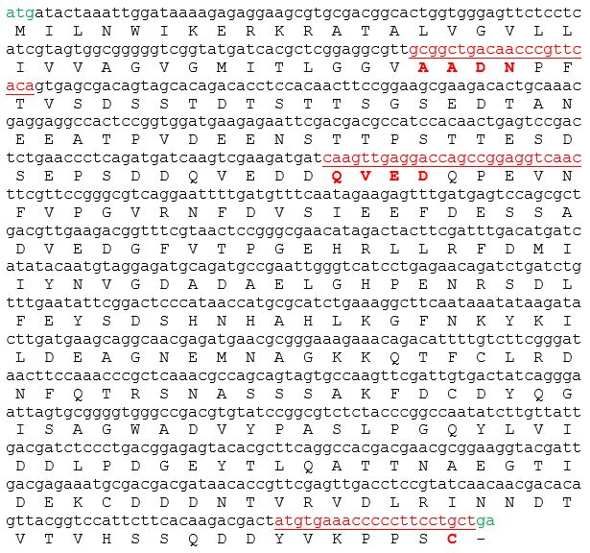

Nucleotide and amino acid sequences of H. turkmenica lysyl oxidase ORF. Red – position of primer sequences used in this study.

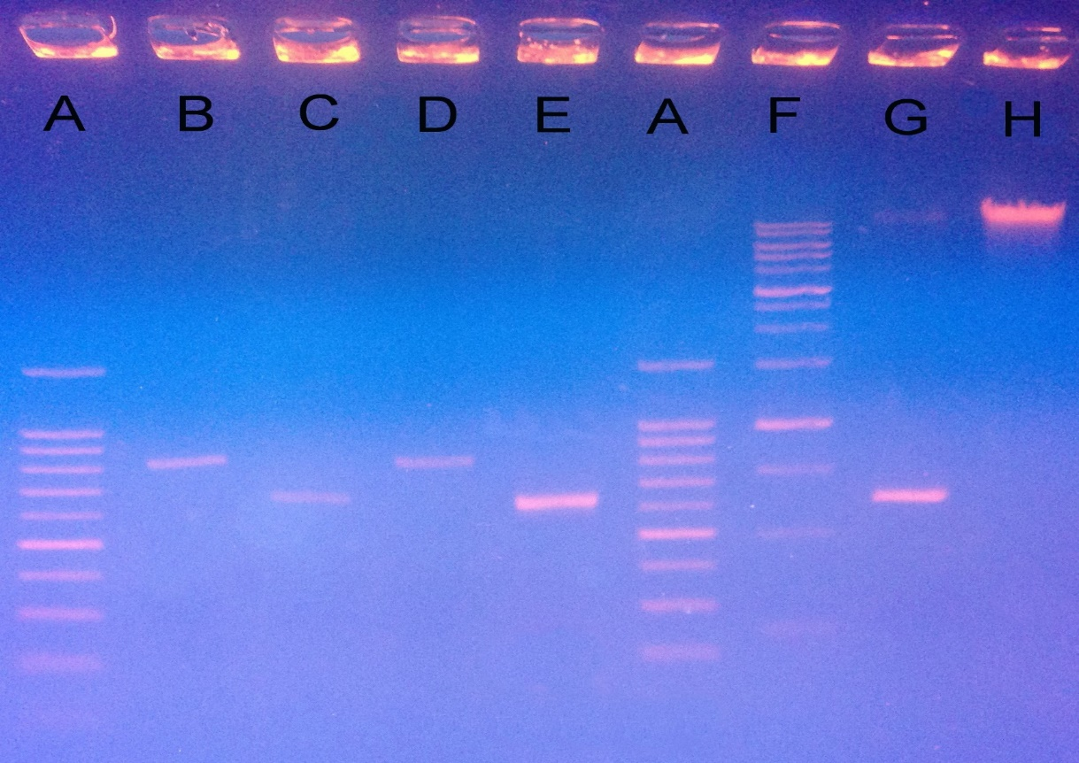
Agarose gel electrophoresis of PCR products. A, 100 bp DNA marker ladder; B, Taq polymerase, HTU-AADN; C, Taq polymerase, HTU-QVED; D, Phusion polymerase, HTU-AADN; E, Phusion polymerase, HTU-QVED; F, 1 kb DNA ladder; G, Phusion polymerase, HTU-QVED; H, H. turkmenica VKM B-1732 genomic DNA.

Expression of both HTU-AA and HTU-QV fragments simultaneously

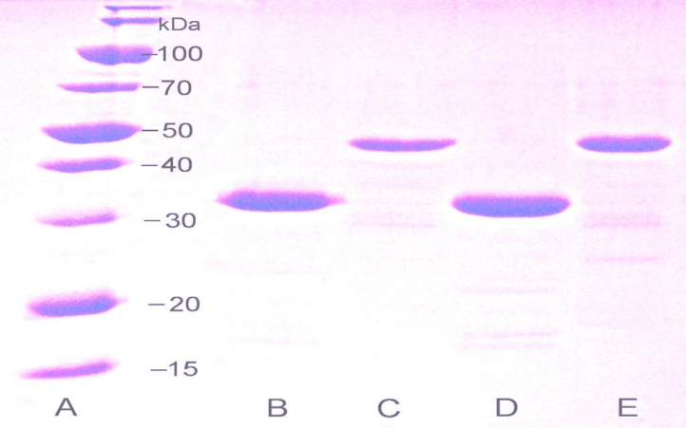

Electrophoretic analysis of purified recombinant proteins HTU-AA and HTU-QV, fragments of H. turkmenica LOX. A , molecular weight marker proteins; B, D, protein HTU-QV; C, E, protein HTU-AA.

Immunoblotting detection of full-length HTU-LOX in E. coli with anti-HTU-LOX antibodies. SDS-PAGE in Any kD gradient gel (Bio-Rad, USA). 1, 2 – chemiluminescence of bound HRP-labeled antibodies (affinity purified); molecular weight markers to the right. 1 – proteins from E. coli producing an unrelated recombinant protein (human paraoxonase 1212) as a negative control, 2 – E. coli with expression of a full length HTU-LOX. Proteins were
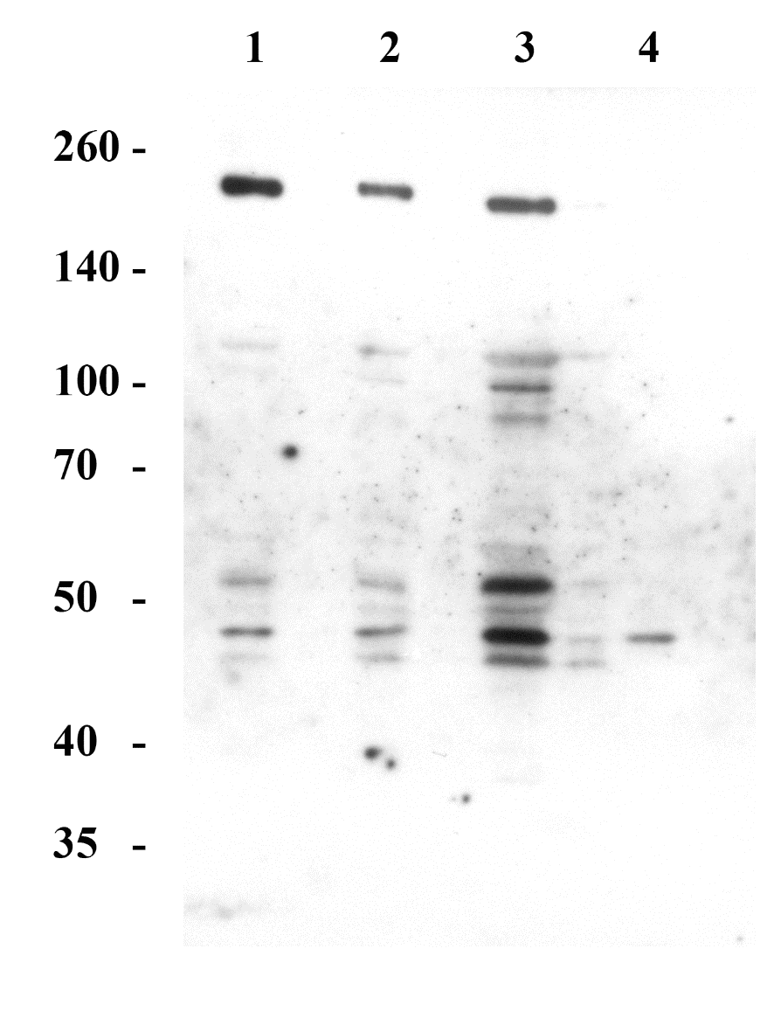

Immunoblotting detection of lysyl oxidase in H. turkmenica cells with anti-HTU-LOX antibodies. SDS-PAGE in 8% gel. 1, 2, 3, 4 – chemiluminescence of bound HRP-labeled antibodies (crude serum, not affinity purified); molecular weight markers on the left. 1 – H. turkmenica cells grown in IAO medium to log-phase (OD₆₀₀ 0.3); 2 – cells in stationary phase (OD₆₀₀ 1.2); 3 – cells grown to stationary phase were incubated at room temperature (around 25°C) for 7 days; 4 - 3 – cells were incubated at room temperature (around 25°C) for one month in saturated medium with precipitating salt.

SUPPLEMENTARY TABLE
Lack of detectable amine oxidase activity of full-length HTU-LOX protein expressed in E. coli and in Haloterrigena proteins
Sample | Activity,  nmole*mg⁻¹*sec⁻¹
E. coli crude cell lysate, full-length HTU-LOX | <0.0001
E. coli crude cell lysate, HTU-AA | 0.0053
Purified and refolded HTU-QV | 0.079
Haloterrigena turkmenica, secreted proteins | <0.0001
Haloterrigena turkmenica, crude cell lysate | <0.0001

XL-1 E. coli were induced with IPTG as described in Results, cells pelleted, lysed using freeze-thawing followed by homogenization by bead-beating (water, 0.1 mm glass beads) and extensively dialyzed against the acetate folding buffer. Fresh Haloterrigena cells were centrifuged and lysed in water similarly to the procedure described in the immunoblotting section (before the addition of TCEP and other components) and extensively dialyzed against the acetate folding buffer. Secreted proteins fraction has been obtained by ultrafiltration and washing of the cleared Haloterrigena culture supernatant on a 10000 MWL filter (Amicon, USA). For activity measurement, 2 mM histamine has been chosen here as amine substrate. <0.0001 indicates values below detection limit with this assay.

