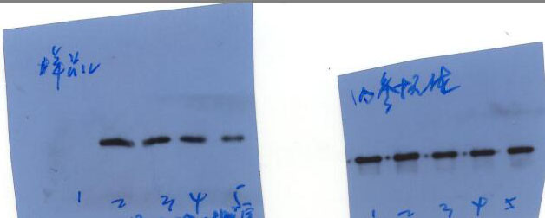

PAkt-S473

S473

GAPDH

S473