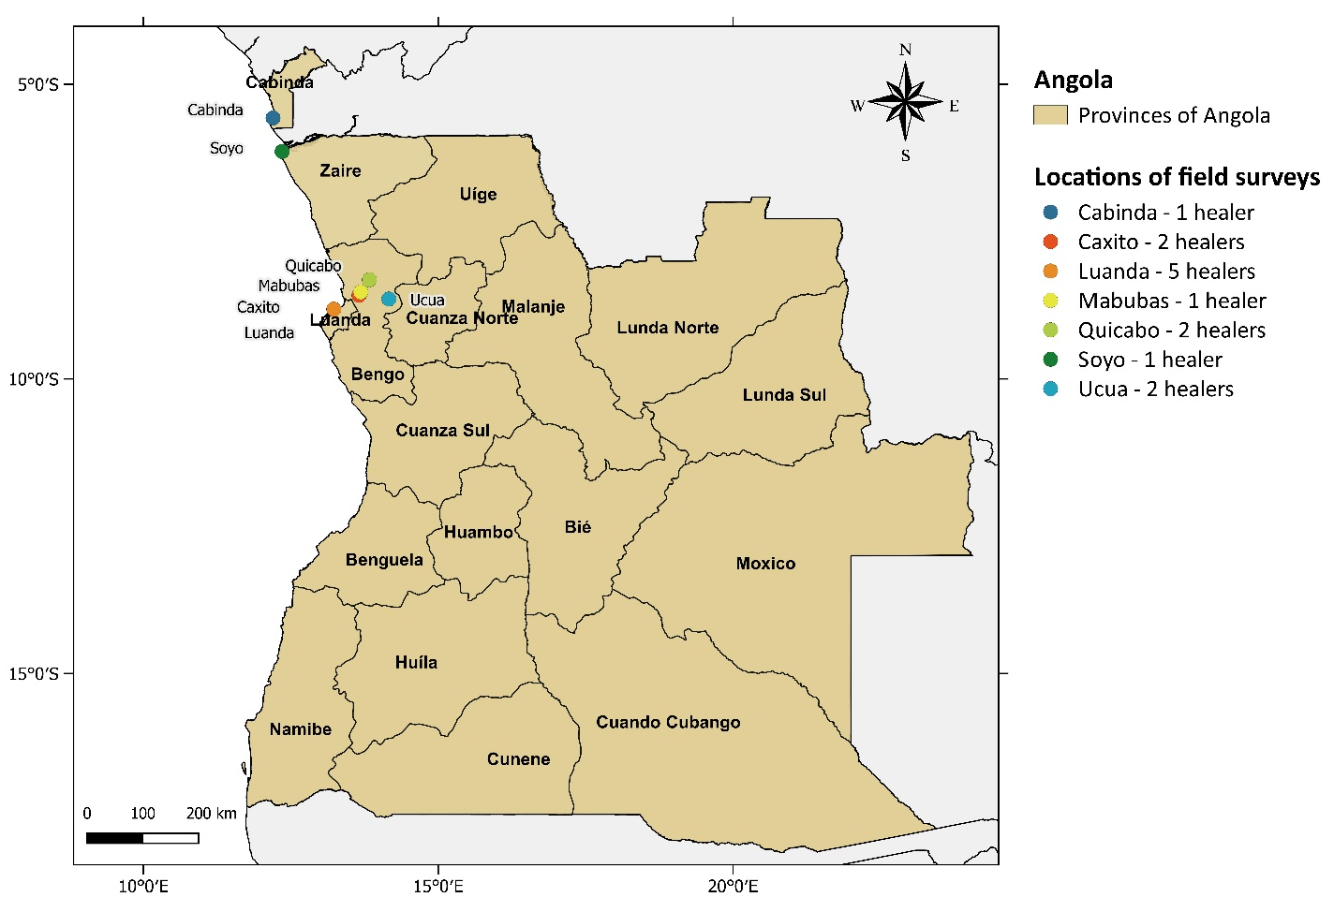
Supplemental Data S1. Study area with information about field surveys and healers

Healer Name | Gender | Age | Province | Location | Year
Amélia Mugunga | Female | 71 | Bengo | Mabubas | 2008
Antónia Augusto | Female | 82 | Bengo | Caxito | 2011
Carlota Pontes | Female | 65 | Bengo | Quicabo | 2008
Daniel Samuel | Male | 41 | Zaire | Soyo | 2013
Delfina Capita | Female | 83 | Luanda | Luanda | 2009
Eva Afonso | Female | 101 | Bengo | Ucua | 2011
Joana Vieira | Female | 63 | Luanda | Luanda | 2012
Manuel de Carvalho | Male | 61 | Luanda | Luanda | 2013
Maria Mateus | Female | 68 | Luanda | Luanda | 2012
Nphumu Nkonde | Male | 72 | Cabinda | Cabinda | 2013
Quissanga João | Male | 101 | Bengo | Ucua | 2008
Sabina Gomes | Female | 85 | Bengo | Caxito | 2010
Teresa Teixeira | Female | 50 | Luanda | Luanda | 2013
Teresa Tomense | Female | 75 | Bengo | Quicabo | 2009
Healers’ information:

