Table S6 Conserved motifs identified in the SaGLIP proteins

Motif No. | Motif consensus sequence | E value | No. of SaGLIP proteins | Length (amino acids) | Relative Entropy | Bayes Threshold
1 | 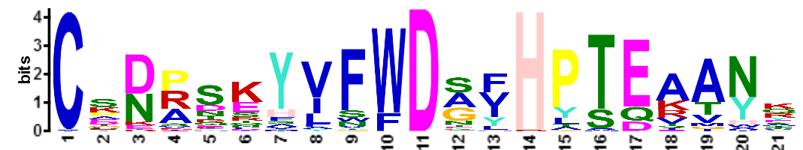 | 8.6e-977 | 80 | 21 | 58.6 | 8.47137
2 | 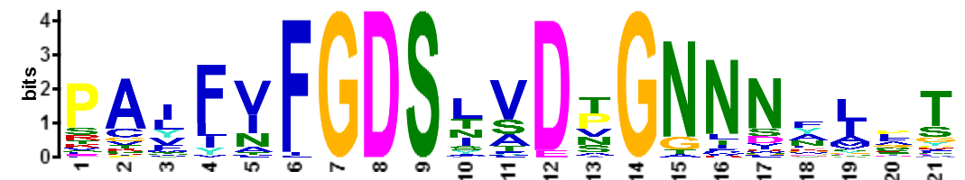 | 7.7e-758 | 80 | 21 | 49.9 | 8.72356
3 | 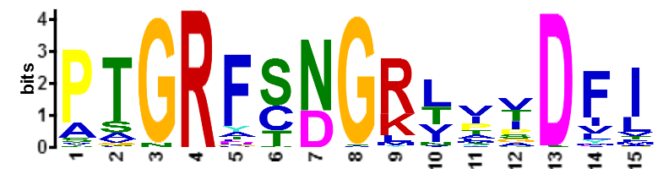 | 9.4e-608 | 79 | 15 | 41 | 8.75204
4 | 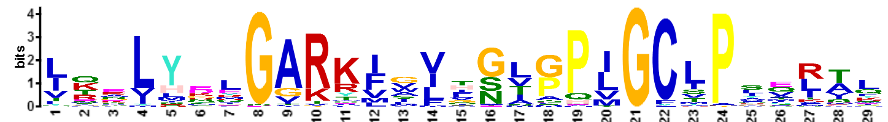 | 3.9e-880 | 80 | 29 | 59.1 | 8.43848
5 | 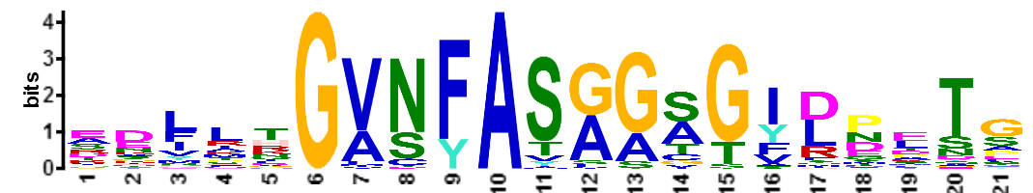 | 8.2e-574 | 79 | 21 | 42.8 | 8.47499
6 | 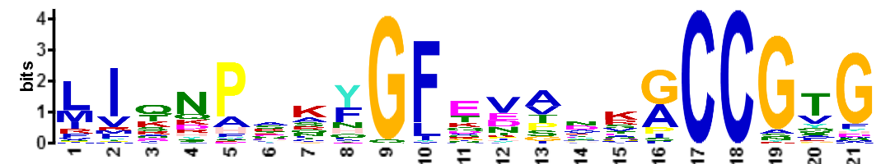 | 8.5e-535 | 70 | 21 | 44.9 | 8.508
7 | 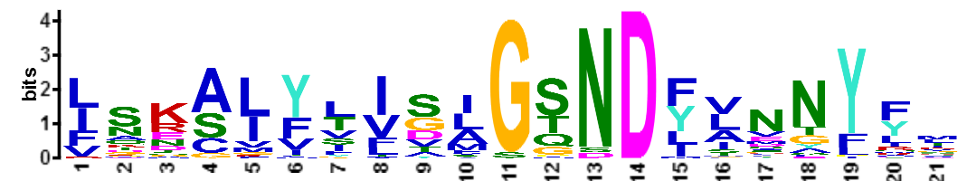 | 1.5e-493 | 72 | 21 | 42.7 | 10.0304
8 | 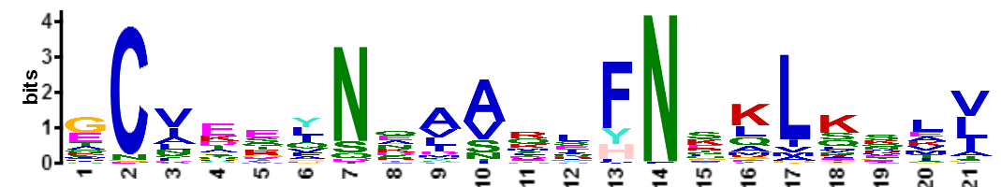 | 9.3e-401 | 79 | 21 | 35.5 | 8.72787
9 | 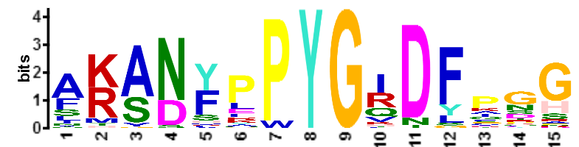 | 3.0e-362 | 58 | 15 | 38.9 | 9.60239
10 | 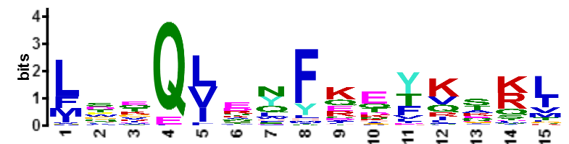 | 1.50E-245 | 79 | 15 | 26.3 | 8.49918
11 | 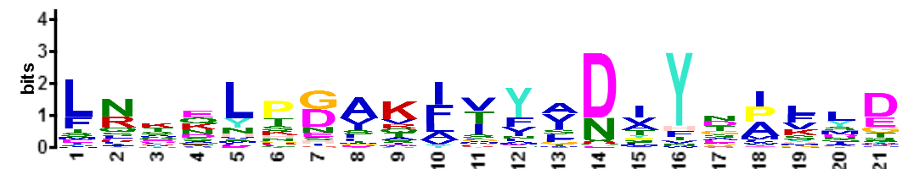 | 7.70E-239 | 70 | 21 | 31.4 | 8.508
12 | 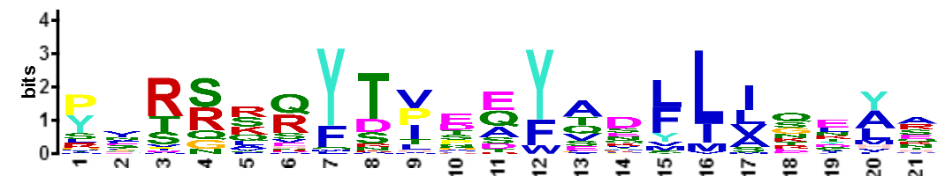 | 1.30E-192 | 49 | 21 | 36.9 | 8.86353
13 | 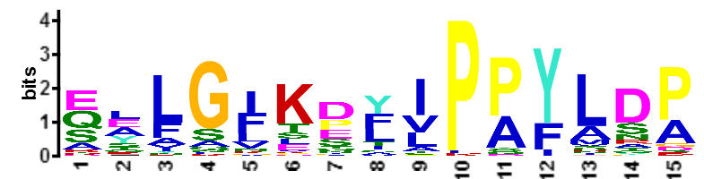 | 2.20E-175 | 49 | 15 | 31.8 | 8.8877
14 | 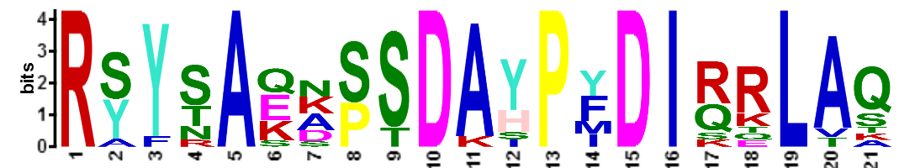 | 1.50E-96 | 12 | 21 | 68.8 | 12.3116
15 | 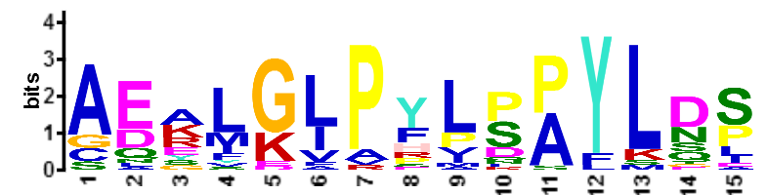 | 5.10E-63 | 24 | 15 | 35.5 | 11.3355
16 | 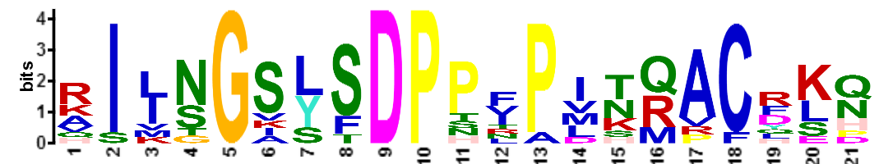 | 2.50E-47 | 11 | 21 | 59.1 | 11.6926
17 | 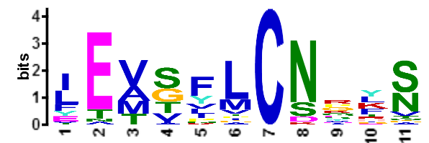 | 1.10E-42 | 30 | 11 | 25.2 | 9.85392
18 | 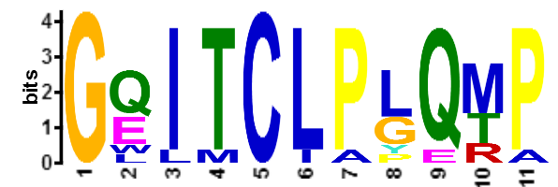 | 7.90E-34 | 10 | 11 | 39.9 | 12.4586
19 | 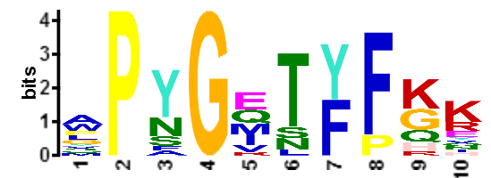 | 4.90E-23 | 18 | 10 | 27.7 | 11.5188
20 | 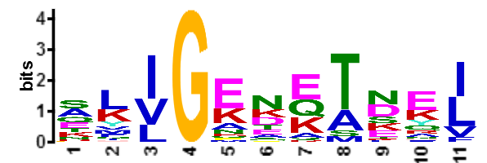 | 3.00E-21 | 30 | 11 | 23.2 | 11.2045
21 | 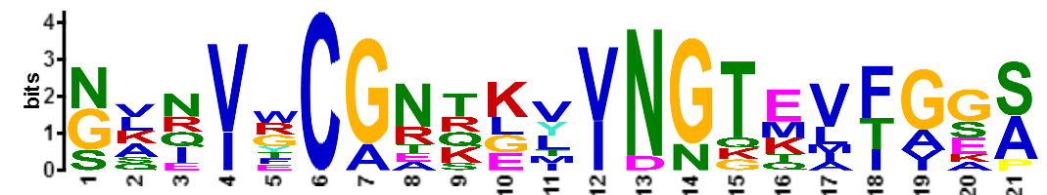 | 1.30E-18 | 10 | 21 | 53.9 | 11.7265
22 | 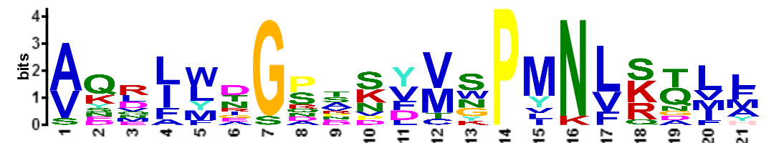 | 6.60E-18 | 12 | 21 | 48.9 | 10.8706
23 | 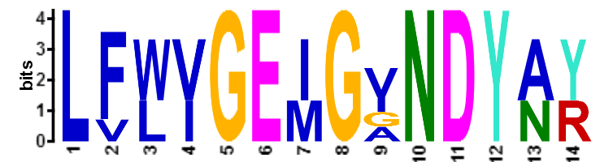 | 1.20E-11 | 5 | 14 | 51.5 | 12.7549

