Supporting information
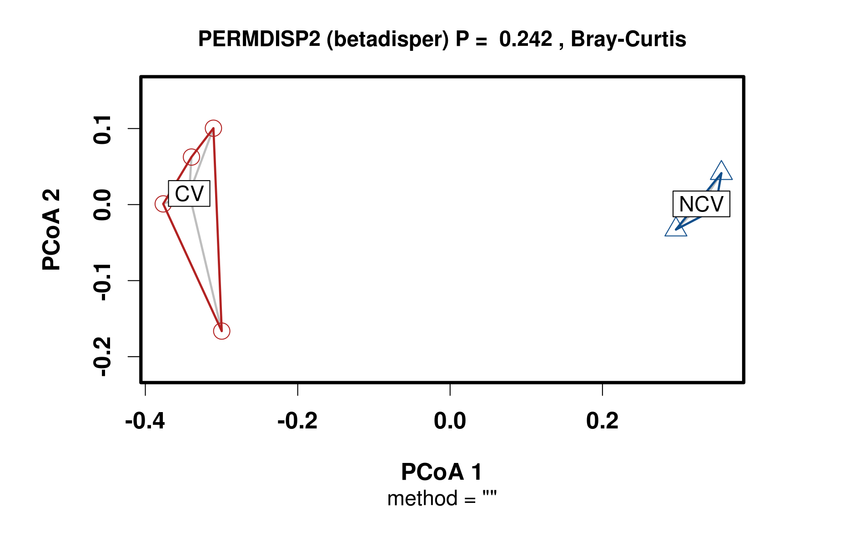

Fig. S1. Permutational multivariate dispersion (PERMDISP) test of bacterial community composition of concentrated vinasse (C) and non-concentrated vinasse (N)

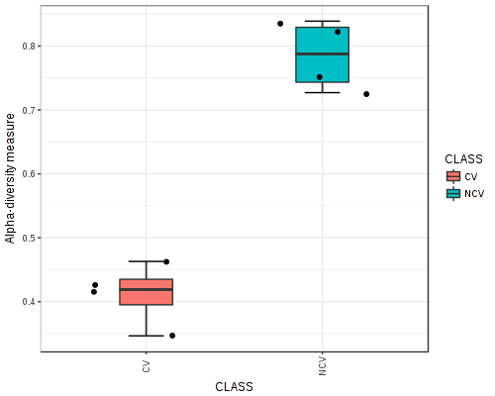
Fig. S2. Alpha-diversity index (Simpson) of concentrated vinasse (CV) and non-concentrated vinasse (NCV).

Table S1. Chemical characteristics of the concentrated vinasse (CV) and non-cocncentrated (NCV).

 | pH | C org^{b} | N tot ^{c} | NH₄⁺-N ^{d} | NO₃⁻N ^{e} | P | K | C/N
 |  | g L⁻¹ | g L⁻¹ | mg L⁻¹ | m g L⁻¹ | g kg⁻¹ | g kg⁻¹
CV | 4.8 | 28.8 | 0.51 | 45.7 | 8.8 | 0.11 | 3.5 | 57/1
NCV | 3.9 | 31.4 | 0.89 | 41.6 | 4.1 | 0.23 | 4.7 | 35/1

^{b} C org: Total organic carbon;
^{c} N tot:Total organic nitrogen;
^{d}NH₄⁺-N: ammonium;
^{e} NO₃⁻-N: nitrate.

Table S2. Primers and PCR conditions of each gene.

Gene | Primer | Reference
narG | narG1960m2F | Bru et al., 2007
 | narG2050m2R
nirK | nirK 1F | Braker et al., 1998
 | nirK 5R
nirS | nirScd3af | Throback et al., 2004
 | nirSR3cd
nosZ | nosZ2F | Henry et al., 2006
 | nosZ2R
amoA | AmoA-1F | Rotthauwe et al., 1997
 | AmoA-2R-TC
nifH | PolF | Poly et al. (2001)
 | PolR

