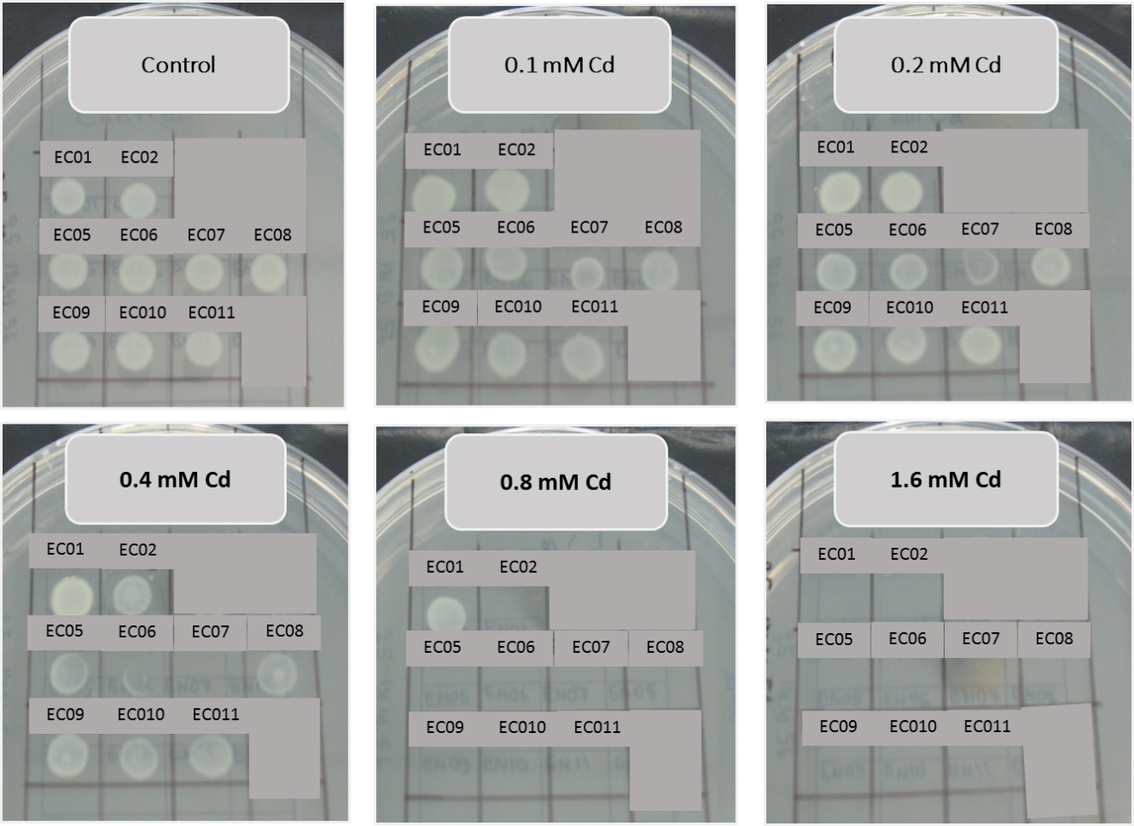
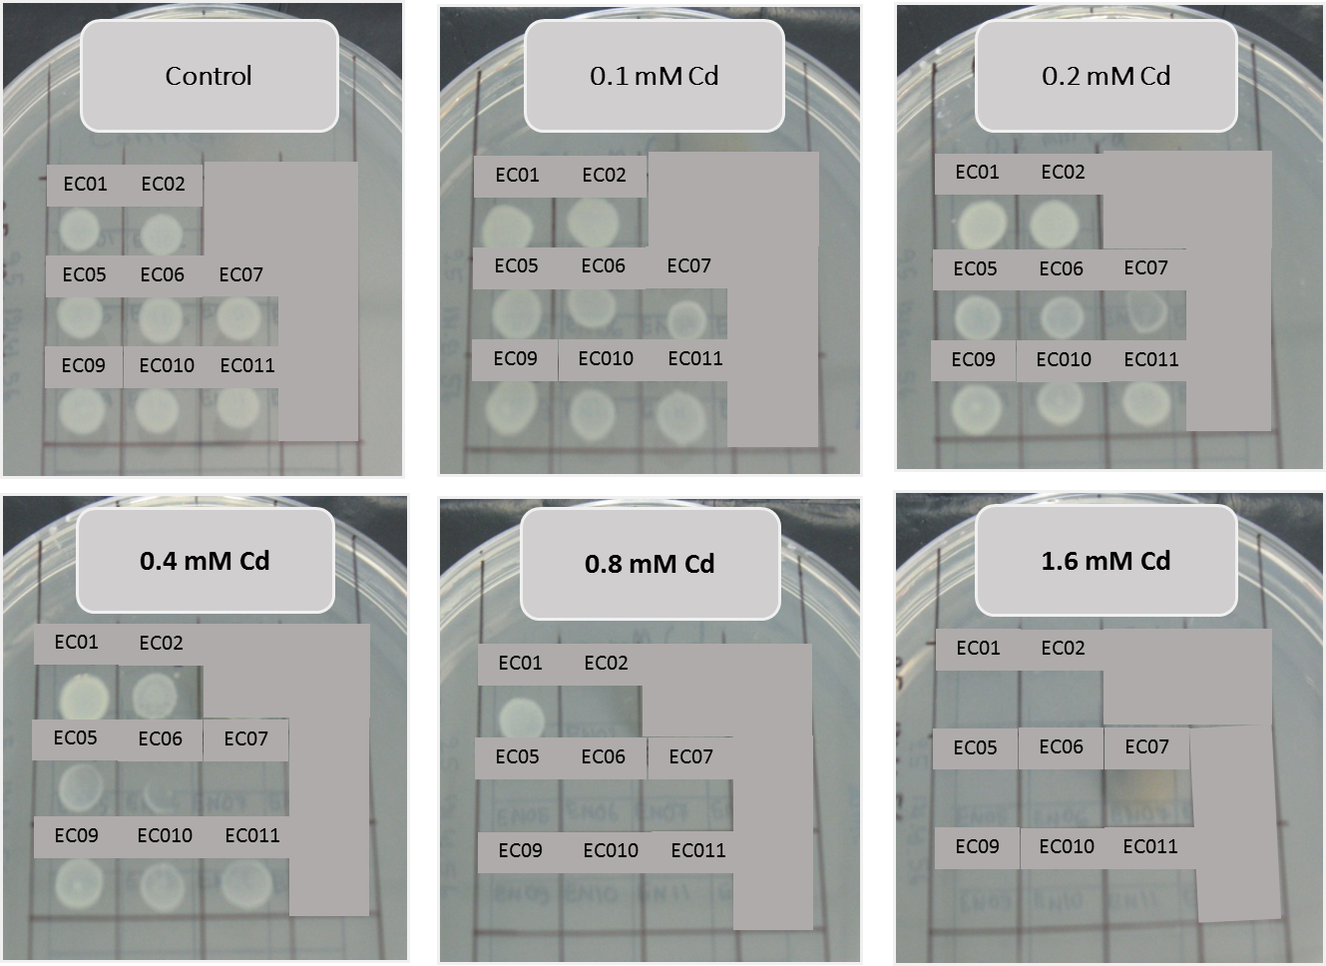
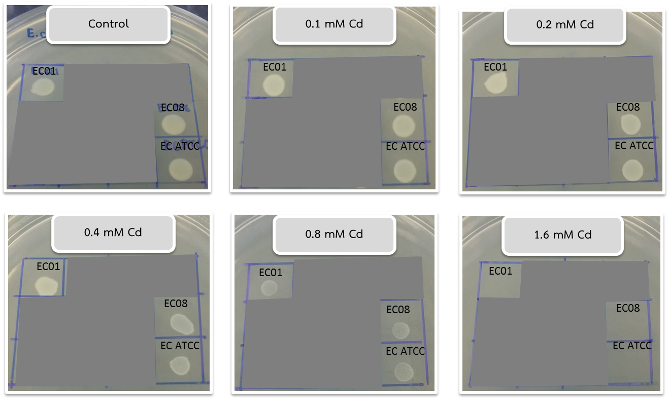
Supplementary Figures 1, 2 and 3 The MICs of 9 isolates of E. cloacae and standard strain ATCC 13047 against cadmium were performed by the Agar Dilution method according to CLSI, 2012 recommendation

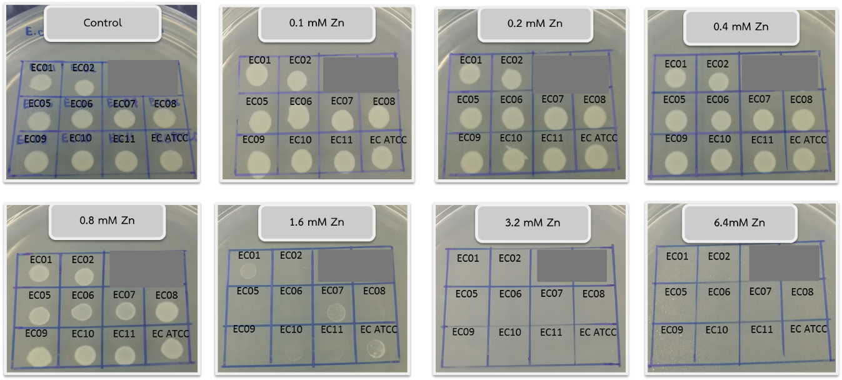
Supplementary Figure 4 The MICs of 9 isolates of E. cloacae and standard strain ATCC 13047 against zinc were performed by the Agar Dilution method according to CLSI, 2012 recommendations

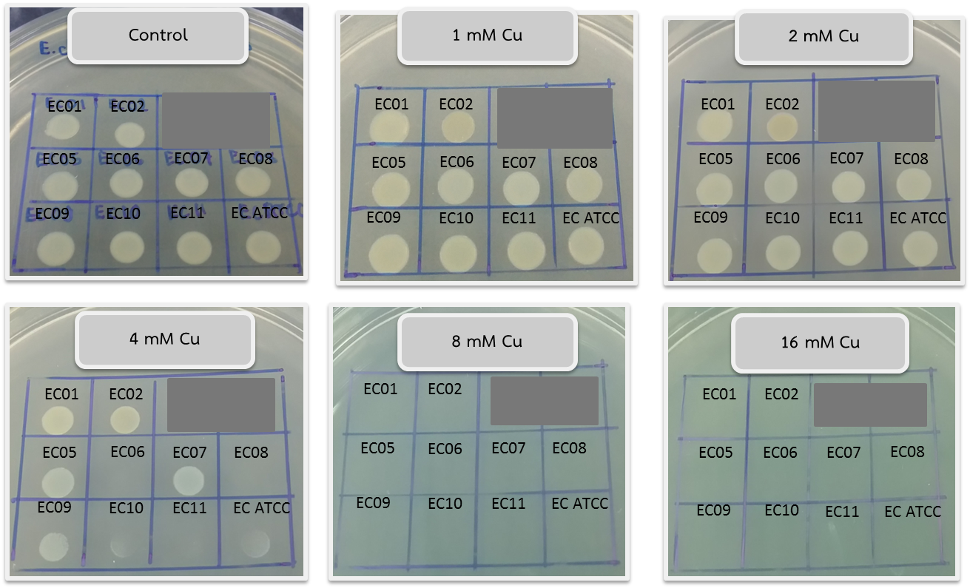
Supplementary Figure 5 The MICs of 9 isolates of E. cloacae and standard strain ATCC 13047 against copper were performed by the Agar Dilution method according to CLSI, 2012 recommendations

