Supplementary material

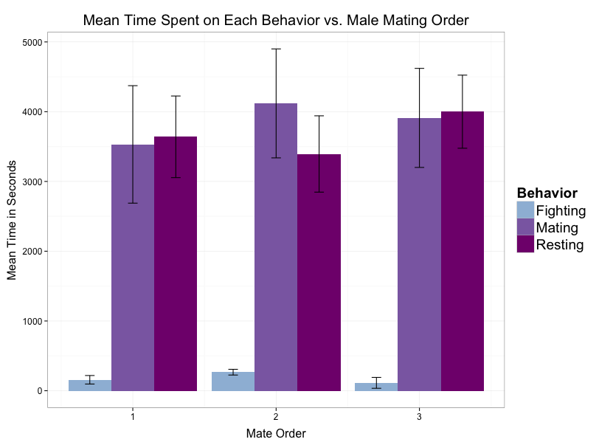
S1: Mean time (in seconds) spent on fighting, mating, or resting for all male Octopus oliveri from each category of male order (first, second, third). Error bars represent standard error.

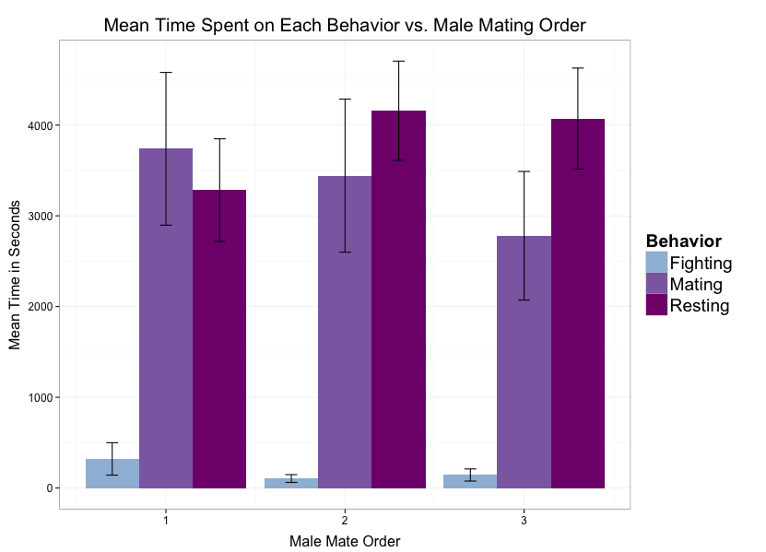
S2. Mean time (in seconds) spent on fighting, mating, or resting in individual male Octopus oliveri between given mate order. Error bars represent standard error.

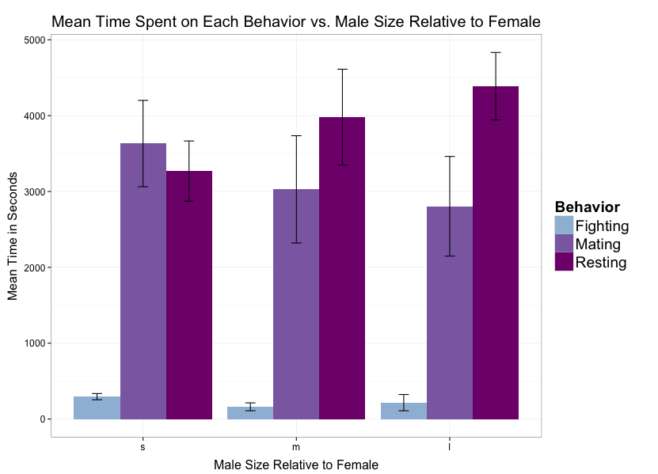
S3. Mean time (in seconds) spent on fighting, mating, or resting when comparing male size relative to female. Size s: small, m: medium, l: large. Error bars represent standard error.

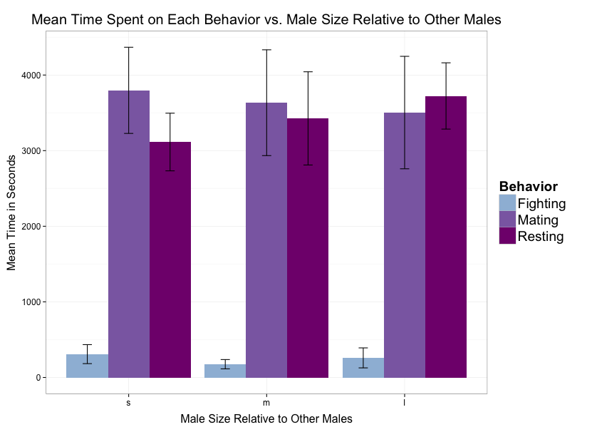
S4. Mean time (in seconds) spent on fighting, mating, or resting when comparing male size relative to other male Octopus oliveri in the population. Size s: small, m: medium, l: large. Error bars represent standard error.

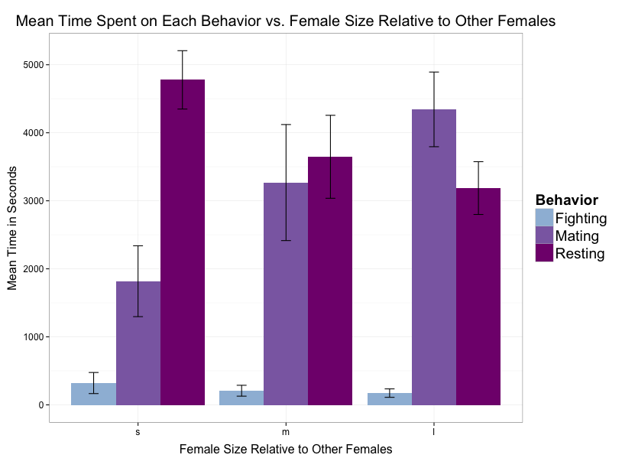
S5. Mean time (in seconds) spent on fighting, mating, or resting when comparing female size relative to other female Octopus oliveri in the population. Size s: small, m: medium, l: large. Error bars represent standard error.

S6. 48 species-specific microsatellite loci isolated for Octopus oliveri. Of the initial 48 loci identified (Fernandez-Silva et al. 2013) the first 5 to work (denoted in *bold below) were used in this study because they amplified consistently and provided the exclusion power needed for this work (see S7).
Locus | size | Motif | Primer Sequence (5'-3')
Octoli_001 | 4 | ACAT | F: GCATTAAGTCATCAACATGC
 |  |  | R: ATGCCAGCATGGTACTTC
Octoli_002 | 4 | ATCT | F: CACAGATACATCCGCACACG
 |  |  | R: TTGAGAGACGCCGACCAC
*Octoli_003 | 4 | TAGA | F: GCACGTTGTACGCGATTC
 |  |  | R: ATATGCATGAAGACGCAACTC
Octoli_004 | 4 | ATAC | F: TGCTTCTCAACCACATGTATGC
 |  |  | R: ACGCACACACTTGATGTAGAGTTC
Octoli_005 | 4 | ATCT | F: ACCGTCATCTATCAATCCATC
 |  |  | R: TGCTAGATATGTTCATATTGAGAACT
Octoli_006 | 4 | ATAG | F: TTATGCGCTTAATTCGGTAT
 |  |  | R: CTTCTCATTCTCCAACATTGA
*Octoli_007 | 4 | TATG | F: CGCAGACGAGGAATCAATAG
 |  |  | R: GGAGAACAGACACAAGAACACAG
Octoli_008 | 4 | ATCT | F: CATGAATGCAGTATTAGTATGA
 |  |  | R: AACTTAGTCTCTCCACTCTGAT
Octoli_009 | 4 | AGAT | F: CGATCTGAGCCAGCACTTC
 |  |  | R: TCCACACACACGTATATTATATGGAC
Octoli_010 | 4 | CATA | F: CGCCAGTGATTGAACTTATGAC
 |  |  | R: ATCAGGAAGAGGTGGTGCAG
Octoli_011 | 4 | CATA | F: ACCATCCATCCATCCATCC
 |  |  | R: GTGTGAGCTCGTGAGTGAGG
Octoli_012 | 4 | TATG | F: GTGTGAGTGCATATGTGTG
 |  |  | R: CACTAGCGATACGATACATAA
Octoli_013 | 4 | AGAT | F: TCCACACGATAGACAGAGAGACAG
 |  |  | R: TTGAGAGACGCCGACCAC
Octoli_014 | 4 | ATAC | F: TGCATACACACACATACACA
 |  |  | R: TTGTTATTCCGATTCCTG
Octoli_015 | 4 | TAGA | F: TGCAATCACCTTAGGACCAAC
 |  |  | R: CAGCAATGGAGCTGAGAGTG
Octoli_016 | 4 | TATT | F: TGTGTATGTCTTAAGCCTCGT
 |  |  | R: TATAAGGAGTGGAGGAGCAA
*Octoli_017 | 4 | TATG | F: AGCAACACGATGGCCTCTAC
 |  |  | R: AGTCCAACAAGCTTCGATCC
Octoli_018 | 4 | TTGC | F: CCAATAACTCGTGACATCTG
 |  |  | R: AACTACTTGTCCGATATACGC
Octoli_019 | 3 | CAC | F: CGCATGCGTTAAGTGACAG
 |  |  | R: CGTCCATAGACGTGAGGAAG
*Octoli_020 | 3 | GTA | F: TTACTCATCTAGCCAATCAGTATGCAG
 |  |  | R: TAATACGGCCGTCGCTCTG
Octoli_021 | 3 | GTT | F: TTGCATTGGATGTGAATTATTA
 |  |  | R: TCTAAGGACTGAACGAGCTG
Octoli_022 | 3 | TGA | F: AGCCATGTGGTTGAGAACG
 |  |  | R: GCGTGCCTCTCTTCATCAG
*Octoli_023 | 3 | GAT | F: GCCATGAATTCCAAGTAACTAACC
 |  |  | R: CATCGTCATACGCCATCATC
Octoli_024 | 3 | TAT | F: TCATGTTGAGAGTCGTTCCTG
 |  |  | R: TGGTGCTATTGAGTTAGACATGG
Octoli_025 | 3 | CTT | F: TTCTTCACCATCACCACAGG
 |  |  | R: AGCAGTACCAGCCAGATGC
Octoli_026 | 3 | GCG | F: GCGGTGGTGGTGGTAGTAG
 |  |  | R: TCATCAGCCTTGTTCTATGACTG
Octoli_027 | 3 | ATA | F: ACACCATCAAGCATGTCGTC
 |  |  | R: CACTTGTGTACTGGATCCGATG
Octoli_028 | 3 | TAT | F: GTATGAAGCAGAGGTGACGATG
 |  |  | R: CATGATTGCTGCTGACAAGG
Octoli_029 | 3 | TAG | F: CCAGCATCATCATCACCTTC
 |  |  | R: CTGTGTGCCTTGAGAGACG
Octoli_030 | 3 | ATC | F: CATTCCAGCGTGAAGCAAG
 |  |  | R: TTCTAACCACACAGCCATGC
Octoli_031 | 3 | ATC | F: TCTTAACATTCTGACTAACAATAATGG
 |  |  | R: GTCACTGGTGGATGATGATG
Octoli_032 | 3 | ATC | F: TTCACTGCACTTCCGAGT
 |  |  | R: CCACGTGTATGACTGGTACTT
Octoli_033 | 3 | TTC | F: TGATTGAATTCTTGTGGTATCT
 |  |  | R: AAGTACTATTGTATGGTGCTCAA
Octoli_034 | 3 | TGG | F: CATGTGTGCTTGTGTGGAAC
 |  |  | R: CCACCACGTATACTAACGAACG
Octoli_035 | 3 | TTA | F: TCAGTTAAGATAAGAAGCCATGACAG
 |  |  | R: GCCAGCTCACTGTGTTGTTG
Octoli_036 | 3 | GAT | F: GCTGCTGCTACTGATGATG
 |  |  | R: TCTATCATCATCCTCCTCCTC
Octoli_037 | 3 | GAT | F: TCCTGTTGAATGAATGTTAC
 |  |  | R: TGTTGATATCTCCTCATGTC
Octoli_038 | 3 | GTA | F: AACAATAATATGGCGGAACAG
 |  |  | R: ACTGACTGCTGCTGCTCTAC
Octoli_039 | 3 | ATG | F: AAGCATGGATGATGAAGAAT
 |  |  | R: ACGGACAACAGACAACAATA
Octoli_040 | 3 | GTG | F: CTGCATCTCTTCTGTGAAC
 |  |  | R: AGTTAGTAGTACGAAGAAGTAAGAA
Octoli_041 | 2 | AC | F: GTGATGGTGCAGAATGGAAG
 |  |  | R: ACCACGCACACACTATTGC
Octoli_042 | 2 | AC | F: CAGTGGTGATGGTGTGAG
 |  |  | R: GTTAGTAACCGACCACGAC
Octoli_043 | 2 | AC | F: AGATATGTATACCGTCGTTG
 |  |  | R: TTAATTAGTTAGTTAGTCGAGTAGTAG
Octoli_044 | 2 | TG | F: TTGCTTGTGTGTGGAGAAGG
 |  |  | R: CACACCTACCTACCACCTACCG
Octoli_045 | 2 | CA | F: GAGACTTACTTCGTTGTGTGG
 |  |  | R: AGGAGTGTGTCGTATATATAATAATTG
Octoli_046 | 2 | CA | F: GTTAGCCTTACACTCTGCTAATTCC
 |  |  | R: CGCGTCTGTATGTGTGTCG
Octoli_047 | 2 | TG | F: TTCCATTCTGAGGTGGAACAC
 |  |  | R: CGTTCGTCTCTCTCTTCTTCTCTC
Octoli_048 | 2 | AC | F: GCATATGTGTGCGTATAGTTG
 |  |  | R: GGTCGAAGGAAGTAATTAGTTATAG

S7. Expected exclusion probabilities for the 5 microsatellite loci from S6 used in this study to evaluate multiple paternity in Octopus oliveri. Although exclusion probabilities for individual loci can be rather low, the combined power for all loci exceeds 95% even when neither parent is known.
﻿Expected exclusion probabilities
 | Neither parent known | One parent known with certainty, one unknown | Parent pairs known
Octoli_3 | 0.552 | 0.714 | 0.881
Octoli_7 | 0.468 | 0.643 | 0.826
Octoli_17 | 0.138 | 0.257 | 0.393
Octoli_22 | 0.665 | 0.799 | 0.936
Octoli_23 | 0.530 | 0.695 | 0.866
All Loci | 0.968 | 0.995 | 1.000

S8. Power analysis to determine the number of eggs needed to sample per clutch to detect multiple paternity in Octopus oliveri. We selected a sample size of 34 eggs, to have a 95% chance of detecting at least 10 possible sires.

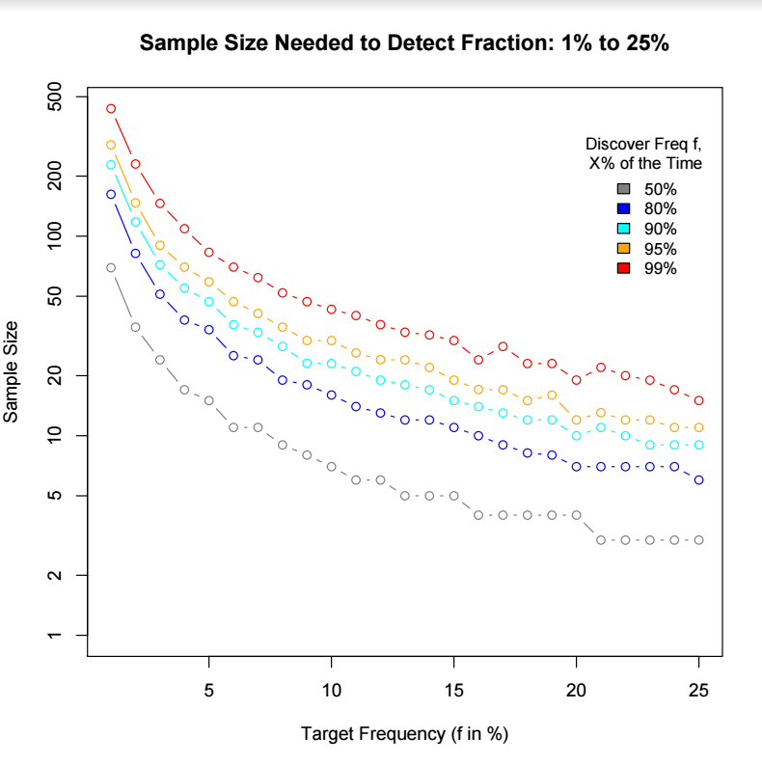

S9. Number of non-maternal alleles detected in a sample of 34 eggs for each of 8 experimental and 3 wild-caught females of Octopus oliveri. Data are presented for each locus and the minimum number of males needed to account for those alleles.
Experimental Females | Locus Octoli_3 | Locus Octoli_7 | Locus Octoli_17 | Locus Octoli_22 | Locus Octoli_23 | Min no. of males (SLM) | Min no. of males (GERUD)
F1 | 6 | 4 | 2 | 7 | 5 | 4 | 5+
F2 | 4 | 2 | 1 | 4 | 3 | 2 | 4
F3 | 4 | 3 | 2 | 5 | 4 | 3 | 5
F4 | 4 | 2 | 1 | 5 | 4 | 3 | 5
F5 | 5 | 4 | 0 | 5 | 5 | 3 | 5*
F6 | 3 | 1 | 1 | 4 | 6 | 4 | 5+
F7 | 5 | 1 | 1 | 6 | 5 | 3 | 5*
F8 | 4 | 2 | 3 | 4 | 4 | 3 | 5+
Non-experimental females
F9 | 2 | 1 | 0 | 2 | 4 | 2 | 3
F10 | 3 | 3 | 0 | 5 | 2 | 3 | 4
F11 | 1 | 1 | 1 | 1 | 1 | 1 | 2

+ indicates GERUD unable to calculate higher minimum number of sires due to program freezing,
*locus Octoli_17 removed from analysis and genotype array rerun to confirm result.

S10. Number of eggs per brood of experimental female Octopus oliveri sired by each male, as calculated by CERVUS, with 95% and 80% confidence levels. If none of the candidate fathers matched the offspring genotype, they were considered as sired by “other”.
95% Confidence |  |  |  |  | 80% Confidence
Female | 1st male | 2nd male | 3rd male | Other | 1st male | 2nd male | 3rd male | Other | N
Set 1
F1 | 0 | 4 | 4 | 26 | 5 | 4 | 10 | 15 | 34
F2 | -- | 11 | 0 | 23 | -- | 12 | 8 | 14 | 34
Set 2
F3 | -- | -- | 19 | 15 | -- | -- | 22 | 12 | 34
Set 3
F4 | 26 | ** | 1 | 7 | 28 | -- | 4 | 2 | 34
F5 | 0 | ** | 16 | 18 | 2 | -- | 23 | 9 | 34
Set 4
F6 | 17 | 3 | 1 | 13 | 25 | 4 | 5 | 0 | 34
F7 | 16 | 2 | 0 | 16 | 21 | 2 | 0 | 11 | 34
F8 | 11 | 2 | 0 | 21 | 21 | 4 | 3 | 6 | 34
Average | 11.67 | 3.14 | 5.13 | 17.38 | 17 | 5.2 | 9.38 | 8.63 | 34
Total | 70 | 22 | 41 | 139 | 102 | 26 | 75 | 69 | 272
-- indicates no mating occurred, ** indicates paternal genotype missing
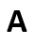
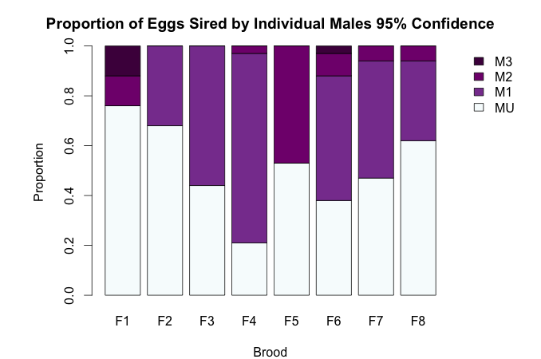
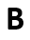
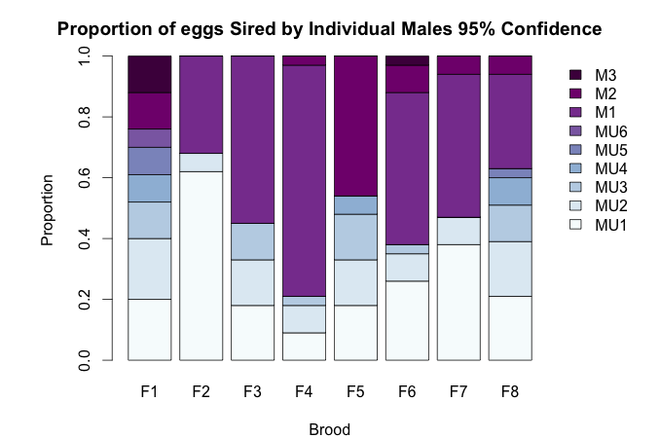
S11. A) Percentage of eggs sired by Octopus oliveri males ranked by order for each of the female broods. MU: Unknown males, M1: First male to mate in experimental trials, M2: Second experimental male, M3: Third male. B) Same data but with unknown males split into putative wild genotypes to show distribution among unknown mates.
S12. Number of unknown candidate male Octopus oliveri that contribute to each brood and number of eggs attributed to each male in mating trials.
Female ID | Number of Unassigned Eggs | Number of Sires | Distribution of offspring among sires
F1 | 26 | 6 | 7, 7, 3, 2, 3, 4
F2 | 23 | 2 | 21, 2
F3 | 15 | 3 | 6, 5, 4
F4 | 7 | 3 | 3, 3, 1
F5 | 18 | 4 | 6, 5, 5, 2
F6 | 13 | 3 | 9, 3, 1
F7 | 16 | 2 | 13, 3
F8 | 21 | 5 | 7, 6, 4, 3, 1
Non-Experimental Females
F9 | 34 | 3 | 18, 11, 5
F10 | 24 | 4 | 9, 9, 4, 2
F11 | 34 | 2 | 30, 4

S13. AIC Model selection table of explanatory variables for the proportion of offspring sired by male Octopus oliveri, listed in order of the highest to lowest weighted. (Continued on next page).
Explanatory variables | DF | AICc | Δ AIC | Weight
male order x male size | 5 | 110.9 | 0 | 0.538
male order x number of arch and pumps x male size | 6 | 114 | 3.06 | 0.116
male order | 4 | 115.2 | 4.3 | 0.063
male order x mating time x male size | 6 | 115.3 | 4.36 | 0.061
male order x male size x removal of sperm packet | 6 | 115.3 | 4.38 | 0.057
male size | 3 | 116.2 | 5.3 | 0.038
male order x number of arch and pumps | 5 | 116.8 | 5.87 | 0.029
male order x mating time | 5 | 117.5 | 6.62 | 0.02
mating time | 3 | 117.8 | 6.92 | 0.017
number of arch and pumps | 3 | 117.9 | 6.99 | 0.016
number of arch and pumps x male size | 4 | 118 | 7.08 | 0.016
removal of sperm packet | 3 | 118 | 7.12 | 0.015
male order x mating time x number of arch and pumps x male size | 7 | 118.3 | 7.44 | 0.013
male order x removal of sperm packet | 5 | 118.6 | 7.69 | 0.012
male order x removal of sperm packet x number of arch and pumps x male size | 7 | 119 | 8.1 | 0.009
male size x removal of sperm packet | 4 | 119.1 | 8.16 | 0.009

(Continued) AIC Model selection table; variables listed in order of the highest to lowest weighted.
Explanatory variables | DF | AICc | Δ AIC | Weight
male order x mating time x removal of sperm packet x male size | 7 | 120.4 | 9.51 | 0.005
mating time x number of arch and pumps | 4 | 120.9 | 9.97 | 0.004
number of arch and pumps x removal of sperm packet | 4 | 120.9 | 10.05 | 0.004
mating time x removal of sperm packet | 4 | 121 | 10.14 | 0.003
mating order x mating time x number of arch and pumps | 6 | 121.1 | 10.18 | 0.003
male size x number of arch and pumps x removal of sperm packet | 5 | 121.7 | 10.84 | 0.002
mating time x number of arch and pumps x male size | 5 | 121.7 | 10.84 | 0.002
mating time x number of arch and pumps x removal of sperm packet | 5 | 121.7 | 10.84 | 0.002
male order x mating time x removal of sperm packet | 6 | 121.8 | 10.93 | 0.002
mating time x arch and pump x removal of sperm packet | 5 | 124.6 | 13.72 | 0.001
mating time x male size x removal of sperm packet | 5 | 122.7 | 11.8 | 0.001
male order x mating time x number of arch and pumps x male size x removal of sperm packet | 8 | 124.5 | 13.61 | 0.001
mating time x number of arch and pumps x removal of sperm packet x male size | 6 | 126.1 | 15.22 | 0
male order x mating time x number of arch and pumps x removal of sperm packet | 7 | 126.2 | 15.28 | 0

