Transcriptional regulation of Bcl-2 gene by the PR/SET domain family member PRDM10

Na Chen¹, Taobo Hu², Yuanyuan Gui¹, Jieying Gao¹,Qingnan Liu¹, Zhihong Li², and Shi Huang^{1∗}

¹Center for Medical Genetics, School of Life Sciences, Central South University, Changsha, Hunan, China 410078

² Department of Orthopedics, the Second Xiangya Hospital, Central South University, Changsha, China 410011

Supplementary Figure 1

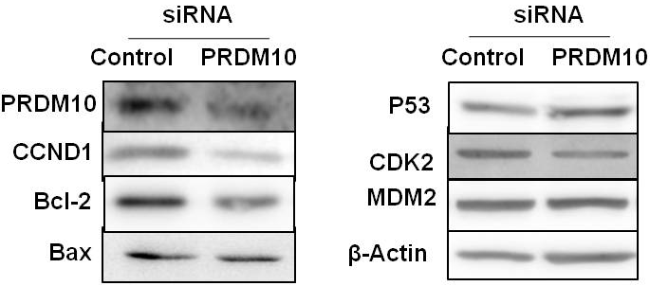
Figure 1 cancer Related genes expression in PRDM10-depleted cells. Immuno-blot analyses of Bcl-2 proteins in PRDM10-depleted cells (siRNA- PRDM10).

Supplementary Materials
Supplementary Table 1.Antibodies used for Western blot
Protein | Catalog Number | MW(kDa) | manufacturer | Type
β-actin | D110001 | 42 | Sangon | Rabbit PAb
PRDM10 | Ab3787 | 120 | Abcam | Mouse MAb
Bcl-2 | SC-509 | 28 | SantaCruz | Mouse MAb
BCl-2 | D160117 | 28 | Sangon | Rabbit PAb
Flag | F1804 | - | SIGMA | Mouse MAb
IgG | D110502 | - | Sangon | Rabbit PAb

Supplementary Table 2. Primers used for real-time PCR analysis
qRT-PCR-analysis | sequence | Product length(bp)
β-actin | FP¹: AGCGAGCATCCCCCAAAGTT  RP²: GGGCACGAAGGCTCATCATT | 285
PRDM10 | FP: GCTGCCTTCCATCGAGAGTG  RP: CCAGTCATCCAGATCCGTGTC | 160
Bcl-2 | FP: GGTGGGGTCATGTGTGTGG  RP: CGGTTCAGGTACTCAGTCATCC | 89
FP¹: Forward Primer
RP²: Reverse Primer

