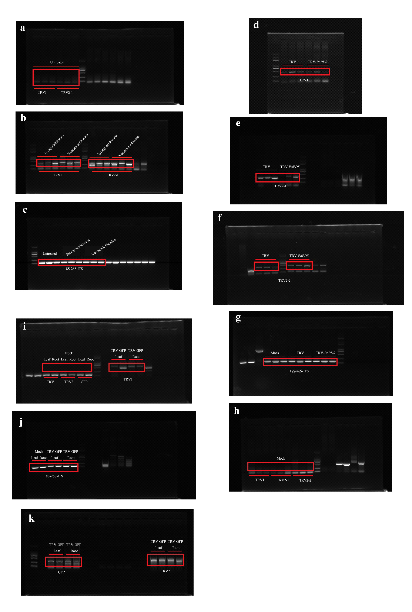
Fig. S1. Uncropped blots used in this manuscript
Full-length uncropped blots for Semi-quantitative RT-PCR analysis of TRV1 and TRV2-1 accumulation levels in TRV empty vector-inoculated leaves by syringe and vacuum methods (a-c); in systemically-infected P.ostii leaves (d-h), and TRV1, TRV2, and GFP accumulation levels in mock treated, TRV-GFP-infected P. ostii leaves and roots. (i-k)

