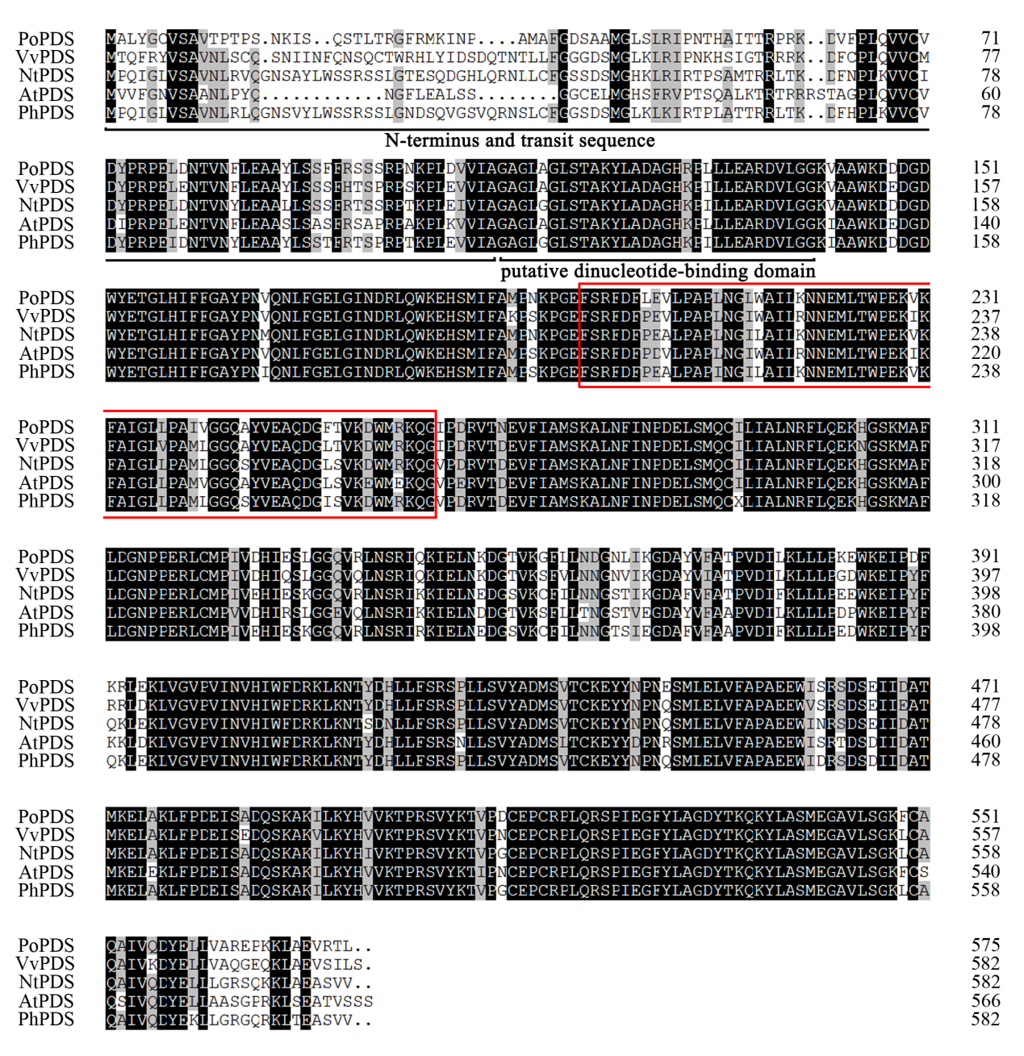
Fig. S2 Multiple sequence alignment of deduced amino acids of PoPDS with other homologies, including Vitis vinifera VvPDS, Nicotiana tabacum NtPDS, Arabidopsis thaliana AtPDS, and Petunia hybrida PhPDS
Sequences were aligned using ClustalW program. The N-terminus and transient sequence and putative dinucleotide-binding domain are underlined. Red box denotes a conserved region in PDS protein sequences for VIGS. Black background represents identical amino acid residues. The GenBank accession number of PoPDS is MK733916.

