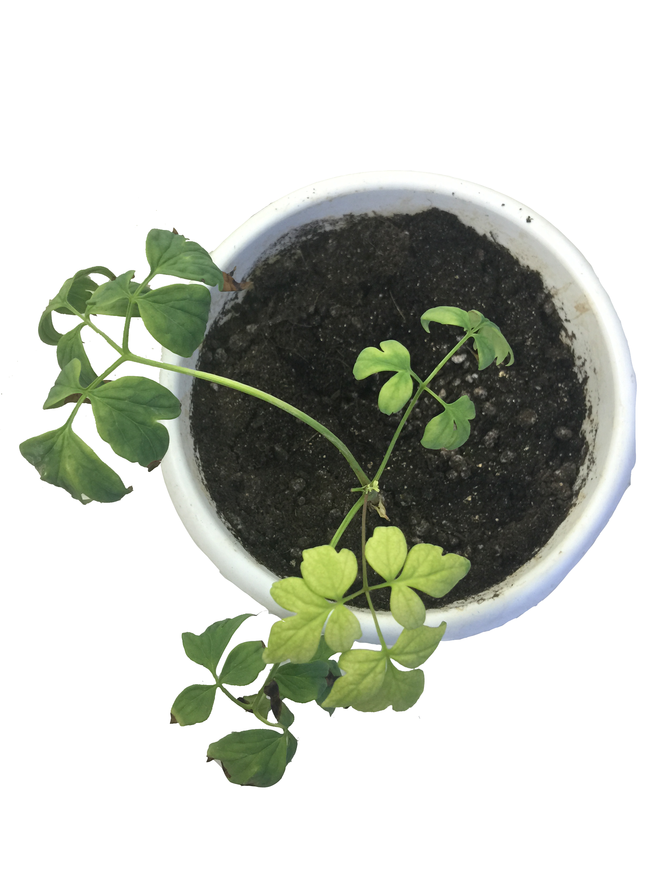
Fig. S3 Phenotypes of TRV-PoPDS-infected leaves in P. ostii seedlings at 2 months after infiltration.

