Appendix 1: Species-area relationship of vascular plants
The results of a power law species-area relationship between area of the hectad that was not pasture and corrected species richness fitted using a non-linear least squares model using the R package nlme where:
$S=cA^{z}$
A = area of non-pasture, S = corrected species richness of the hectad using FRESCALO, and c and z are estimated parameters. Starting values for parameter estimates were extracted from a linear regression in log-log space.
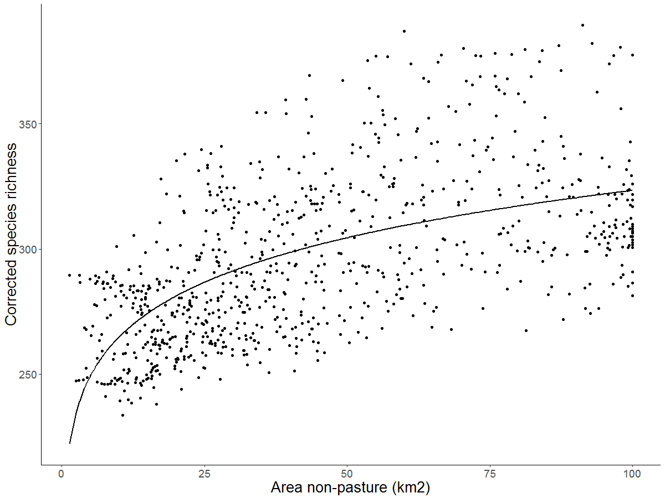
Parameter estimates:
c = 216.82 (standard error = 3.41, P < 0.001)
z = 0.09 (standard error = 0.004, P < 0.001)

