(TS)
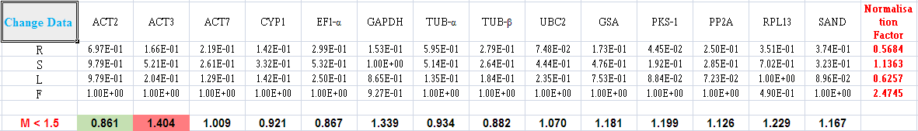

(SG)
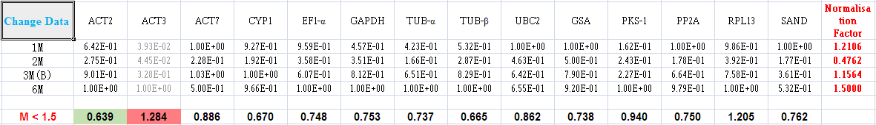

(ST)
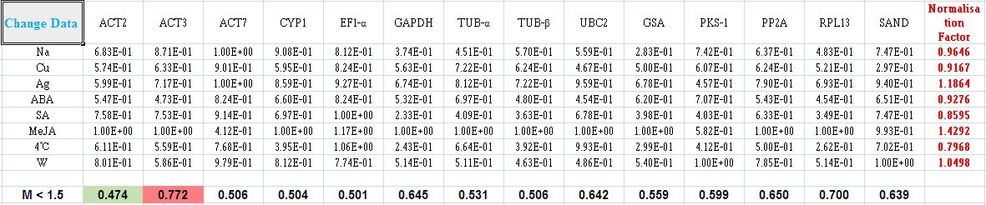

(TT)
