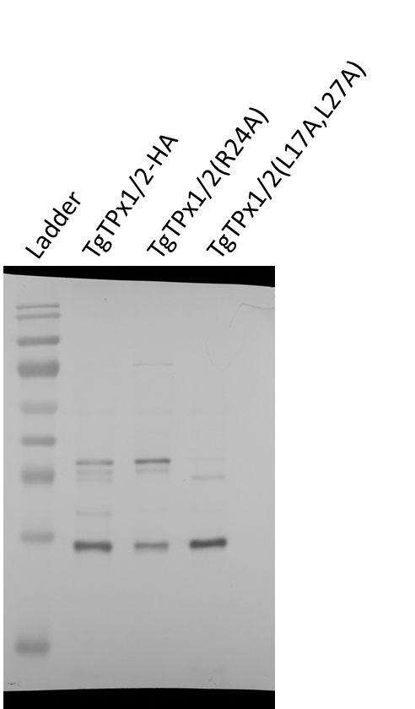
Supplementary figure S2: Full-length Western blot displayed in main figures. High contrast images were not generated and hence multiple exposure images are not included here.

