Appendix
Figure A1: composition of chick regurgitates found at Zeebrugge (period 2006-2018)
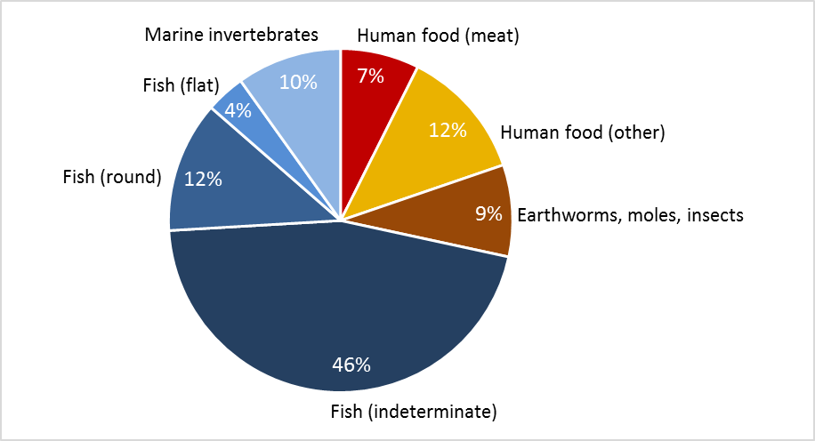

Table A1: Nutrient composition of items found in chick regurgitates from Zeebrugge in the period 2006-2018. Source: Fooddata, Food department, Technical University of Denmark (frida.fooddata.dk).

Food type | Energy (Kj/100g) | Moisture (g/100g) | Protein (g/100g) | Lipids (g/100g) | Ash (g/100g) | Calcium (g/100g) | Phosphorus (g/100g) | Occurrence
Marine Habitat
Sprat | 564 | 78 | 10.3 | 10.5 | 1.2 | 0.28 | 0.22 | 4
Sole | 360 | 78.4 | 18.7 | 1.1 | 1.7 | 0.029 | 0.271 | 9
Whiting | 332 | 80 | 18.2 | 0.6 | 1.2 | 0.05 | 0.183 | 45
Shrimp | 336 | 78.7 | 16.5 | 1.2 | 2.9 | 0.078 | 0.119 | 12
Herring | 784 | 68.6 | 16.5 | 13.6 | 1.2 | 0.0338 | 0.2 | 8
Crab | 473 | 72.4 | 22.9 | 1.8 | 1.9 | 0.12 | 0.22 | 4
Mussel | 348 | 80.6 | 11.9 | 2.2 | 1.6 | 0.03 | 0.145 | 8
Scampi | 464 | 70 | 24 | 1.1 | 4 | 0.115 | 0.265 | 2
Cod | 421 | 57.3 | 24.3 | 0.2 | 18.2 | 0.07 | 0.3 | 2
mackerel | 780 | 68.1 | 17.8 | 12.9 | 1.2 | 0.0146 | 0.196 | 3
Lobster | 393 | 76 | 19.6 | 1.3 | 2.4 | 0.048 | 0.144 | 1
Plaice | 369 | 79.4 | 17.5 | 1.9 | 1.1 | 0.0287 | 0.172 | 1
Squid | 385 | 78.55 | 15.58 | 1.38 | <0.01 | 0.032 | 0.221 | 4
Terrestrial Habitat
Chicken (full) | 888 | 65.5 | 17.1 | 15.9 | 0.9 | 0.01 | 0.166 | 5
Chicken butchery | 473 | 76.2 | 18.2 | 4.2 | 0.9 | 0.011 | 0.148 | 2
Bread | 1146 | 33.7 | 8.8 | 3.9 | 1.5 | 0.039 | 0.114 | 19
Potato raw | 326 | 79.5 | 2 | 0.3 | 0.9 | 0.0068 | 0.0553 | 1
Fries | 1299 | 37.1 | 3.7 | 14.8 | 2.2 | 0.0132 | 0.12 | 12
Pork butchery | 432 | 78.6 | 16.1 | 4.3 | 1 | 0.0053 | 0.204 | 3
Pork sausage | 889 | 65 | 12.3 | 16.8 | 2.4 | 0.0407 | 0.245 | 1
sausage mixed | 1108 | 58.3 | 12.5 | 22.6 | 3 | 0.0246 | 0.223 | 1
Rice | 1518 | 10.9 | 7.8 | 1.2 | 0.7 | 0.13 | 0.171 | 2
Spinach | 102 | 91.8 | 2.6 | 0.6 | 1.9 | 0.129 | 0.0413 | 1
Chips | 2221 | 1.3 | 5.4 | 31.9 | 3.7 | 0.024 | 0.148 | 3
Pasta | 1532 | 9.5 | 12.3 | 1.8 | 0.8 | 0.02 | 0.14 | 2
Pastry | 1884 | 12 | 5.8 | 20.9 | 0.9 | 0.033 | 0.097 | 1
Potato cooked | 360 | 77.5 | 1.7 | 0.1 | 0.7 | 0.008 | 0.04 | 1
Bacon | 1374 | 51.9 | 14.8 | 30.3 | 3 | 0.006 | 0.167 | 1
Egg | 608 | 74.2 | 13.7 | 9.5 | 1.2 | 0.0413 | 0.181 | 1
Ham | 467 | 74.7 | 15.7 | 5.4 | 4.2 | 0.006 | 0.2 | 2
TOTAL |  |  |  |  |  |  |  | 159

Figure A2: PCA biplot of items found in chick regurgitates from Zeebrugge in the period 2006-2018, based on their nutrient composition.
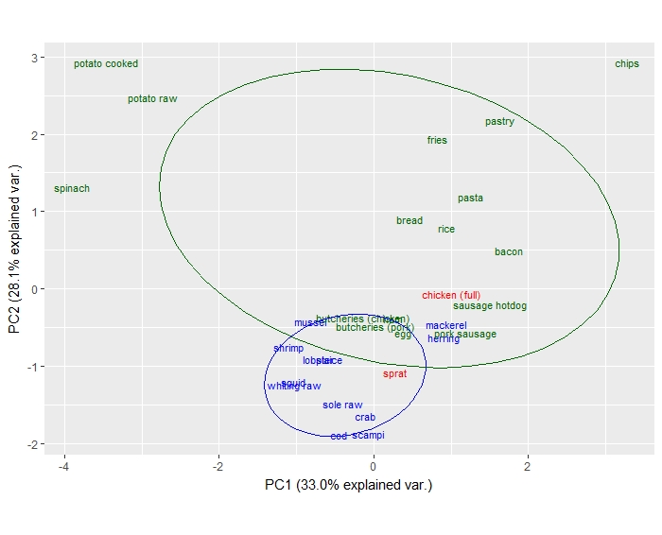

Table A2: TEFs (SD) calculated for fish and chicken on L. fuscus P1 feathers.
Source | TEF Δ13C | TEF Δ15N
Fish | 3.0 (.4) | 5.2 (.6)
Chicken | 2.0 (.4) | 3.5 (.5)

Figure A3: Innermost right primary feather length (mm) of chicks raised in the aviary (grey lines), with average values (red line), indicating the averages for 10, 20 and 30 days after hatching.

