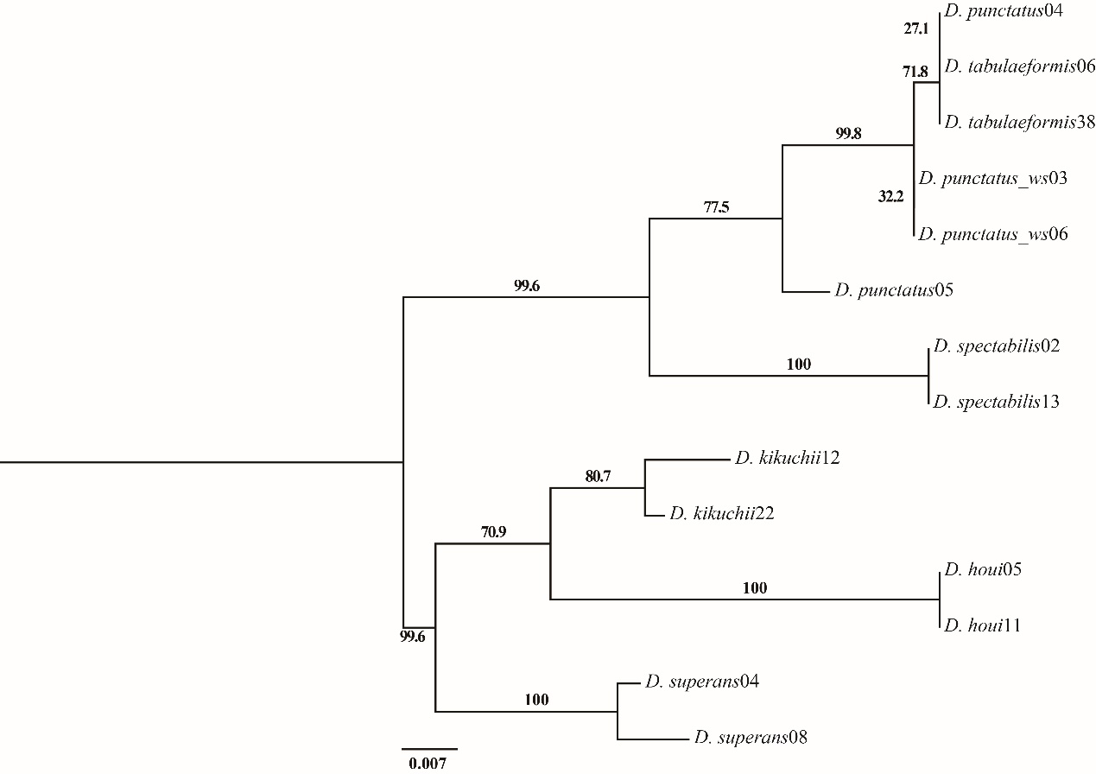

Supplemental Information 6 (A) Phylogenetic tree (ML) of *Dendrolimus* species constructed with A+T rich region. Numbers above or below branches indicate bootstrap value.

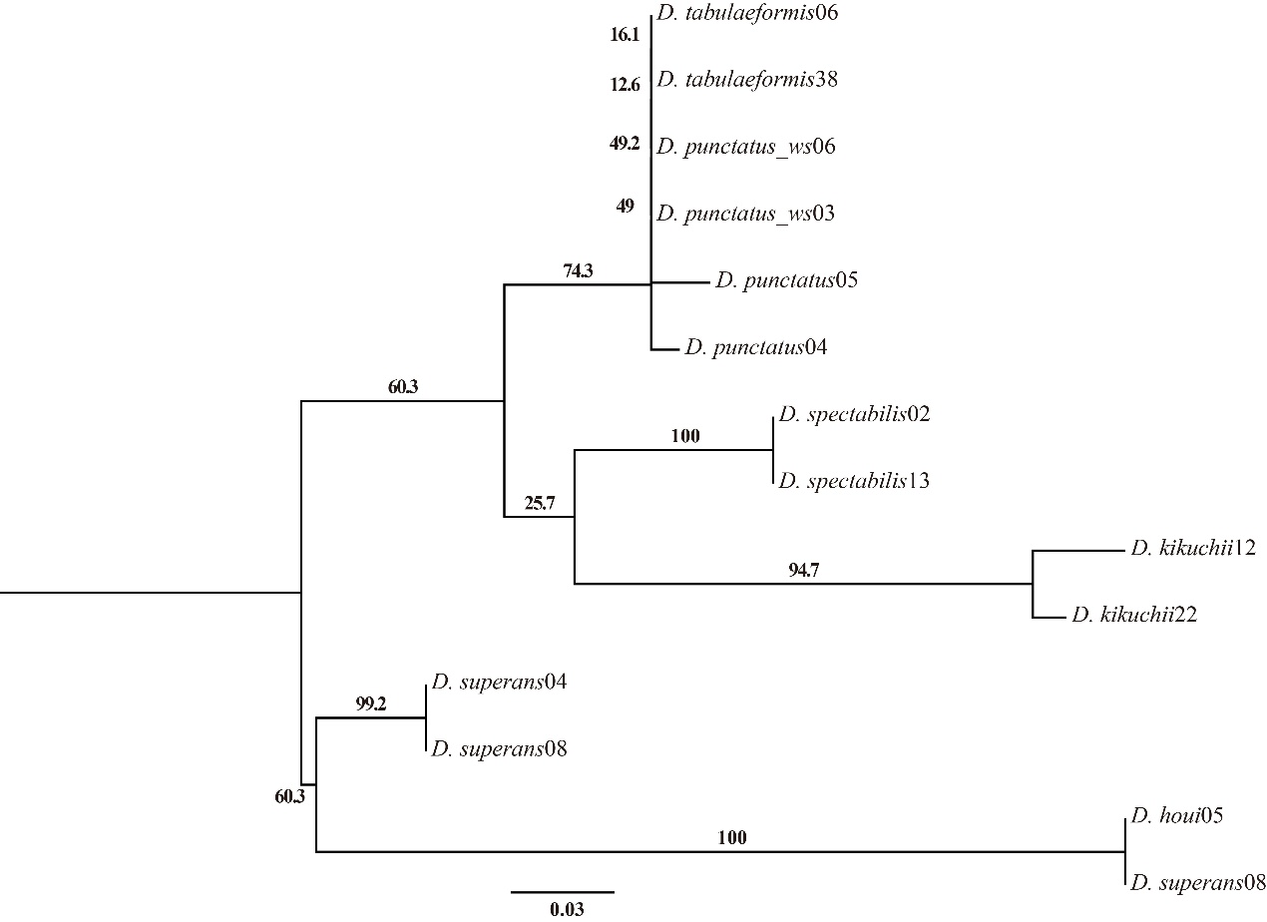

Supplemental Information 6 (B) Phylogenetic tree (ML) of *Dendrolimus* species constructed with intergenic region. Numbers above or below branches indicate bootstrap value.