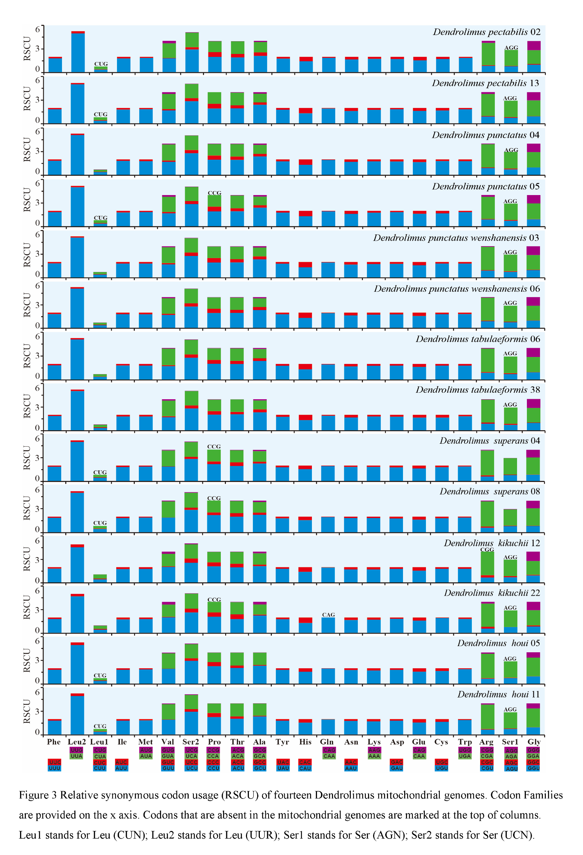

Supplemental Information 4 Relative synonymous codon usage (RSCU)of fourteen *Dendrolimus* mitochondrial genomes. Codon Families are provided on the x axis. Codons that are absent in the mitochondrial genomes are marked at the top of columns Leul stands for Leu(CUN), Leu2 stands for Leu(UUR), Serl stands for Ser(AGN), Ser2 stands for Ser(UCN)