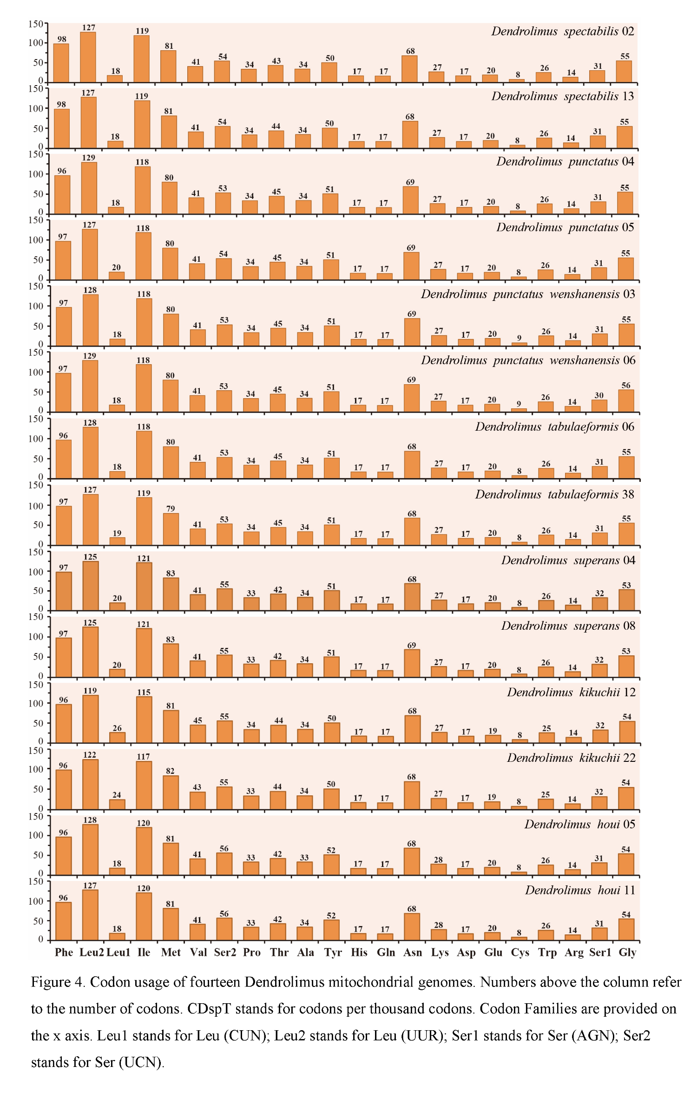  
Supplemental Information 5 Codon usage of fourteen *Dendrolimus* mitochondrial genomes. Numbers above the column refer to the number of codons. CDSPT stands for codons per thousand codons Codon Families are provided on the x axis. Leul stands for Leu(CUN): Leu stands for Leu(UUR), Serl stands for Ser(AGN), Ser2 stands for Ser(UCN).