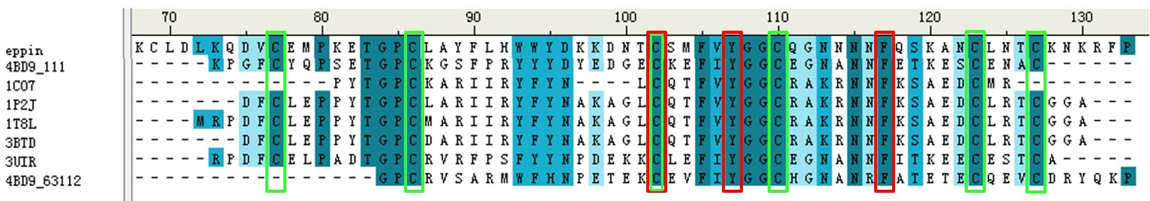
Figure S1. The protein sequence alignment between EPPIN C-terminus domain and different structure templates. The red frames indicated the important residues of EPPIIN C-terminus domain for its binding to SEMG1 protein and the green frame represented the conserved cysteines which could from the disulfide bonds. The sequence identity and sequence similarity between EPPIN C-terminus domain (first line) and carboxypeptidase inhibitor SmCI (PDB ID: 4BD9, chain B) (second line) was 29.4% and 45.1% respectively.
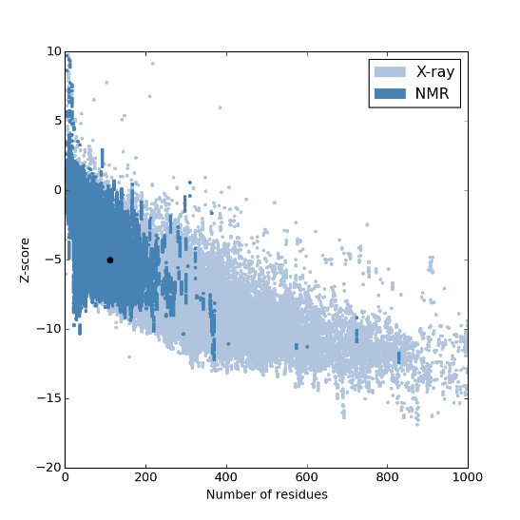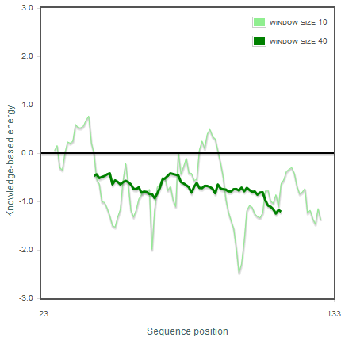
(A) (B)
Figure S2. (A) Overall model quality and (B) local model quality of EPPIN model predicted by ProSA-web. In the figure of overall model quality, black dot represented our EPPIN model, showing the model had the quality as the NMR structures.
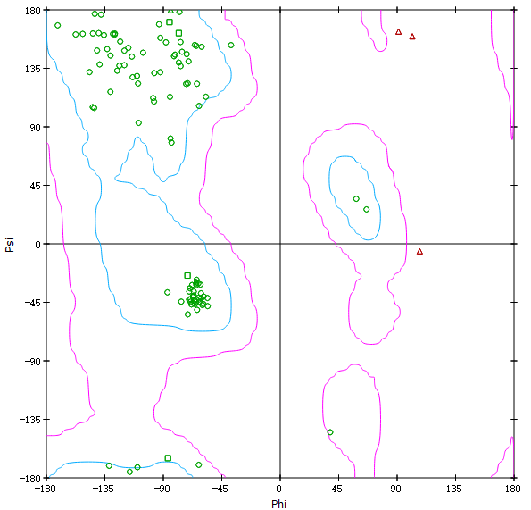
Figure S3. Ramachandran plots of EPPIN model. Residues marked by green showed that these residues had the excellent or acceptable angles; however, residues marked by red meant that angles were not acceptable. For our model, only three residues' angle were not good, but these residues were not involved in the binding pocket. Moreover, even the crystal structures also had some residues with bad angles.
Figure S4. The molecular dynamics simulation box of EPPIN- SEMG1¹⁰⁻⁸ complex with chloride ion (yellow balls) and water. EPPIN was colored with green and cyan from N-terminal to C-terminal, SEMG1¹⁰⁻⁸ was colored with magenta.

Table S1. Values of the binding free energy (kJ mol⁻¹) and its components for three different binding poses of EPPIN-SEMG1¹⁰⁻⁸ complex calculated by MM/PBSA method
Pose | $$∆E_{int}$$ | $$∆E_{vdw}$$ | $$∆E_{ele}$$ | $$∆G_{polar}$$ | $$∆G_{SA}$$ | $$∆G_{bind}$$
Pose1 | 0.00(0.00) | -43.84(4.93) | -200.69(37.50) | 215.06(32.87) | -5.85(0.50) | -35.32(9.29)
Pose2 | 0.00(0.00) | -87.02(6.94) | -195.80(39.74) | 250.89(39.23) | -9.15(0.46) | -41.08(9.08)
Pose3 | 0.00(0.00) | -54.35(7.43) | -275.64(40.41) | 283.30(40.46) | -6.81(0.59) | -53.50(7.43)
Standard deviations are reported in parentheses. ΔE_{int} is the internal energy related to bond, angle, and dihedral parameters, ΔE_{ele} is the electrostatic energy, ΔE_{vdw} is the van derWaals energy, ΔG_{polar} is the electrostatic solvation energy, and ΔG_{SA} is the non-electrostatic solvation energy. ΔGbind was calculated via the following equation: ΔG_{bind} =ΔE_{int} +ΔE_{ele} +ΔE_{vdw} +ΔG_{polar(PB)} +ΔG_{SA}

Table S2. Values of the binding free energy (kJ mol⁻¹) and its components for three different binding poses of EPPIN-SEMG1¹⁰⁻⁸ complex calculated by MM/GBSA method
Pose | $$∆E_{vdw}$$ | $$∆E_{ele}$$ | $$∆G_{polar}$$ | $$∆G_{non-polar}$$ | $$∆G_{bind}$$
Pose1 | -43.84(4.93) | -200.69(37.50) | 217.75(33.83) | -7.16(0.79) | -33.95(8.65)
Pose2 | -87.02(6.94) | -195.80(39.74) | 243.72(38.14) | -11.87(0.85) | -50.98(8.21)
Pose3 | -54.35(7.43) | -275.64(40.41) | 294.50(38.78) | -8.70(0.87) | -44.19(6.35)
Standard deviations are reported in parentheses. ΔE_{ele} is the electrostatic energy, ΔE_{vdw} is the van derWaals energy, ΔG_{polar} is the electrostatic solvation energy, and ΔG_{non-polar} is the non-electrostatic solvation energy. ΔGbind was calculated via the following equation: ΔG_{bind} = ΔE_{ele} +ΔE_{vdw} +ΔG_{polar(GB)} +ΔG_{non-polar}

