Supplementary Data 4
Results
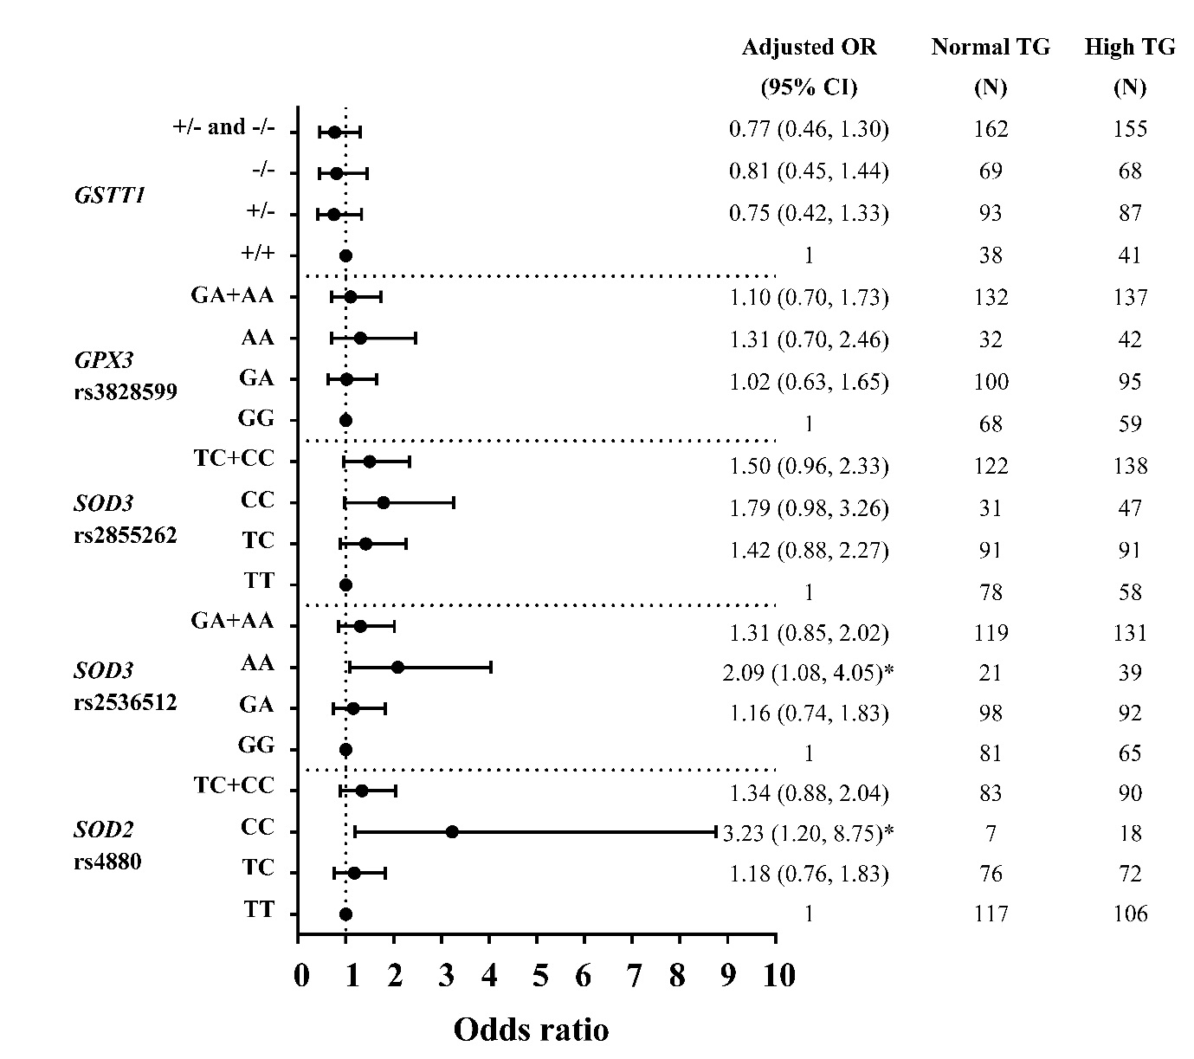

Figure S1 Adjusted Odds ratios (ORs) and 95% CI for the risk of HTG as the function of antioxidant related gene polymorphisms. The ORs were adjusted for age, gender, prevalence of having low HDL-C level, smoking status, and administration of fibrate. N: total number of genotype carriers in each group. * indicates statistically significant; p <0.05.

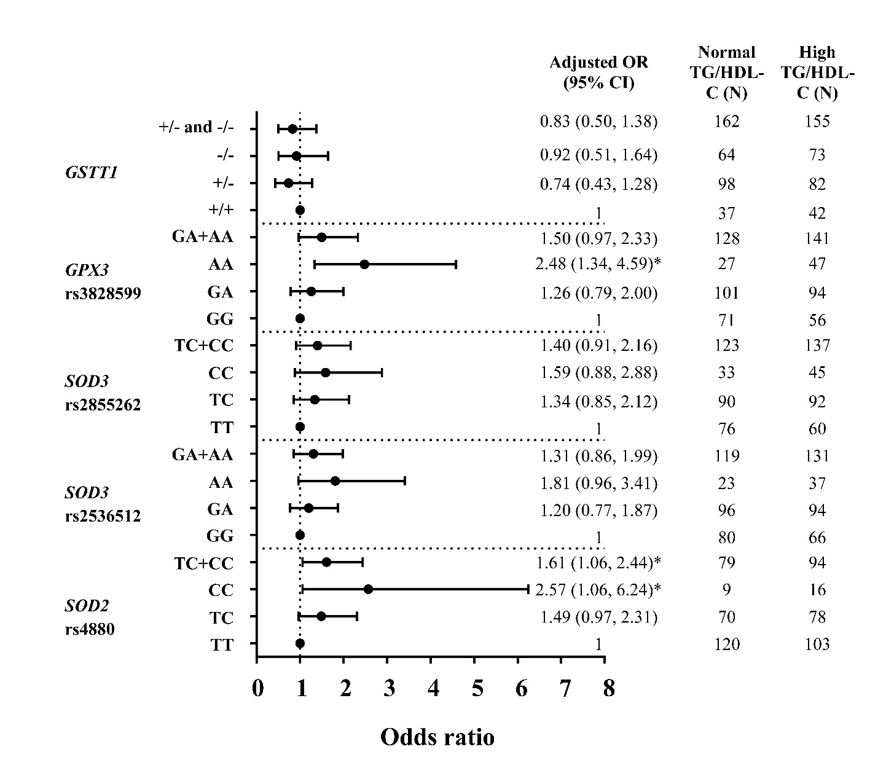
Figure S2 Adjusted Odds ratios (ORs) and 95% CI for the risk of high TG/HDL-C ratio (≥3.7) as the function of antioxidant related gene polymorphisms. The ORs were adjusted for age, gender, smoking status, and administration of fibrate. N: total number of genotype carriers in each group. * indicates statistically significant; p <0.05.

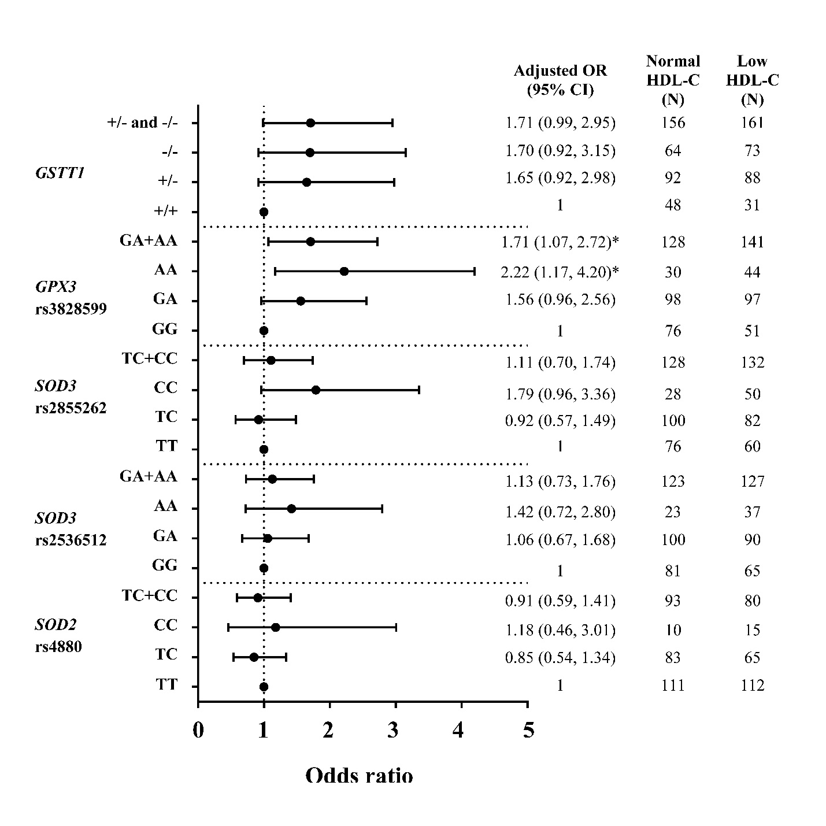
Figure S3 Adjusted Odds ratios (ORs) and 95% CI for the risk of low HDL-C (<1 mmol/L) as the function of antioxidant related gene polymorphisms. The ORs were adjusted for age, gender, prevalence of HTG, smoking status, and administration of fibrate. N: total number of genotype carriers in each group. * indicates statistically significant; p <0.05.

Table S3 The associations between antioxidant gene polymorphisms and the risk of Gensini score >32

Polymorphisms | Gensini  score  ≤32; N (%)  (n=268) | Gensini score  >32; N (%)  (n=121) | Crude odds ratio (95%CI) | p-value | ªAdjusted Odds Ratio  (95% CI) | p-value
SOD2 rs4880
TT | 151 (56.3%) | 69 (57.0%) | 1 | - | 1 | -
TC | 102 (38.1%) | 42 (34.7%) | 0.90 (0.57, 1.43) | 0.656 | 0.95 (0.49, 1.82) | 0.866
CC | 15 (5.6%) | 10 (8.3%) | 1.46 (0.62, 3.41) | 0.383 | 1.88 (0.49, 7.28) | 0.361
TC+CC | 117 (43.7%) | 52 (43.0%) | 0.97 (0.63, 1.50) | 0.900 | 1.04 (0.56, 1.95) | 0.896
SOD3 rs2536512
GG | 106 (39.6%) | 37 (30.6%) | 1 | - | 1 | -
GA | 120 (44.8%) | 67 (55.4%) | 1.60 (0.99, 2.58) | 0.055 | 1.75 (0.84, 3.61) | 0.133
AA | 42 (15.7%) | 17 (14.0%) | 1.16 (0.59, 2.28) | 0.668 | 1.54 (0.56, 4.26) | 0.407
GA+AA | 162 (60.4%) | 84 (69.4%) | 1.49 (0.94, 2.35) | 0.090 | 1.73 (0.86, 3.47) | 0.123
SOD3
rs2855262
TT | 98 (36.6%) | 35 (28.9%) | 1 | - | 1 | -
TC | 118 (44.0%) | 61 (50.4%) | 1.45 (0.88, 2.37) | 0.143 | 1.58 (0.76, 3.30) | 0.219
CC | 52 (19.4%) | 25 (20.7%) | 1.35 (0.73, 2.49) | 0.342 | 1.33 (0.51, 3.47) | 0.563
TC+CC | 170 (63.4%) | 86 (71.1%) | 1.42 (0.89, 2.26) | 0.142 | 1.50 (0.75, 3.02) | 0.254
GPX3 rs3828599
GG | 80 (29.9%) | 43 (35.5%) | 1 | - | 1 | -
GA | 137 (51.1%) | 56 (46.3%) | 0.76 (0.47, 1.23) | 0.267 | 1.08 (0.54, 2.17) | 0.822
AA | 51 (19.0%) | 22 (18.2%) | 0.80 (0.43, 1.50) | 0.488 | 1.46 (0.53, 4.03) | 0.469
GA+AA | 188 (70.1%) | 78 (64.5%) | 0.77 (0.49, 1.22) | 0.265 | 1.15 (0.59, 2.24) | 0.673
GSTT1 gene deletion polymorphism
+/+ | 56 (20.9%) | 19 (15.7%) | 1 | - | 1 | -
+/- | 121 (45.1%) | 57 (47.1%) | 1.39 (0.76, 2.55) | 0.290 | 1.12 (0.43, 2.92) | 0.823
-/- | 91 (34.0%) | 45 (37.2%) | 1.46 (0.78, 2.74) | 0.242 | 1.96 (0.66, 5.83) | 0.228
+/- and -/- | 212 (79.1%) | 102 (84.3%) | 1.42 (0.80, 2.51) | 0.231 | 1.50 (0.61, 3.69) | 0.381

Note: ªData was calculated with logistic regression analysis adjusted for age, gender, DM, HT, waist/hip ratio, and cigarette smoking.

Table S4 The associations between genetic risk score and the risk of Gensini score >32

Genetic risk score | Gensini  score  ≤32; N (%)  (n=268) | Gensini score  >32; N (%)  (n=121) | Crude odds ratio (95%CI) | p-value | ªAdjusted Odds Ratio  (95% CI) | p-value
0-2 | 52 (19.4%) | 19 (15.7%) | 1 | - | 1 | -
3 | 56 (20.9%) | 23 (19.0%) | 1.12 (0.55, 2.30) | 0.749 | 1.20 (0.38, 3.81) | 0.757
4-5 | 100 (37.3%) | 53 (43.8%) | 1.45 (0.78, 2.70) | 0.241 | 1.77 (0.67, 4.70) | 0.250
6-10 | 60 (22.4%) | 26 (21.5%) | 1.19 (0.59, 2.38) | 0.632 | 2.32 (0.66, 8.13) | 0.187

Note: ªData was calculated with logistic regression analysis adjusted for age, gender, DM, HT, waist/hip ratio, and cigarette smoking.

