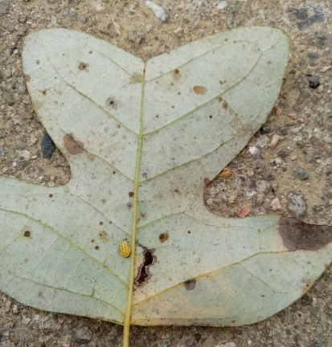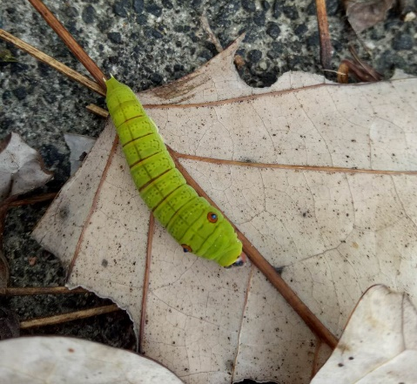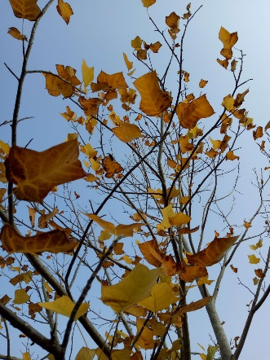
C
B
A
Figure S1 Terrestrial insects found on the leaves (A and B) and intact leaf litter (C).

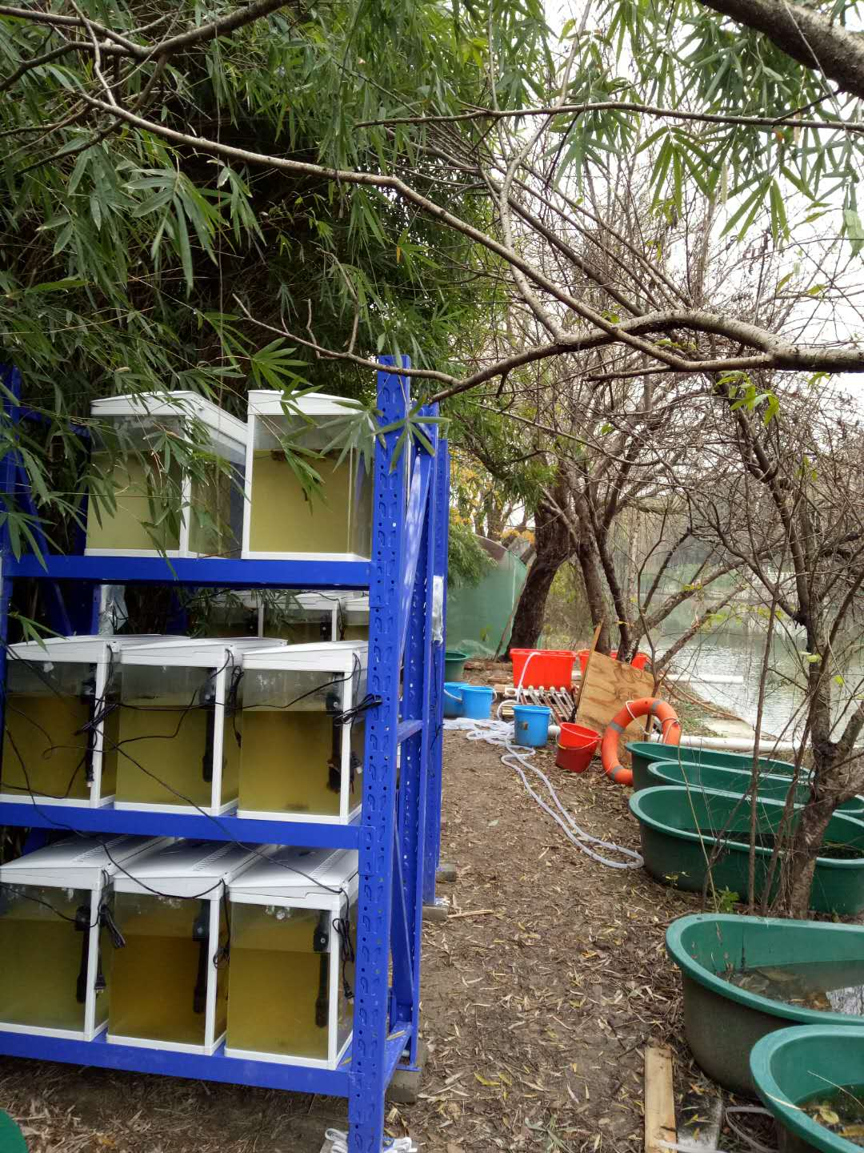
Figure S2 Experimental Mesocosms installed on the riparian zone of a stream.

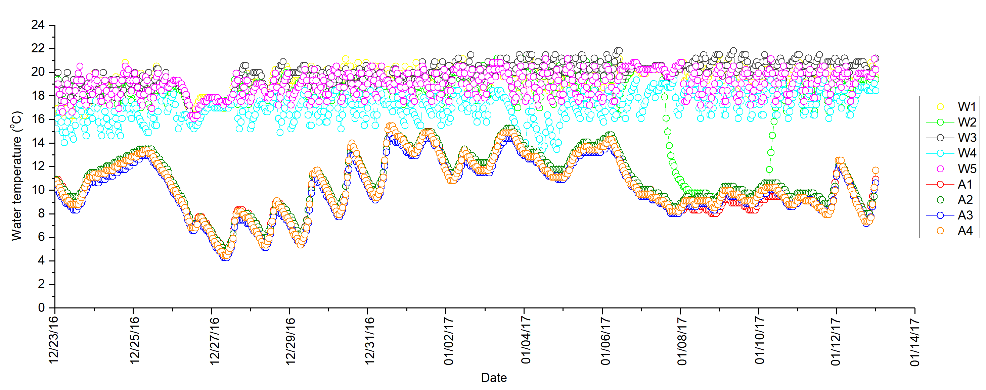
Figure S3 Hourly changes of water temperature in five warming (W1-W5) and four ambient (A1-A4) treatments during the experimental period.

Figure S4 Boxplot of leaf litter breakdown rates for each treatment. Letters in the x axis mean: D (insect damaged); I (intact leaves); A (ambient temperature); W (warming); N (without snails); Y (with snails).

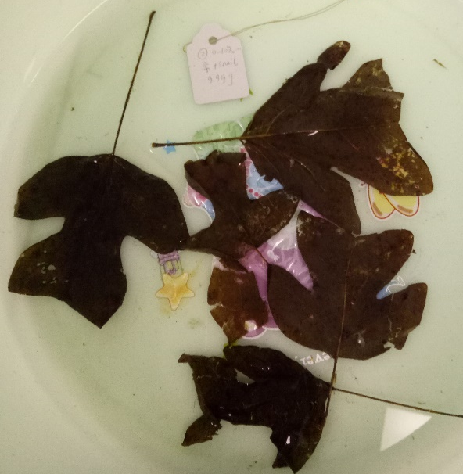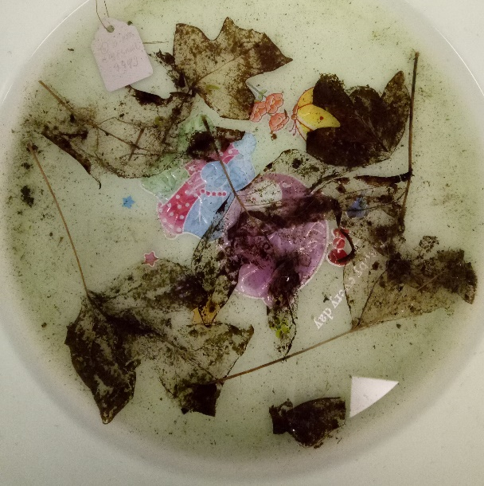
B
A
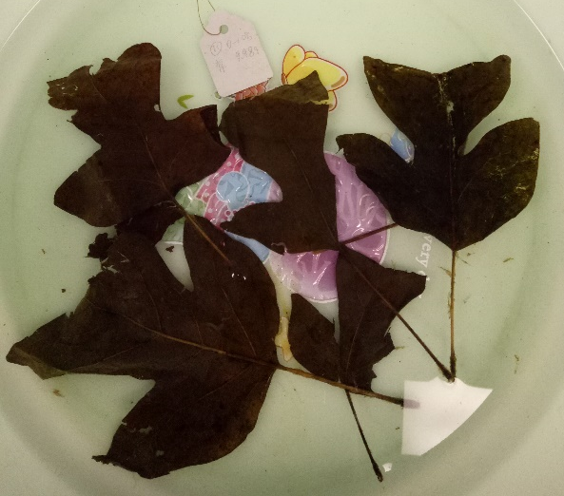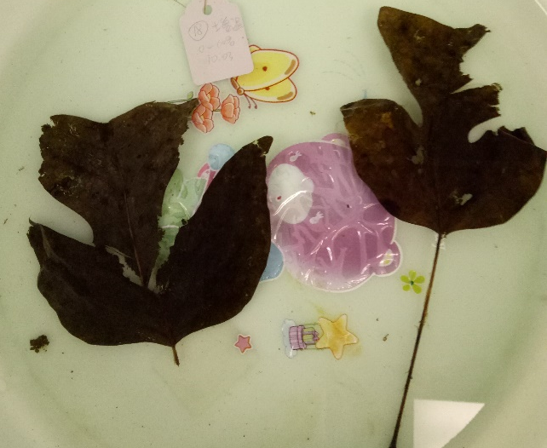
D
C
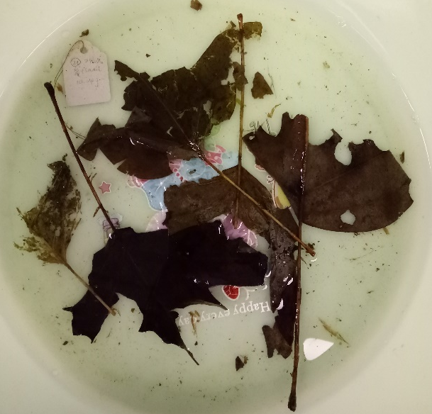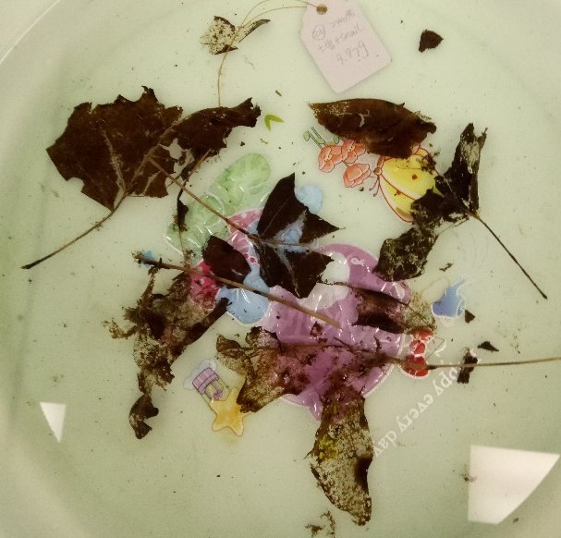
F
E
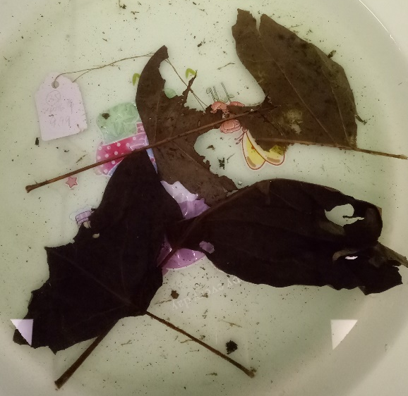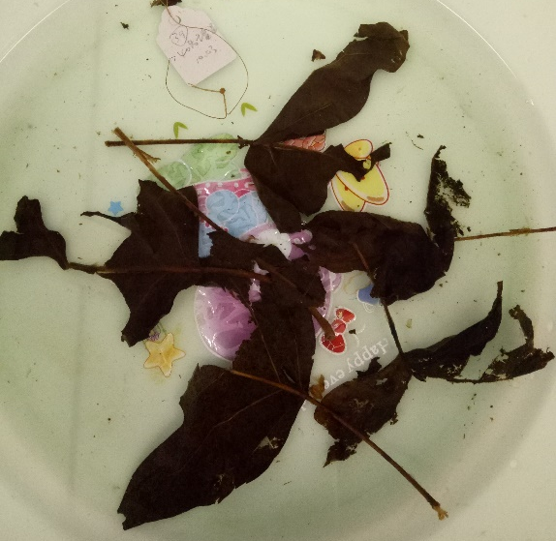
G
H
Figure S5 Leaf appearance after the experiment (Day 25) in treatments of (A) intact leaves + ambient temperature + snails; (B) intact leaves + warming temperature + snails; (C) intact leaves + ambient temperature + no snails; (D) intact leaves + warming temperature + no snails; (E) terrestrial insect damaged leaves + ambient temperature + snails; (F) terrestrial insect damaged leaves + warming temperature + snails; (G) terrestrial insect damaged leaves + ambient temperature + no snails; and (H) terrestrial insect damaged leaves + warming temperature + no snails.

Table S1 Summary results of three-way ANOVA with repeated measures for the effects of water temperature (T), snail (S), and litter quality (Q) on water quality in experimental mesocosms. P-values < 0.05 are in bold print.

Source of variation |  | pH |  | Turbidity (NTU) |  | DO (%) |  | DO (mg/L) |  | Ammonia (mg/L) |  |  | Conductivity (μs/cm)
Between-Subjects effects | df | F | P | F | P | F | P | F | P | F | P | df | F | P
Q | 1 | 10.559 | 0.003 | 1.051 | 0.313 | 2.039 | 0.163 | 0.169 | 0.684 | 1.000 | 0.325 | 1 | 0.662 | 0.422
T | 1 | 69.820 | <0.001 | 424.048 | <0.001 | 260.390 | <0.001 | 513.690 | <0.001 | 251.504 | <0.001 | 1 | 300.323 | <0.001
S | 1 | 16.757 | <0.001 | 51.027 | <0.001 | 5.357 | 0.027 | 0.598 | 0.445 | 30.959 | <0.001 | 1 | 0.878 | 0.356
Q × T | 1 | 2.182 | 0.149 | 0.747 | 0.394 | 0.008 | 0.928 | 0.574 | 0.454 | 1.361 | 0.252 | 1 | 1.042 | 0.315
Q × S | 1 | 21.549 | <0.001 | 0.782 | 0.383 | 1.517 | 0.227 | 0.784 | 0.383 | 5.189 | 0.030 | 1 | 0.523 | 0.475
T × S | 1 | 1.711 | 0.200 | 14.898 | 0.001 | 0.718 | 0.403 | 0.049 | 0.827 | 8.302 | 0.007 | 1 | 0.520 | 0.476
Q × T × S | 1 | 1.603 | 0.215 | 10.346 | 0.003 | 3.021 | 0.092 | 1.512 | 0.228 | 0.151 | 0.700 | 1 | <0.001 | 0.996
Error | 32 |  |  |  |  |  |  |  |  |  |  | 32
Within-Subjects effects
Time | 2 | 44.196 | <0.001 | 230.871 | <0.001 | 59.741 | <0.001 | 153.381 | <0.001 | 195.765 | <0.001 | 1.434 | 15.607 | <0.001
Time × Q | 2 | 1.842 | 0.167 | 3.653 | 0.031 | 1.173 | 0.316 | 0.359 | 0.700 | 6.153 | 0.004 | 1.434 | 4.101 | 0.035
Time × T | 2 | 29.390 | <0.001 | 14.033 | <0.001 | 6.438 | 0.003 | 76.869 | <0.001 | 3.181 | 0.048 | 1.434 | 93.201 | <0.001
Time × S | 2 | 0.635 | 0.533 | 10.012 | <0.001 | 2.683 | 0.076 | 1.400 | 0.254 | 0.317 | 0.729 | 1.434 | 0.833 | 0.406
Time × Q × T | 2 | 6.254 | 0.003 | 4.861 | 0.011 | 0.465 | 0.630 | 0.707 | 0.497 | 2.164 | 0.123 | 1.434 | 0.587 | 0.506
Time × Q × S | 2 | 4.903 | 0.010 | 4.596 | 0.014 | 0.147 | 0.864 | 0.002 | 0.998 | 4.263 | 0.018 | 1.434 | 0.806 | 0.416
Time × T × S | 2 | 0.204 | 0.816 | 0.136 | 0.873 | 0.310 | 0.735 | 0.573 | 0.567 | 0.900 | 0.411 | 1.434 | 0.399 | 0.605
Time × Q × T × S | 2 | 1.601 | 0.210 | 5.110 | 0.009 | 2.554 | 0.086 | 2.549 | 0.086 | 1.270 | 0.288 | 1.434 | 0.570 | 0.514
Error | 64 |  |  |  |  |  |  |  |  |  |  | 45.895

