Supplementary Information for

An integrative approach to discern the seed dispersal role of frugivorous guilds in a Mediterranean semiarid priority habitat

Authors: Acosta-Rojas, D.C.^{1, 2}, Jiménez-Franco, M.V.³, Zapata, V.M.⁴, & De la Rúa, P.¹, Martínez-López, V.^{1, 4†}

¹ Department of Zoology and Physical Anthropology. Faculty of Veterinary. University of Murcia. Murcia, 30100 Spain; ²Senckenberg Biodiversity and Climate Research Centre (BiK-F). Frankfurt am Main, Germany; ³Department of Applied Biology, Faculty of Experimental Sciences, Miguel Hernández University, 03202 Elche, Spain; ⁴Department of Ecology and Hydrology. Faculty of Biology, University of Murcia. Murcia, 30100 Spain.

Corresponding author email: vicente.martinez2@um.es
Fig. S1 Estimated distribution map of 5220 Habitat* in Spain. (Source: Atlas de los Hábitat de España, 2005).
Fig. S2 Interaction matrix of dispersed seeds of fleshy-fruited species featuring modules.
Table S1. Density of fleshy-fruited shrub species (individuals/100m²) recorded in vegetation sampling of habitat 5220* of Sierra de la Fausilla (Murcia Region - Spain).
Table S2. Plant species dispersed by mammals and birds in Sierra de la Fausilla (Murcia Region, Spain). Values are the amount of seeds of each plant species found in animal-dispersed samples (i.e. faeces of mammals and faeces and regurgitations of birds).
Table S3. Permutational Multivariate Analysis of Variance PERMANOVA with Bonferroni correction, using Bray Curtis distances and 9999 permutation of plant communities dispersed by mamals, birds and censed in plots.
Table S4. Species-specific level parameters of the network between fleshy-fruited plants and vertebrates (mammals and birds) in the coast of Cartagena (SE Spain). The highest values for each parameter are shown in bold.

Fig. S1 Estimated distribution map of 5220 Habitat* in Spain. (Source: Atlas de los Hábitat de España, 2005).

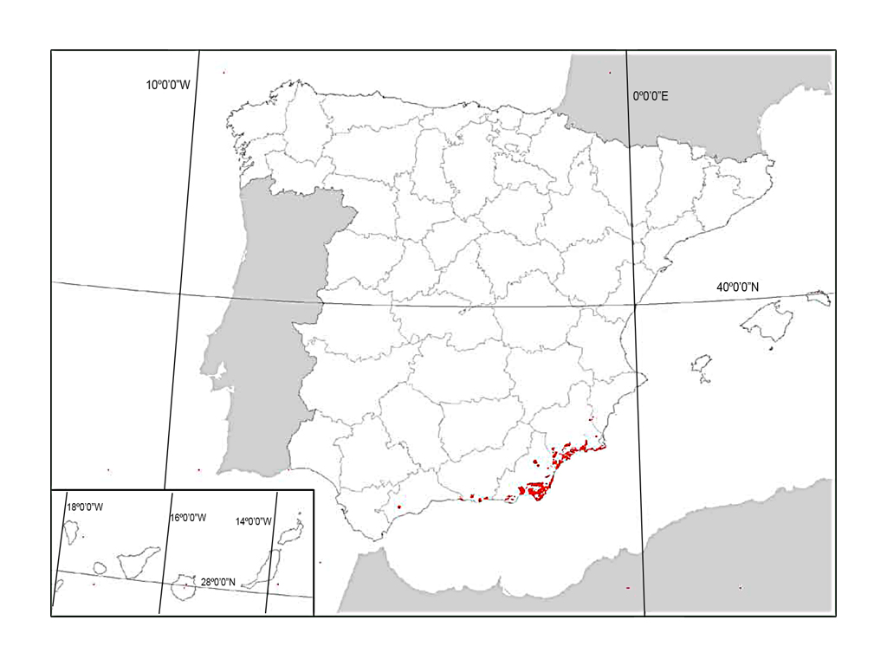

Fig. S2 Interaction matrix of dispersed seeds of fleshy-fruited species featuring modules (red boxes delineate five modules). Darker blue squares indicate more observed interactions.

Table S1. Density of fleshy-fruited shrub species (individuals/100m²) recorded in vegetation sampling of habitat 5220* of Sierra de la Fausilla (Murcia Region - Spain).
Plants |  | Sampling site
Family | Species | Escombreras | Gorguel | Cola de Caballo
Anacardiaceae
 | Pistacia lentiscus | - | 12 | 17
Arecaceae
 | Chamaerops humilis | 1 | 20 | 31
Asparagaceae
 | Asparagus albus | 64 | 1 | 1
 | Asparagus horridus | 17 | 28 | 7
Celastraceae
 | Maytenus senegalensis | 9 | - | 5
Rhamnaceae
 | Rhamnus alaternus | - | - | 2
 | Rhamnus lycioides | 1 | 2 | 17
Rubiaceae
 | Rubia peregrina | 2 | - | -
Santalaceae
 | Osyris lanceolata | 2 | 41 | 13
Solanaceae
 | Lycium intricatum | 18 | - | -
 | Withania frutescens | 8 | - | 2
Thymelaeaceae
 | Daphne gnidium | - | - | 1
Density (average ± standard deviation) |  | 10 ± 18. 1 | 8.6 ± 13.8 | 8 ± 9.6

Table S2. Plant species dispersed by mammals and birds in Sierra de la Fausilla (Murcia Region, Spain). Values are the amount of seeds of each plant species found in animal-dispersed samples (i.e. faeces of mammals and faeces and regurgitations of birds).
Plants |  | Seed dispersers
Family | Species | Mammals | Birds
Anacardiaceae
 | Pistacia lentiscus | - | 45
Arecaceae
 | Chamaerops humilis | 7 | -
 | Phoenix roebelenii | 3 | -
 | Phoenix dactylifera | 10 | 1
Asparagaceae
 | Asparagus albus | - | 45
 | Asparagus horridus | - | 15
Fabaceae
 | Ceratonia siliqua | 14 | -
Moraceae
 | Ficus carica | 723 | 10
Myrtaceae
 | Myrtus communis | - | 3
Rhamnaceae
 | Rhamnus alaternus | 1 | 1
 | Rhamnus lycioides | 4 | -
Santalaceae
 | Osyris lanceolata | - | 36
Solanaceae
 | Lycium intricatum | - | 112
 | Withania frutescens | - | 49
Thymelaeaceae
 | Daphne gnidium | - | 8

Table S3. Permutational Multivariate Analysis of Variance PERMANOVA with Bonferroni correction, using Bray Curtis distances and 9999 permutation of plant communities dispersed by mammals, birds and censed in plots.
 | Degree freedom | Sum of squares | Average sum of squares | F | R² | p-value | p-value adjusted
General | 2 | 3.822 | 1.911 | 6.179 | 0.208 | <0.001
Residuals | 47 | 14.535 | 0.309 |  | 0.792
Total | 49 | 18.357 |  |  | 1
---
Pair comparison
Plants dispersed by mammals vs.  Plants dispersed by birds |  |  |  | 5.355 | 0.196 | 0.001 | 0.003
Plants dispersed by mammals vs.  Plants of semiarid shrubs |  |  |  | 10.142 | 0.229 | 0.001 | 0.003
Plants dispersed by birds vs. Plants of semiarid shrubs |  |  |  | 3.377 | 0.082 | 0.002 | 0.006

Table S4. Species-specific level parameters of the network between fleshy-fruited plants and vertebrates (mammals and birds) in the coast of Cartagena (SE Spain). The highest values for each parameter are shown in bold

Plants | Degree | Species strength | d’
Phoenix dactylifera | 2 | 0.342 | 0.455
Ficus carica | 4 | 1.351 | 0.458
Phoenix roebelenii | 2 | 0.222 | 0.420
Ceratonia siliqua | 3 | 1.778 | 0.711
Rhamnus lycioides | 1 | 1.000 | 1.000
Rhamnus alaternus | 2 | 0.064 | 0.056
Chamaerops humilis | 2 | 0.278 | 0.436
Asparagus albus | 3 | 0.841 | 0.194
Asparagus horridus | 1 | 0.088 | 0.100
Daphne gnidium | 2 | 0.395 | 0.105
Lycium intricatum | 2 | 0.442 | 0.158
Myrtus comunis | 1 | 0.009 | 0.000
Osyris lanceolata | 2 | 1.212 | 0.228
Pistacia lentiscus | 7 | 4.093 | 0.363
Withania frutescens | 2 | 0.884 | 0.308
Dispersers
Martes foina | 3 | 1.119 | 0.634
Meles meles | 2 | 0.714 | 0.671
Vulpes vulpes | 6 | 3.238 | 0.734
Oryctolagus cuniculus | 1 | 1.000 | 1.000
Erinaceus europaeus | 1 | 0.143 | 0.443
Erithacus rubecula | 1 | 0.212 | 0.481
Phoenicurus ochruros | 3 | 0.433 | 0.448
Sylvia atricapilla | 1 | 0.040 | 0.079
Sylvia melanocephala | 2 | 0.370 | 0.395
Sylvia undata | 1 | 0.030 | 0.000
Turdus merula | 2 | 0.130 | 0.159
Turdus philomelos | 2 | 0.186 | 0.238
Turdus viscivorus | 11 | 7.385 | 0.403

References
Ministerio de Agricultura y Pesca, Alimentación y Medio Ambiente (MAPAMA). (2005). Atlas de los Hábitat de España. Spain. http://www.mapama.gob.es

