**Full-length uncropped blots**

**Fig. 4. *DNLA decreased the accumulation of Aβthrough decreasing APP***

(A)the protein expression of Aβ1-42

Aβ1-42 control 0.35 3.5 35 350 700ng/mL



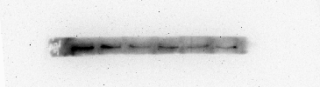

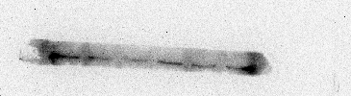

β-ACTIN



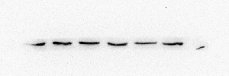

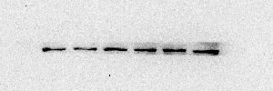

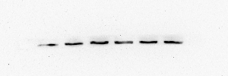

(B)the protein expression of PS1

PS1 control 0.35 3.5 35 350 700ng/mL

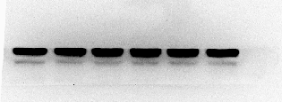

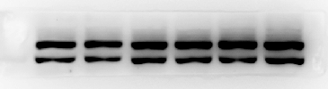

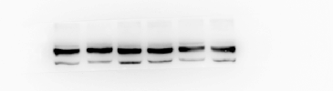

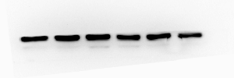

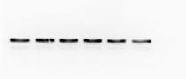

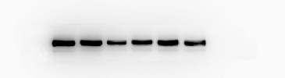

GAPDH

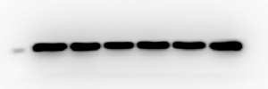

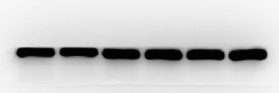

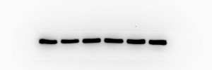

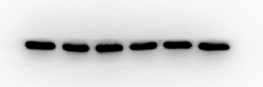

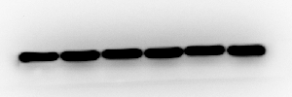

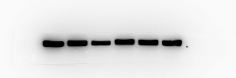

he protein expression of APP

(C) APP control 0.35 3.5 35 350 700ng/mL

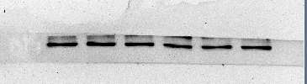

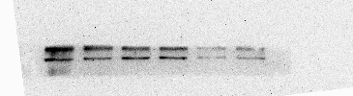

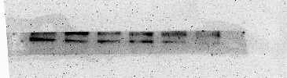

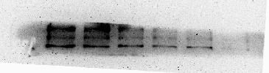

GAPDH

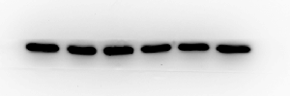

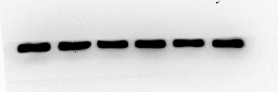

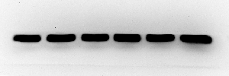

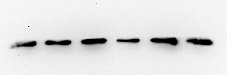

**Fig. 5.** DNLA reduced the production of Aβ through non-amyloidogenic pathways

1. the protein expression of ADAM10

ADAM10 control 0.35 3.5 35 350 700ng/mL

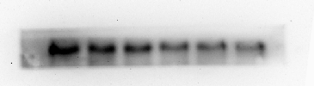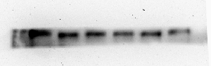

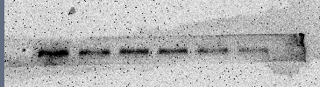4

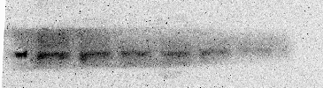

GAPDH

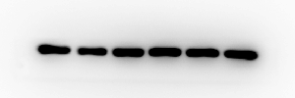

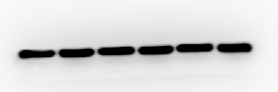

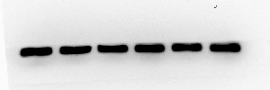4

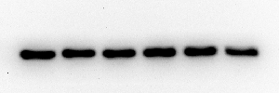

1. the protein expression of ADAM17

ADAM17 control 0.35 3.5 35 350 700ng/mL

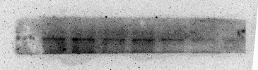

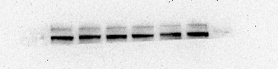

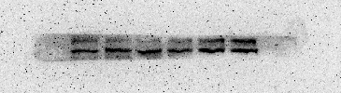

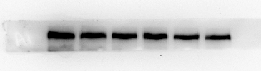

GAPDH

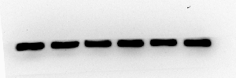

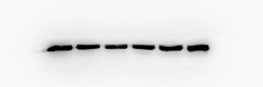

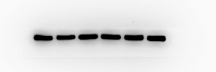

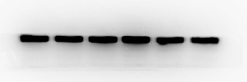

**Fig. 6. *DNLA decreased accumulation of Aβ by inducing BACE1 (β-secretase)***

the protein expression of ***BACE1***

***BACE1*** control 0.35 3.5 35 350 700ng/mL

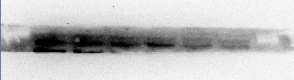

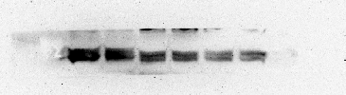

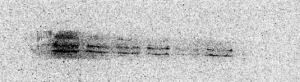

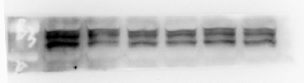

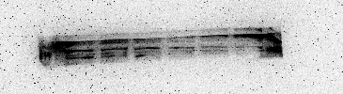

GAPDH

