Supporting Information
Journal:
Title: “Magnetically Directed Antioxidant and Antimicrobial Agent; Size-Controlled Synthesis and Surface Functionalization of magnetite with Quercetin”

A | B
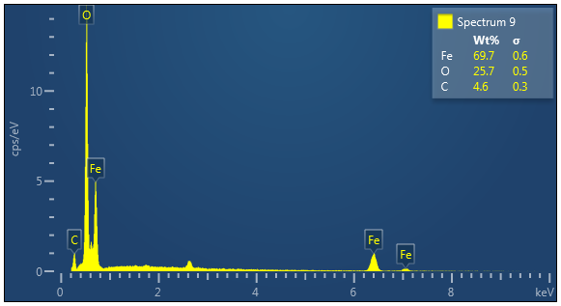 | 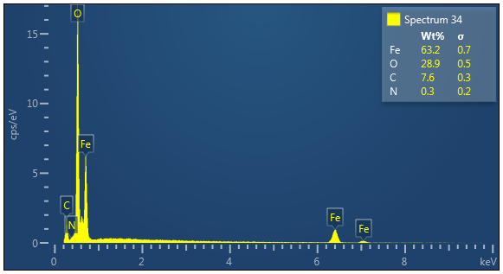

Figure S1 EDX spectrum of IONP@Q1 A) Before DPPH assay B) After DPPH assay
A | B
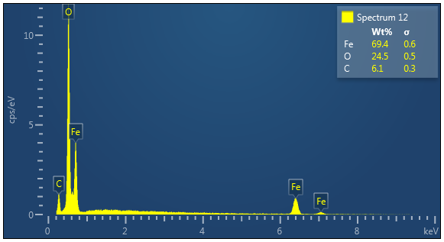 | 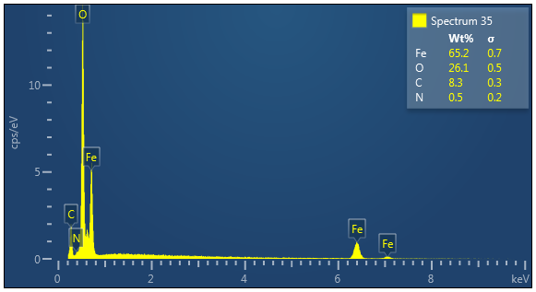

Figure S2 EDX spectrum of IONP@Q2 A) Before DPPH assay B) After DPPH assay

A | B
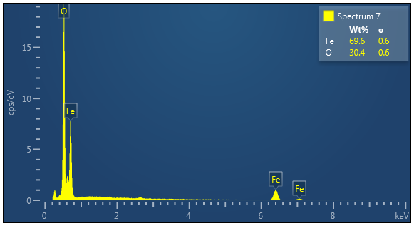 | 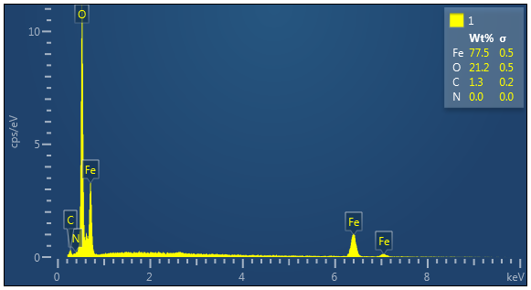

Figure S3 EDX spectrum of IONP A) Before DPPH assay B) After DPPH assay

Table S2. PASS result for Q
Pa | Pi
0,955 | 0,002 | Arylacetonitrilase inhibitor
0,954 | 0,002 | Chlordecone reductase inhibitor
0,950 | 0,002 | Dehydro-L-gulonate decarboxylase inhibitor
0,950 | 0,003 | Testosterone 17beta-dehydrogenase (NADP+) inhibitor
0,944 | 0,002 | Glutathione thiolesterase inhibitor
0,943 | 0,002 | Alkane 1-monooxygenase inhibitor
0,941 | 0,003 | Sugar-phosphatase inhibitor
0,938 | 0,002 | NADPH-cytochrome-c2 reductase inhibitor
0,934 | 0,001 | Threonine aldolase inhibitor
0,934 | 0,001 | Catechol 1,2-dioxygenase inhibitor
0,933 | 0,002 | 2-Hydroxyquinoline 8-monooxygenase inhibitor
0,933 | 0,002 | Glucan endo-1,6-beta-glucosidase inhibitor
0,932 | 0,002 | Arylsulfate sulfotransferase inhibitor
0,930 | 0,002 | Ribulose-phosphate 3-epimerase inhibitor
0,929 | 0,002 | 2-Nitropropane dioxygenase inhibitor
0,928 | 0,004 | Alkenylglycerophosphocholine hydrolase inhibitor
0,928 | 0,003 | Monodehydroascorbate reductase (NADH) inhibitor
0,926 | 0,002 | UDP-N-acetylglucosamine 4-epimerase inhibitor
0,926 | 0,002 | Glutamyl endopeptidase II inhibitor
0,924 | 0,001 | Phloroglucinol reductase inhibitor
0,924 | 0,002 | Aspartate-phenylpyruvate transaminase inhibitor
0,923 | 0,002 | Fatty-acyl-CoA synthase inhibitor
0,923 | 0,003 | Pullulanase inhibitor
0,923 | 0,005 | Methylenetetrahydrofolate reductase (NADPH) inhibitor
0,921 | 0,003 | Antiseptic
0,919 | 0,003 | Taurine dehydrogenase inhibitor
0,919 | 0,003 | Prolyl aminopeptidase inhibitor
0,915 | 0,002 | Corticosteroid side-chain-isomerase inhibitor
0,915 | 0,003 | Dextranase inhibitor
0,913 | 0,002 | Bisphosphoglycerate phosphatase inhibitor
0,915 | 0,004 | Ubiquinol-cytochrome-c reductase inhibitor
0,912 | 0,001 | Cis-1,2-dihydro-1,2-dihydroxynaphthalene dehydrogenase inhibitor
0,910 | 0,003 | Arginine 2-monooxygenase inhibitor
0,909 | 0,002 | Gamma-guanidinobutyraldehyde dehydrogenase inhibitor
0,909 | 0,002 | 5-O-(4-coumaroyl)-D-quinate 3'-monooxygenase inhibitor
0,907 | 0,002 | Sulfite reductase inhibitor
0,908 | 0,003 | 2-Dehydropantoate 2-reductase inhibitor
0,905 | 0,002 | NADH kinase inhibitor
0,908 | 0,006 | Aspulvinone dimethylallyltransferase inhibitor
0,903 | 0,001 | Procollagen-lysine 5-dioxygenase inhibitor
0,905 | 0,004 | Glucose oxidase inhibitor
0,901 | 0,002 | Alcohol oxidase inhibitor
0,902 | 0,004 | Feruloyl esterase inhibitor
0,901 | 0,003 | Phosphatidylcholine-retinol O-acyltransferase inhibitor
0,901 | 0,003 | Creatininase inhibitor
0,901 | 0,004 | Aldehyde oxidase inhibitor
0,898 | 0,002 | Sulfite oxidase inhibitor
0,898 | 0,002 | Hyponitrite reductase inhibitor
0,898 | 0,003 | 3-Hydroxybenzoate 6-monooxygenase inhibitor
0,897 | 0,001 | Aminobutyraldehyde dehydrogenase inhibitor
0,899 | 0,005 | Sphinganine kinase inhibitor
0,898 | 0,004 | Anaphylatoxin receptor antagonist
0,898 | 0,004 | Superoxide dismutase inhibitor
0,896 | 0,003 | Fusarinine-C ornithinesterase inhibitor
0,895 | 0,002 | Aryl-alcohol dehydrogenase (NADP+) inhibitor
0,896 | 0,003 | 2-Hydroxymuconate-semialdehyde hydrolase inhibitor
0,895 | 0,002 | Peptide alpha-N-acetyltransferase inhibitor
0,895 | 0,003 | Dimethylargininase inhibitor
0,893 | 0,003 | N-benzyloxycarbonylglycine hydrolase inhibitor
0,892 | 0,002 | Methylamine-glutamate N-methyltransferase inhibitor
0,890 | 0,002 | Chenodeoxycholoyltaurine hydrolase inhibitor
0,891 | 0,003 | Peroxidase inhibitor
0,891 | 0,003 | Trans-acenaphthene-1,2-diol dehydrogenase inhibitor
0,890 | 0,002 | Electron-transferring-flavoprotein dehydrogenase inhibitor
0,890 | 0,002 | Glutamine-phenylpyruvate transaminase inhibitor
0,889 | 0,003 | Polyamine-transporting ATPase inhibitor
0,889 | 0,002 | Crotonoyl-[acyl-carrier-protein] hydratase inhibitor
0,887 | 0,001 | 2,5-Dihydroxypyridine 5,6-dioxygenase inhibitor
0,886 | 0,002 | Opheline kinase inhibitor
0,886 | 0,002 | Taurocyamine kinase inhibitor
0,887 | 0,002 | 4-Methoxybenzoate monooxygenase (O-demethylating) inhibitor
0,886 | 0,002 | Gluconate 5-dehydrogenase inhibitor
0,884 | 0,001 | Astringent
0,885 | 0,003 | Pterin deaminase inhibitor
0,885 | 0,002 | L-glutamate oxidase inhibitor
0,885 | 0,003 | Nitrate reductase (cytochrome) inhibitor
0,884 | 0,002 | Magnesium-protoporphyrin IX monomethyl ester (oxidative) cyclase inhibitor
0,888 | 0,007 | Glutamate-5-semialdehyde dehydrogenase inhibitor
0,883 | 0,003 | L-glucuronate reductase inhibitor
0,881 | 0,001 | Glyoxylate oxidase inhibitor
0,882 | 0,002 | N-acetylneuraminate synthase inhibitor
0,882 | 0,002 | S-alkylcysteine lyase inhibitor
0,881 | 0,002 | N-acylmannosamine kinase inhibitor
0,881 | 0,002 | Rhamnulose-1-phosphate aldolase inhibitor
0,881 | 0,002 | Cyclohexyl-isocyanide hydratase inhibitor
0,882 | 0,003 | Acetylesterase inhibitor
0,881 | 0,002 | 3-Hydroxybenzoate 4-monooxygenase inhibitor
0,881 | 0,002 | tRNA-pseudouridine synthase I inhibitor
0,880 | 0,002 | N-Acyl-D-aspartate deacylase inhibitor
0,880 | 0,002 | Glutamate decarboxylase inhibitor
0,880 | 0,003 | Exoribonuclease II inhibitor
0,890 | 0,014 | Membrane integrity agonist
0,878 | 0,002 | Ferredoxin-NAD+ reductase inhibitor
0,878 | 0,002 | Naphthalene 1,2-dioxygenase inhibitor
0,878 | 0,002 | NADPH-ferrihemoprotein reductase inhibitor
0,882 | 0,007 | Benzoate-CoA ligase inhibitor
0,877 | 0,002 | Benzoate 4-monooxygenase inhibitor
0,877 | 0,003 | Allyl-alcohol dehydrogenase inhibitor
0,878 | 0,003 | Glucan endo-1,3-beta-D-glucosidase inhibitor
0,876 | 0,002 | Phosphatidylserine decarboxylase inhibitor
0,875 | 0,003 | Poly(alpha-L-guluronate) lyase inhibitor
0,876 | 0,004 | ADP-thymidine kinase inhibitor
0,873 | 0,002 | Tryptophanamidase inhibitor
0,873 | 0,003 | Aldehyde dehydrogenase (pyrroloquinoline-quinone) inhibitor
0,872 | 0,003 | Mucinaminylserine mucinaminidase inhibitor
0,871 | 0,002 | Fructan beta-fructosidase inhibitor
0,871 | 0,003 | Spermidine dehydrogenase inhibitor
0,869 | 0,003 | Aspartate-ammonia ligase inhibitor
0,868 | 0,002 | Long-chain-aldehyde dehydrogenase inhibitor
0,870 | 0,004 | N-acetylneuraminate 7-O(or 9-O)-acetyltransferase inhibitor
0,867 | 0,001 | Lactaldehyde reductase inhibitor
0,868 | 0,003 | Arylalkyl acylamidase inhibitor
0,868 | 0,003 | Formaldehyde transketolase inhibitor
0,870 | 0,005 | NADPH peroxidase inhibitor
0,867 | 0,002 | N-methylhydantoinase (ATP-hydrolysing) inhibitor
0,866 | 0,003 | 4-Hydroxyproline epimerase inhibitor
0,866 | 0,002 | Pyruvate decarboxylase inhibitor
0,865 | 0,002 | Carbon-monoxide dehydrogenase inhibitor
0,865 | 0,002 | Anthranilate 3-monooxygenase (deaminating) inhibitor
0,864 | 0,001 | 2,6-Dihydroxypyridine 3-monooxygenase inhibitor
0,864 | 0,002 | Catechol 2,3-dioxygenase inhibitor
0,863 | 0,002 | 2-Oxoaldehyde dehydrogenase (NADP+) inhibitor
0,864 | 0,003 | Amine dehydrogenase inhibitor
0,867 | 0,007 | Pro-opiomelanocortin converting enzyme inhibitor
0,863 | 0,003 | Urethanase inhibitor
0,862 | 0,002 | Histidinol-phosphatase inhibitor
0,860 | 0,001 | Gentisate 1,2-dioxygenase inhibitor
0,862 | 0,003 | Xylan endo-1,3-beta-xylosidase inhibitor
0,860 | 0,002 | 2-Dehydropantolactone reductase (A-specific) inhibitor
0,859 | 0,001 | Phenylpyruvate decarboxylase inhibitor
0,859 | 0,002 | Beta-carotene 15,15'-monooxygenase inhibitor
0,858 | 0,003 | 1,4-Lactonase inhibitor
0,858 | 0,003 | Cholestanetriol 26-monooxygenase inhibitor
0,859 | 0,003 | Mitochondrial processing peptidase inhibitor
0,858 | 0,002 | Tpr proteinase (Porphyromonas gingivalis) inhibitor
0,858 | 0,003 | Phenol O-methyltransferase inhibitor
0,857 | 0,002 | Uroporphyrinogen-III synthase inhibitor
0,857 | 0,003 | Sarcosine oxidase inhibitor
0,856 | 0,002 | Glyoxylate reductase inhibitor
0,854 | 0,003 | Peptide-N4-(N-acetyl-beta-glucosaminyl)asparagine amidase inhibitor
0,853 | 0,003 | 4-Nitrophenol 2-monooxygenase inhibitor
0,852 | 0,003 | Anthranilate-CoA ligase inhibitor
0,852 | 0,003 | Poly(beta-D-mannuronate) lyase inhibitor
0,849 | 0,001 | 2-Pyrocatechuate decarboxylase inhibitor
0,849 | 0,002 | Mannan endo-1,4-beta-mannosidase inhibitor
0,849 | 0,002 | 6-Pyruvoyltetrahydropterin synthase inhibitor
0,849 | 0,002 | 4-Chlorophenylacetate 3,4-dioxygenase inhibitor
0,855 | 0,009 | Antieczematic
0,850 | 0,004 | Lysine 2,3-aminomutase inhibitor
0,849 | 0,005 | Fragilysin inhibitor
0,846 | 0,002 | Acylphosphatase inhibitor
0,846 | 0,002 | 6-Carboxyhexanoate-CoA ligase inhibitor
0,846 | 0,002 | Biotin-CoA ligase inhibitor
0,846 | 0,002 | Homoaconitate hydratase inhibitor
0,846 | 0,002 | Triacetate-lactonase inhibitor
0,847 | 0,003 | Fructose 5-dehydrogenase inhibitor
0,845 | 0,002 | Glycerol dehydratase inhibitor
0,846 | 0,003 | Transketolase inhibitor
0,846 | 0,003 | Limulus clotting factor B inhibitor
0,842 | 0,003 | Prostaglandin-A1 DELTA-isomerase inhibitor
0,842 | 0,002 | Glutarate-semialdehyde dehydrogenase inhibitor
0,842 | 0,003 | Pectate lyase inhibitor
0,842 | 0,003 | Antimutagenic
0,840 | 0,002 | 2-Oxoglutarate decarboxylase inhibitor
0,840 | 0,002 | D-xylulose reductase inhibitor
0,839 | 0,002 | Gamma-butyrobetaine dioxygenase inhibitor
0,838 | 0,002 | 3-Hydroxy-4-oxoquinoline 2,4-dioxygenase inhibitor
0,838 | 0,002 | Styrene-oxide isomerase inhibitor
0,838 | 0,002 | Ornithine cyclodeaminase inhibitor
0,838 | 0,002 | Aminocarboxymuconate-semialdehyde decarboxylase inhibitor
0,839 | 0,004 | Levanase inhibitor
0,837 | 0,002 | Guanidinoacetase inhibitor
0,838 | 0,003 | Carnitinamidase inhibitor
0,838 | 0,003 | Hydrogen dehydrogenase inhibitor
0,837 | 0,002 | 4-Hydroxyglutamate transaminase inhibitor
0,836 | 0,002 | Mannitol-1-phosphatase inhibitor
0,836 | 0,002 | Salicylate 1-monooxygenase inhibitor
0,836 | 0,003 | Preneoplastic conditions treatment
0,835 | 0,002 | 3-Carboxyethylcatechol 2,3-dioxygenase inhibitor
0,835 | 0,003 | Leucolysin inhibitor
0,834 | 0,002 | Vanillyl-alcohol oxidase inhibitor
0,836 | 0,004 | Phospholipid-translocating ATPase inhibitor
0,833 | 0,002 | Creatinine deaminase inhibitor
0,833 | 0,002 | Gluconolactonase inhibitor
0,834 | 0,003 | Nicotinate dehydrogenase inhibitor
0,830 | 0,001 | Shikimate 5-dehydrogenase inhibitor
0,831 | 0,003 | S-formylglutathione hydrolase inhibitor
0,830 | 0,002 | N-carbamoyl-L-amino-acid hydrolase inhibitor
0,830 | 0,002 | Camphor 1,2-monooxygenase inhibitor
0,830 | 0,003 | Aryldialkylphosphatase inhibitor
0,830 | 0,003 | Laccase inhibitor
0,849 | 0,024 | CYP2C12 substrate
0,828 | 0,003 | 2-Haloacid dehalogenase (configuration-inverting) inhibitor
0,827 | 0,003 | Opine dehydrogenase inhibitor
0,825 | 0,002 | CDP-4-dehydro-6-deoxyglucose reductase inhibitor
0,828 | 0,005 | Antiinfective
0,827 | 0,004 | DNA-(apurinic or apyrimidinic site) lyase inhibitor
0,835 | 0,013 | Antiseborrheic
0,824 | 0,002 | Mannan endo-1,6-alpha-mannosidase inhibitor
0,824 | 0,002 | D-alanine 2-hydroxymethyltransferase inhibitor
0,823 | 0,004 | UGT1A6 substrate
0,821 | 0,002 | 3-Oxoadipate enol-lactonase inhibitor
0,821 | 0,003 | Thymidylate 5'-phosphatase inhibitor
0,823 | 0,004 | Fibrinolytic
0,822 | 0,004 | Centromere associated protein inhibitor
0,819 | 0,002 | 3-Hydroxyphenylacetate 6-hydroxylase inhibitor
0,821 | 0,003 | Catechol oxidase inhibitor
0,819 | 0,002 | GABA C receptor agonist
0,817 | 0,002 | Diiodophenylpyruvate reductase inhibitor
0,816 | 0,001 | Glycerol-1-phosphatase inhibitor
0,814 | 0,002 | Glycerol dehydrogenase (NADP+) inhibitor
0,814 | 0,002 | Glycerol 2-dehydrogenase (NADP+) inhibitor
0,813 | 0,002 | N-acetyl-gamma-glutamyl-phosphate reductase inhibitor
0,814 | 0,003 | Phenylacetate-CoA ligase inhibitor
0,814 | 0,003 | (R)-Pantolactone dehydrogenase (flavin) inhibitor
0,814 | 0,003 | (R)-6-hydroxynicotine oxidase inhibitor
0,814 | 0,003 | Bothrolysin inhibitor
0,812 | 0,002 | N-hydroxy-2-acetamidofluorene reductase inhibitor
0,812 | 0,002 | Benzaldehyde dehydrogenase (NADP+) inhibitor
0,812 | 0,002 | Trans-pentaprenyltranstransferase inhibitor
0,811 | 0,002 | Pyruvate dehydrogenase (cytochrome) inhibitor
0,811 | 0,002 | Trans-2-enoyl-CoA reductase (NAD+) inhibitor
0,811 | 0,004 | Histidine N-acetyltransferase inhibitor
0,811 | 0,004 | D-lactaldehyde dehydrogenase inhibitor
0,815 | 0,008 | Membrane permeability inhibitor
0,809 | 0,003 | Inulinase inhibitor
0,809 | 0,003 | Alkenylglycerophosphoethanolamine hydrolase inhibitor
0,809 | 0,003 | 4-Phytase inhibitor
0,808 | 0,002 | Glycolate dehydrogenase inhibitor
0,807 | 0,004 | Aryl-acylamidase inhibitor
0,804 | 0,003 | Glycopeptide alpha-N-acetylgalactosaminidase inhibitor
0,803 | 0,003 | Acetylornithine deacetylase inhibitor
0,803 | 0,004 | P-benzoquinone reductase (NADPH) inhibitor
0,814 | 0,015 | Mucomembranous protector
0,801 | 0,002 | 2,4-Diaminopentanoate dehydrogenase inhibitor
0,801 | 0,002 | 3-Hydroxybutyryl-CoA dehydrogenase inhibitor
0,801 | 0,002 | Lysine 6-dehydrogenase inhibitor
0,801 | 0,002 | tRNA nucleotidyltransferase inhibitor
0,801 | 0,002 | Pantoate 4-dehydrogenase inhibitor
0,801 | 0,002 | Aspartyl aminopeptidase inhibitor
0,801 | 0,003 | 4-Hydroxyphenylacetate 3-monooxygenase inhibitor
0,797 | 0,002 | Nicotine dehydrogenase inhibitor
0,798 | 0,004 | Phosphoinositide 5-phosphatase inhibitor
0,796 | 0,002 | Quinoprotein glucose dehydrogenase inhibitor
0,795 | 0,003 | Polygalacturonase inhibitor
0,794 | 0,003 | Cyclomaltodextrinase inhibitor
0,793 | 0,003 | N-Acyl-D-amino-acid deacylase inhibitor
0,793 | 0,003 | L-threonine 3-dehydrogenase inhibitor
0,790 | 0,002 | Phenol 2-monooxygenase inhibitor
0,788 | 0,001 | 3,4-Dihydroxy-9,10-secoandrosta-1,3,5(10)-triene-9,17-dione 4,5-dioxygenase inhibitor
0,789 | 0,002 | Cystathionine beta-synthase inhibitor
0,805 | 0,020 | CYP2J substrate
0,795 | 0,010 | Lysase inhibitor
0,798 | 0,014 | Mucositis treatment
0,787 | 0,004 | Phosphatidylglycerophosphatase inhibitor
0,785 | 0,004 | Isopenicillin-N epimerase inhibitor
0,785 | 0,004 | Sulfite dehydrogenase inhibitor
0,784 | 0,003 | Phenylalanine(histidine) transaminase inhibitor
0,783 | 0,002 | Methylaspartate ammonia-lyase inhibitor
0,784 | 0,003 | Nitrilase inhibitor
0,783 | 0,003 | Arylsulfatase inhibitor
0,784 | 0,003 | Nitrite reductase [NAD(P)H] inhibitor
0,782 | 0,002 | Diphosphomevalonate decarboxylase inhibitor
0,781 | 0,003 | Hydroxylamine reductase (NADH) inhibitor
0,780 | 0,002 | 3-Demethylubiquinone-9 3-O-methyltransferase inhibitor
0,782 | 0,005 | Methylumbelliferyl-acetate deacetylase inhibitor
0,786 | 0,009 | JAK2 expression inhibitor
0,779 | 0,003 | Protein-Npi-phosphohistidine-sugar phosphotransferase inhibitor
0,779 | 0,004 | Kidney function stimulant
0,789 | 0,014 | Beta-adrenergic receptor kinase inhibitor
0,789 | 0,014 | G-protein-coupled receptor kinase inhibitor
0,777 | 0,004 | APOA1 expression enhancer
0,776 | 0,003 | 2,3-Dihydroxyindole 2,3-dioxygenase inhibitor
0,780 | 0,007 | Linoleate diol synthase inhibitor
0,774 | 0,002 | Ferredoxin-nitrite reductase inhibitor
0,773 | 0,002 | Hippurate hydrolase inhibitor
0,774 | 0,002 | Beta-amylase inhibitor
0,779 | 0,009 | Carboxypeptidase Taq inhibitor
0,772 | 0,002 | Carboxylate reductase inhibitor
0,785 | 0,016 | Glycosylphosphatidylinositol phospholipase D inhibitor
0,779 | 0,011 | Prostaglandin-E2 9-reductase inhibitor
0,774 | 0,006 | Lipoprotein lipase inhibitor
0,769 | 0,002 | D-amino-acid dehydrogenase inhibitor
0,782 | 0,016 | CYP2J2 substrate
0,767 | 0,001 | Quinate 5-dehydrogenase inhibitor
0,768 | 0,002 | Succinate-semialdehyde dehydrogenase [NAD(P)+] inhibitor
0,768 | 0,003 | Peptide-tryptophan 2,3-dioxygenase inhibitor
0,766 | 0,003 | Chitosanase inhibitor
0,766 | 0,003 | Pyruvate dehydrogenase (lipoamide) inhibitor
0,765 | 0,002 | Aminomuconate-semialdehyde dehydrogenase inhibitor
0,765 | 0,003 | 2-Enoate reductase inhibitor
0,764 | 0,002 | Phosphoglycerate mutase inhibitor
0,762 | 0,002 | 2,4-Dichlorophenol 6-monooxygenase inhibitor
0,763 | 0,003 | Licheninase inhibitor
0,760 | 0,001 | Tannase inhibitor
0,762 | 0,003 | Dimethylmaleate hydratase inhibitor
0,761 | 0,002 | Glucan endo-1,3-alpha-glucosidase inhibitor
0,762 | 0,003 | Arylesterase inhibitor
0,759 | 0,002 | Chloramphenicol O-acetyltransferase inhibitor
0,761 | 0,007 | Manganese peroxidase inhibitor
0,755 | 0,001 | Orotate reductase (NADPH) inhibitor
0,754 | 0,002 | 4-Hydroxybenzoate 3-monooxygenase inhibitor
0,754 | 0,001 | 3,4-Dihydroxyphenylacetate 2,3-dioxygenase inhibitor
0,754 | 0,003 | H+-exporting ATPase inhibitor
0,753 | 0,003 | Cyanoalanine nitrilase inhibitor
0,752 | 0,002 | 3-Aminobutyryl-CoA ammonia-lyase inhibitor
0,758 | 0,008 | Phthalate 4,5-dioxygenase inhibitor
0,760 | 0,011 | Complement factor D inhibitor
0,750 | 0,002 | L-iduronidase inhibitor
0,751 | 0,003 | Myosin ATPase inhibitor
0,750 | 0,002 | L-amino-acid oxidase inhibitor
0,751 | 0,003 | Alpha-N-acetylglucosaminidase inhibitor
0,751 | 0,004 | Beta-mannosidase inhibitor
0,750 | 0,003 | Glutaminase inhibitor
0,750 | 0,003 | Thiosulfate dehydrogenase inhibitor
0,749 | 0,003 | 1-Alkylglycerophosphocholine O-acetyltransferase inhibitor
0,748 | 0,003 | Plasmanylethanolamine desaturase inhibitor
0,748 | 0,004 | Alcohol dehydrogenase (NADP+) inhibitor
0,752 | 0,008 | Glyceryl-ether monooxygenase inhibitor
0,747 | 0,003 | Benzoylformate decarboxylase inhibitor
0,748 | 0,005 | Insulysin inhibitor
0,770 | 0,027 | Acrocylindropepsin inhibitor
0,770 | 0,027 | Chymosin inhibitor
0,770 | 0,027 | Saccharopepsin inhibitor
0,746 | 0,004 | UGT2B1 substrate
0,743 | 0,002 | Cyclamate sulfohydrolase inhibitor
0,743 | 0,003 | Acetate kinase inhibitor
0,743 | 0,004 | Leukotriene-B4 20-monooxygenase inhibitor
0,741 | 0,003 | Gly-X carboxypeptidase inhibitor
0,779 | 0,042 | Phobic disorders treatment
0,741 | 0,004 | Biotinidase inhibitor
0,740 | 0,005 | X-methyl-His dipeptidase inhibitor
0,737 | 0,002 | Vomilenine glucosyltransferase inhibitor
0,739 | 0,004 | N-hydroxyarylamine O-acetyltransferase inhibitor
0,737 | 0,002 | Leucine dehydrogenase inhibitor
0,737 | 0,004 | Coccolysin inhibitor
0,734 | 0,003 | 4-Coumarate-CoA ligase inhibitor
0,733 | 0,003 | Phenylalanine 4-hydroxylase inhibitor
0,735 | 0,005 | Butyrate-CoA ligase inhibitor
0,733 | 0,003 | Nicotinamidase inhibitor
0,733 | 0,004 | Procollagen N-endopeptidase inhibitor
0,731 | 0,002 | Dopachrome isomerase inhibitor
0,730 | 0,003 | Carnosine synthase inhibitor
0,732 | 0,005 | HMOX1 expression enhancer
0,736 | 0,010 | Pitrilysin inhibitor
0,728 | 0,003 | 2,2-Dialkylglycine decarboxylase (pyruvate) inhibitor
0,727 | 0,003 | Cyclopentanone monooxygenase inhibitor
0,726 | 0,002 | Urease inhibitor
0,729 | 0,006 | Ecdysone 20-monooxygenase inhibitor
0,727 | 0,004 | Rubredoxin-NAD+ reductase inhibitor
0,725 | 0,002 | Lombricine kinase inhibitor
0,741 | 0,018 | Protein-glutamate methylesterase inhibitor
0,725 | 0,002 | Dihydroxy-acid dehydratase inhibitor
0,744 | 0,022 | Nicotinic alpha6beta3beta4alpha5 receptor antagonist
0,727 | 0,007 | Lysostaphin inhibitor
0,723 | 0,002 | 3-Cyanoalanine hydratase inhibitor
0,721 | 0,003 | Aryl-alcohol dehydrogenase inhibitor
0,718 | 0,001 | 4-Hydroxybenzoate decarboxylase inhibitor
0,718 | 0,001 | 4,5-Dihydroxyphthalate decarboxylase inhibitor
0,733 | 0,016 | Alkylacetylglycerophosphatase inhibitor
0,737 | 0,021 | Acylcarnitine hydrolase inhibitor
0,719 | 0,004 | N-(long-chain-acyl)ethanolamine deacylase inhibitor
0,719 | 0,004 | Malate dehydrogenase (acceptor) inhibitor
0,717 | 0,003 | DNA-3-methyladenine glycosylase I inhibitor
0,718 | 0,005 | Cyclohexanone monooxygenase inhibitor
0,717 | 0,004 | Monophenol monooxygenase inhibitor
0,715 | 0,003 | Porphobilinogen synthase inhibitor
0,715 | 0,003 | Gallate decarboxylase inhibitor
0,713 | 0,002 | Protocatechuate 3,4-dioxygenase inhibitor
0,713 | 0,003 | Indoleacetaldoxime dehydratase inhibitor
0,710 | 0,002 | Acyl-lysine deacylase inhibitor
0,709 | 0,006 | Aspartyltransferase inhibitor
0,717 | 0,013 | Oxidoreductase inhibitor
0,707 | 0,004 | Aldehyde dehydrogenase (NADP+) inhibitor
0,703 | 0,002 | Glutathione dehydrogenase (ascorbate) inhibitor
0,706 | 0,005 | Cytochrome-b5 reductase inhibitor
0,708 | 0,008 | UGT1A9 substrate
0,702 | 0,003 | Alanine transaminase inhibitor
0,712 | 0,014 | UDP-glucuronosyltransferase substrate
0,700 | 0,002 | (S)-3-hydroxyacid ester dehydrogenase inhibitor
0,700 | 0,002 | Prephenate dehydrogenase inhibitor
0,700 | 0,003 | Sphinganine-1-phosphate aldolase inhibitor
0,700 | 0,003 | Glucuronate isomerase inhibitor
0,700 | 0,004 | Erythropoiesis stimulant
0,718 | 0,023 | TP53 expression enhancer

