The red area represents CK treatment (the volume ratio of soft rock to sand is 0:1), the purple area represents C1 treatment (the volume ratio of soft rock to sand is 1:5), the blue area represents C2 treatment (the volume ratio of soft rock to sand is 1:2), and the yellow area represents C3 treatment (the volume ratio of soft rock to sand is 1:1).
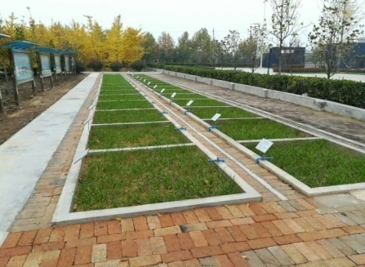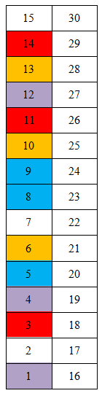
18
17
16
3
1
2
North

Each number corresponds to the test plot treatments
Test plot number | 2, 7, 15 | 6, 10, 13 | 5, 8, 9 | 1, 4, 12 | 3, 11, 14
Compound ratio | Loess: Sand =1:2 | Soft rock: sand =1:1 | Soft rock: sand =1:2 | Soft rock: sand =1:5 | Soft rock: sand =0:1
Soil ages | 2009 | 2009 | 2009 | 2009 | 2009
Test plot number | 17, 22, 30 | 21, 25, 28 | 20, 23, 24 | 16, 19, 27 | 18, 26, 29
Compound ratio | Loess: Sand =1:2 | Soft rock: sand =1:1 | Soft rock: sand =1:2 | Soft rock: sand =1:5 | Soft rock: sand =0:1
Soil ages | 2016 | 2016 | 2016 | 2016 | 2016

