The microstructure of compound soil in different proportions of soft rock and sand. Magnification is 1000 times.
(a): the volume ratio of soft rock to sand is 0:1 (CK);
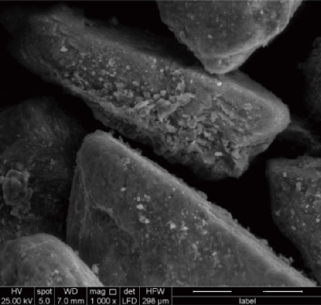

(b): the volume ratio of soft rock to sand is 1:5 (C1);
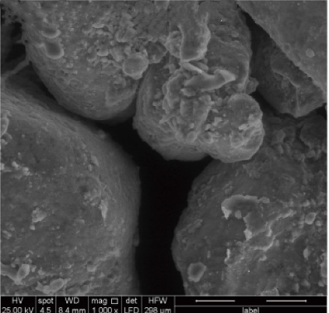

(c): the volume ratio of soft rock to sand is 1:2 (C2);
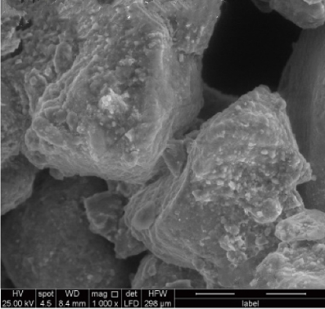

(d): the volume ratio of soft rock to sand is 1:1 (C3).
