Supplementary Figures

Figure S1 Distributions of OTUs across sample sites for bacterial modules
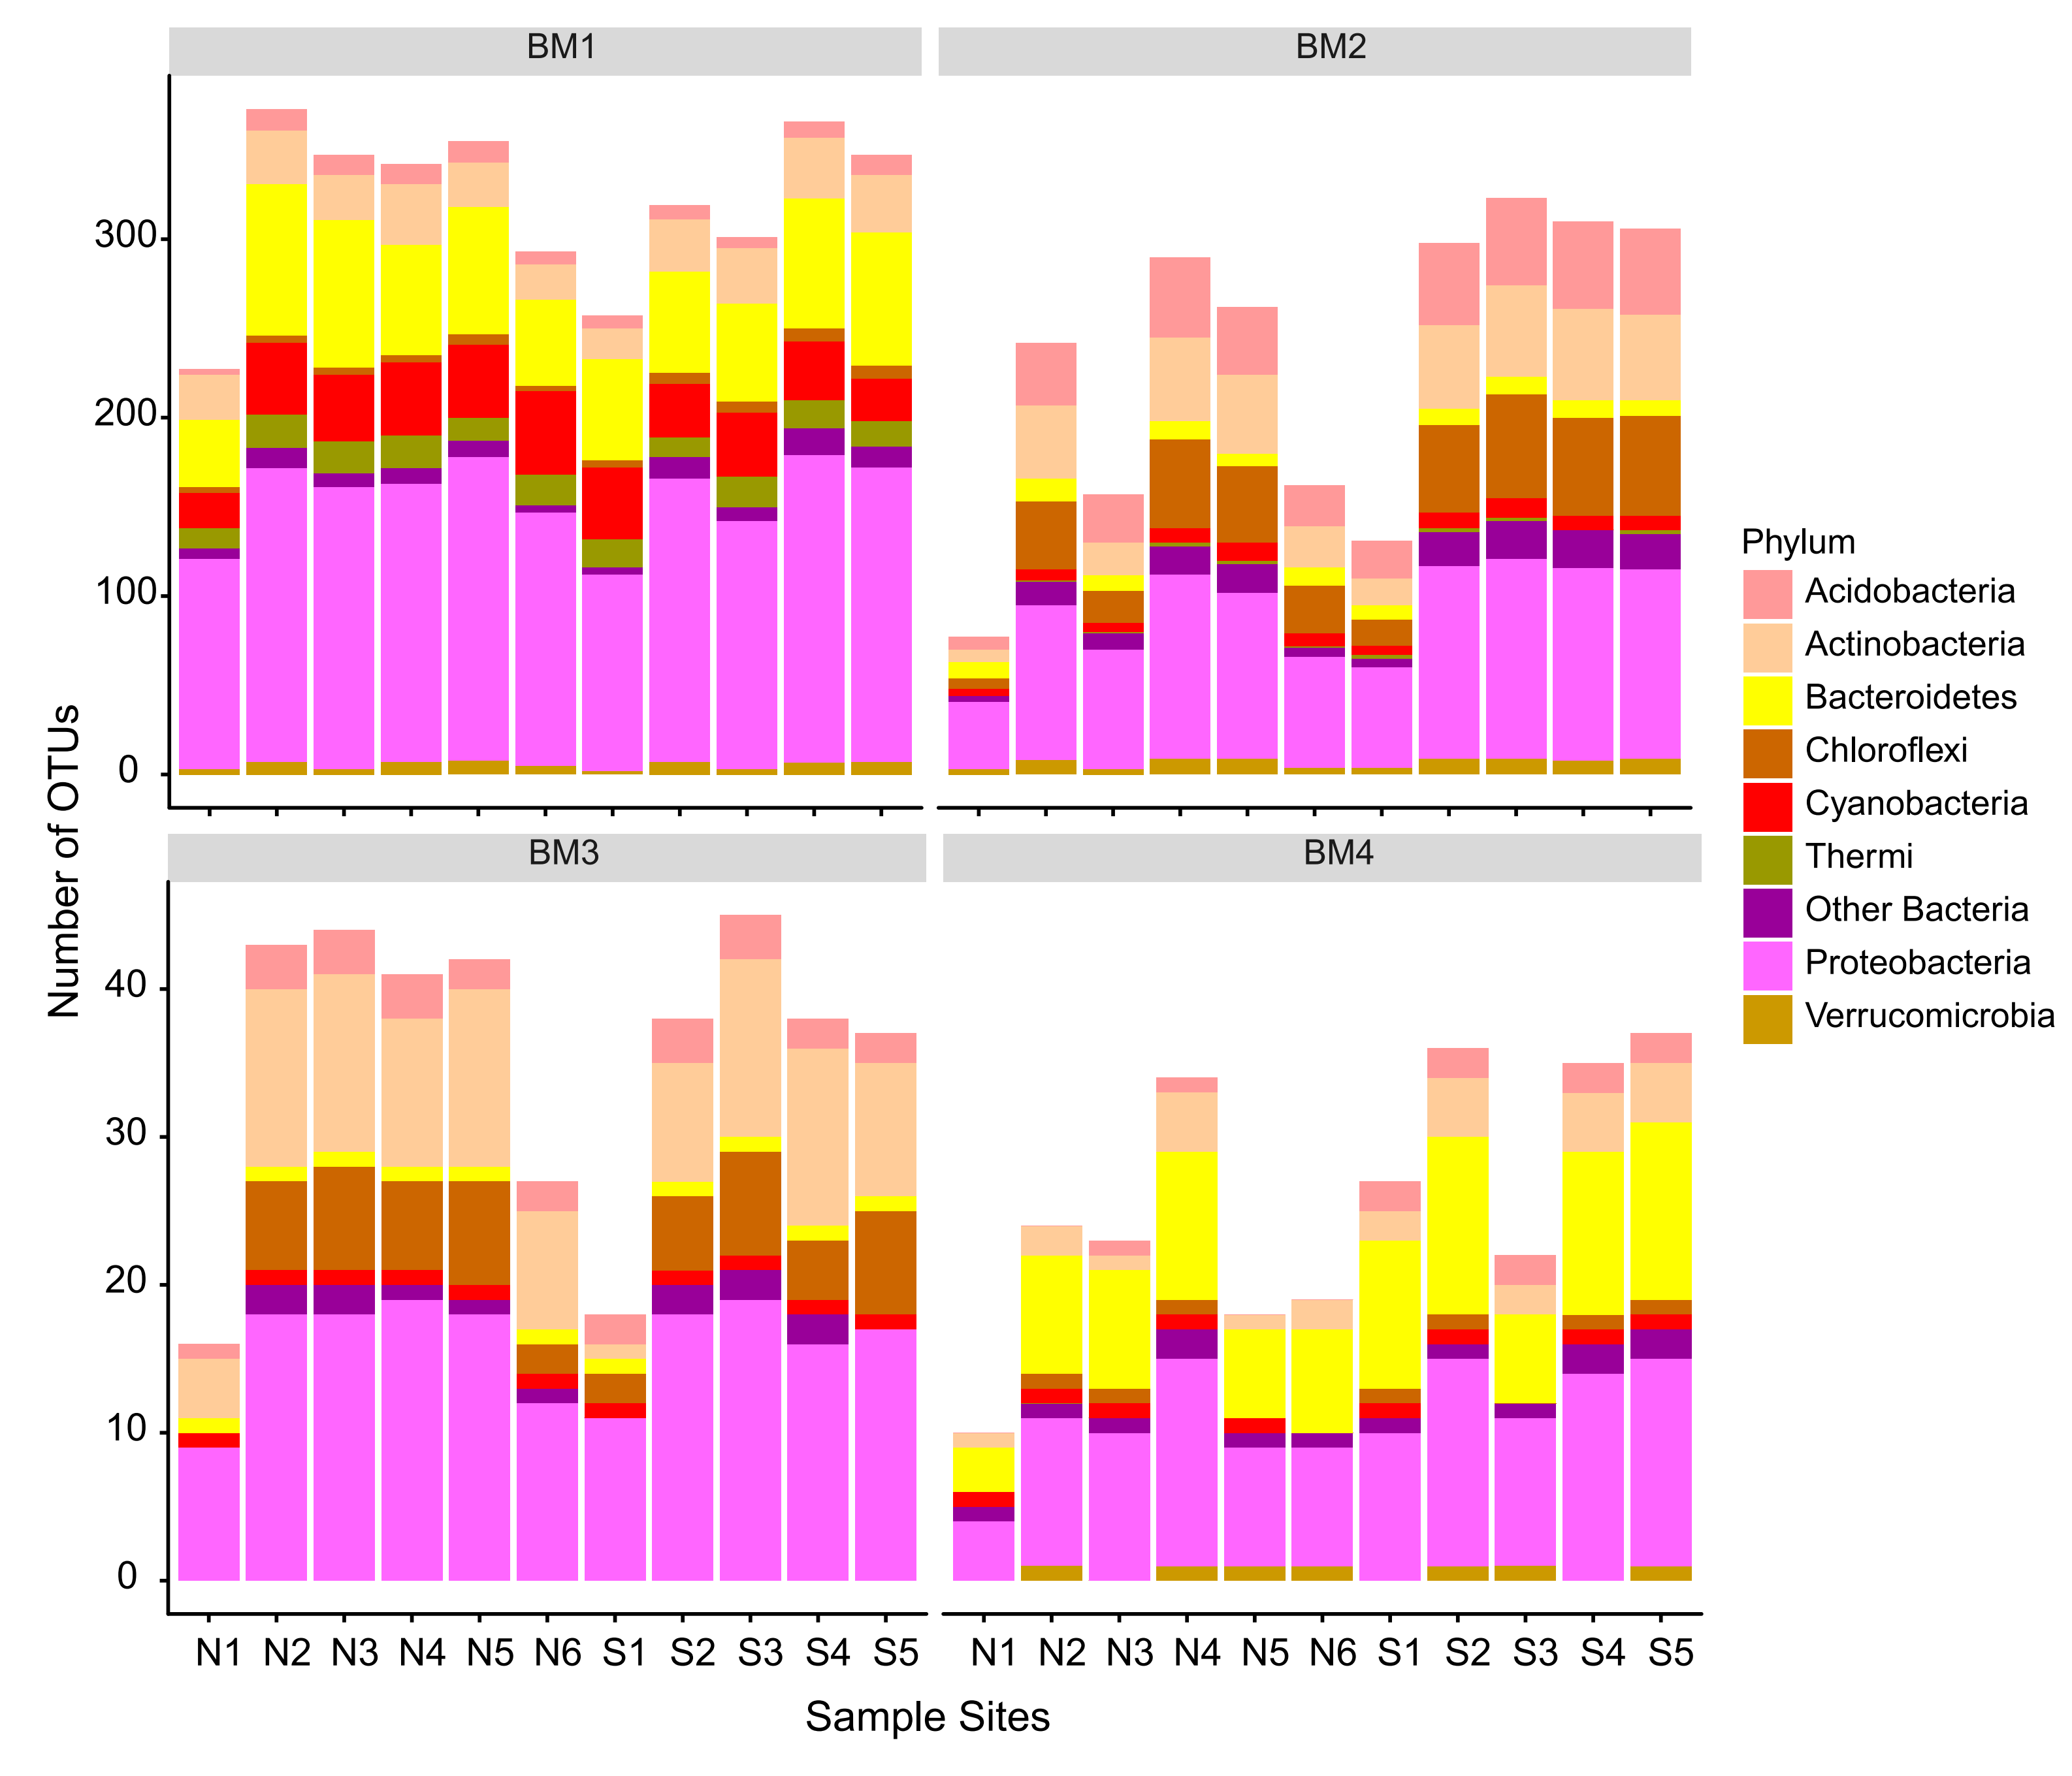
Figure S2 Distributions of OTUs across sample sites for fungal modules
