Sup. 4A. Cells (%) in sub-G1 phase

A549 | CTR | 24h | 48h | 72h
Exp. 1 | 4.3 | 31.4 | 76.2 | 62.6
 | 6.1 | 27.6 | 76.7 | 63.6
 | 2.2 | 31.8 | 72.1 | 63.1
Exp. 2 | 1.9 | 31.6 | 58.8 | 62.1
 | 1.7 | 33.1 | 48.2 | 62.2
 | 1.7 | 32.4 | 50.8 | 62.0
Exp. 3 | 5.8 | 23.3 | 63.9 | 64.1
 | 6.6 | 17.3 | 69.1 | 64.2
 | 7.2 | 22.1 | 66.5 | 64.9
Mean | 4.2 | 27.8 | 64.7 | 63.2
Std. Dev. | 2.3 | 5.7 | 10.3 | 1.1

A427 | CTR | 24h | 48h | 72h
Exp. 1 | 10.1 | 20.9 | 75.4 | 85.2
 | 12.8 | 16.6 | 76.9 | 84.9
 | 12.4 | 12.2 | 51.2 | 84.6
Exp. 2 | 5.4 | 7.1 | 91.6 | 83.6
 | 9.6 | 17.9 | 79.7 | 83.6
 | 13.8 | 12.7 | 79.9 | 83.5
Exp. 3 | 14.1 | 27.5 | 67.1 | 84.4
 | 12.0 | 25.5 | 66.3 | 83.8
 | 17.0 | 30.0 | 60.1 | 83.0
Mean | 11.9 | 18.9 | 72.0 | 84.1
Std. Dev. | 3.3 | 7.7 | 12.1 | 0.7

Sup. 4B. TMRE low cells (%)

A549 | CTR | ICRP
Experiment 1 | 4.6 | 71.7
 | 4.4 | 76.2
 | 3.2 | 74.0
Experiment 2 | 1.9 | 75.6
 | 11.4 | 77.5
 | 8.0 | 76.5
Experiment 3 | 10.8 | 67.6
 | 15.3 | 68.0
 | 13.1 | 67.8
Mean | 8.1 | 72.8
STD.DEV. | 4.7 | 4.1

A427 | CTR | ICRP
Experiment 1 | 6.6 | 74.4
 | 5.9 | 70.2
 | 6.3 | 69.5
Experiment 2 | 12.3 | 70.1
 | 11.4 | 65.9
 | 11.8 | 62.9
Experiment 3 | 15.2 | 57.6
 | 15.5 | 71.7
 | 15.4 | 59.3
Mean | 11.1 | 66.8
STD.DEV. | 4.0 | 5.7

Representative histograms’ gating for SubG1

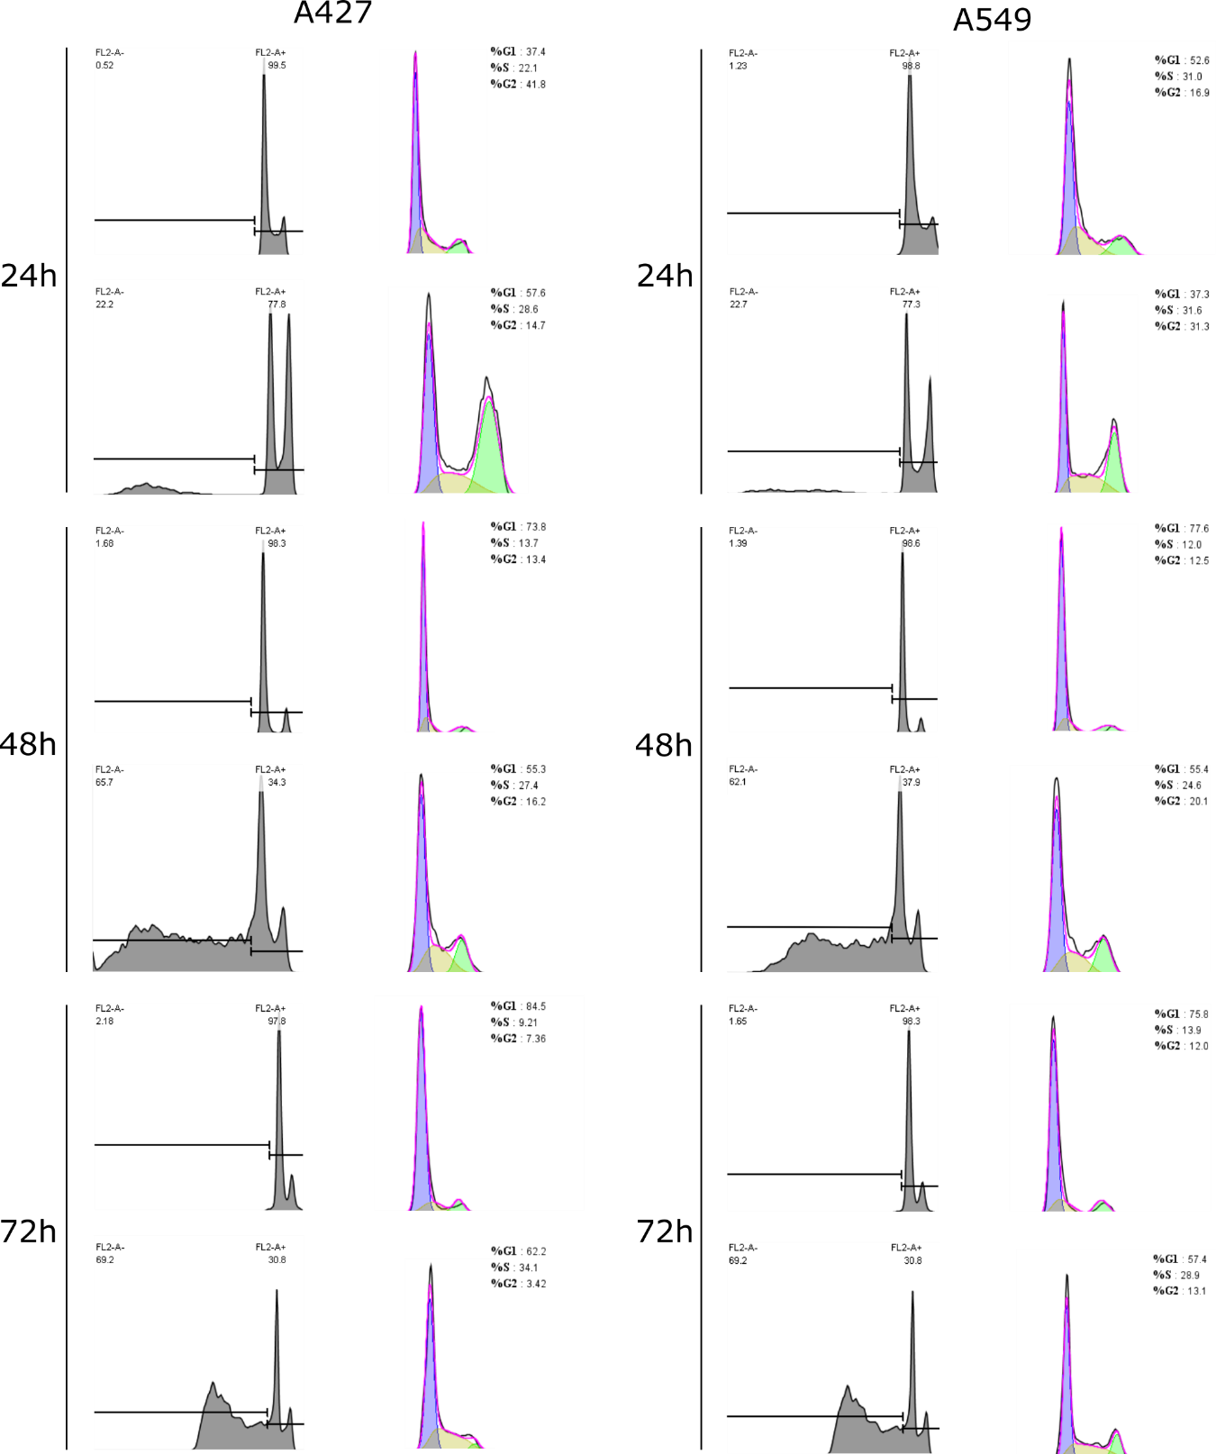

Representative histograms For TMRE

A549

A549 TMRE CTR.fcs A549 TMRE 1.5.fcs
A549 A549
8564 12399

A427

A427 TMRE CTR.fcs A427 TMRE 1.5.fcs
A427 A427
3723 11052

Sup. 4C. Cell death by Ann/PI (%) in presence or absence of QVD

A549 | CTR | ICRP | ETO | CTR + QVD | ICRP + QVD | ETO + QVD
Experiment 1 | 5.6 | 50.4 | 58.0 | 6.1 | 70.0 | 4.2
 | 5.0 | 48.0 | 60.1 | 3.5 | 68.0 | 8.4
 | 4.9 | 53.0 | 56.5 | 4.8 | 69.0 | 6.3
Experiment 2 | 3.2 | 40.6 | 62.1 | 4.2 | 49.0 | 7.2
 | 2.8 | 43.0 | 64.1 | 4.9 | 46.0 | 5.9
 | 5.8 | 41.1 | 60.6 | 5.5 | 43.0 | 4.5
Experiment 3 | 5.7 | 50.1 | 60.5 | 5.8 | 69.2 | 5.5
 | 5.7 | 50.3 | 65.8 | 4.2 | 44.4 | 4.9
 | 2.6 | 39.6 | 50.1 | 3.9 | 58.5 | 8.3
MEAN | 4.6 | 46.2 | 59.8 | 4.8 | 57.5 | 6.1
STD.DEV. | 1.3 | 5.1 | 4.6 | 0.9 | 11.8 | 1.6

A427 | CTR | ICRP | ETO | CTR + QVD | ICRP + QVD | ETO + QVD
Experiment 1 | 6.4 | 42.5 | 51.0 | 5.7 | 57.5 | 3.5
 | 6.2 | 47.5 | 51.4 | 6.1 | 55.4 | 4.1
 | 6.3 | 45.3 | 50.6 | 5.5 | 59.8 | 3.0
Experiment 2 | 7.4 | 41.9 | 50.4 | 4.5 | 60.7 | 3.5
 | 8.1 | 40.2 | 49.9 | 4.1 | 52.3 | 3.5
 | 7.7 | 41.0 | 50.9 | 5.0 | 66.9 | 3.0
Experiment 3 | 5.2 | 53.6 | 50.0 | 5.1 | 49.0 | 4.0
 | 3.2 | 51.7 | 50.1 | 4.6 | 43.6 | 4.1
 | 4.2 | 52.8 | 50.4 | 5.4 | 37.8 | 2.5
MEAN | 6.3 | 45.5 | 50.5 | 5.1 | 53.7 | 3.5
STD.DEV. | 1.6 | 5.0 | 0.5 | 0.6 | 9.1 | 0.6

Representative histograms

