Sup. 2 A. A549 and A427 cells (%) with AnnV+/PI- and AnnV+/PI+ staining

A549 | CTR | ICRP
 |  | 1.25 | 1.5 | 1.75
Experiment 1 | 5.6 | 16.7 | 50.4 | 78.5
 | 5.0 | 12.3 | 48.0 | 79.2
 | 4.9 | 14.8 | 53.0 | 78.9
Experiment 2 | 3.2 | 5.7 | 40.6 | 53.0
 | 2.8 | 6.8 | 43.0 | 50.5
 | 5.8 | 6.5 | 41.1 | 51.8
Experiment 3 | 5.7 | 9.2 | 50.1 | 54.0
 | 5.7 | 5.3 | 50.3 | 56.0
 | 2.6 | 16.3 | 39.6 | 55.0
MEAN | 4.6 | 10.4 | 46.2 | 61.9
STD.DEV. | 1.3 | 4.7 | 5.1 | 12.8

A427 | CTR | ICRP
 |  | 1.25 | 1.5 | 1.75
Experiment 1 | 6.4 | 25.5 | 42.5 | 86.0
 | 6.2 | 28.9 | 47.5 | 88.5
 | 6.3 | 32.2 | 45.3 | 87.0
Experiment 2 | 7.4 | 33.0 | 41.9 | 81.2
 | 8.1 | 30.8 | 40.2 | 77.9
 | 7.7 | 31.3 | 41.0 | 82.8
Experiment 3 | 5.2 | 5.2 | 53.6 | 67.0
 | 3.2 | 7.8 | 51.7 | 70.0
 | 4.2 | 6.6 | 52.8 | 68.5
MEAN | 6.3 | 24.3 | 45.5 | 80.0
STD.DEV. | 1.6 | 11.3 | 5.0 | 7.9

Sup. 2 B. APC-Annexin-V (FL4-H) and Propidium Iodide (FL2-H) staining representative dot plots

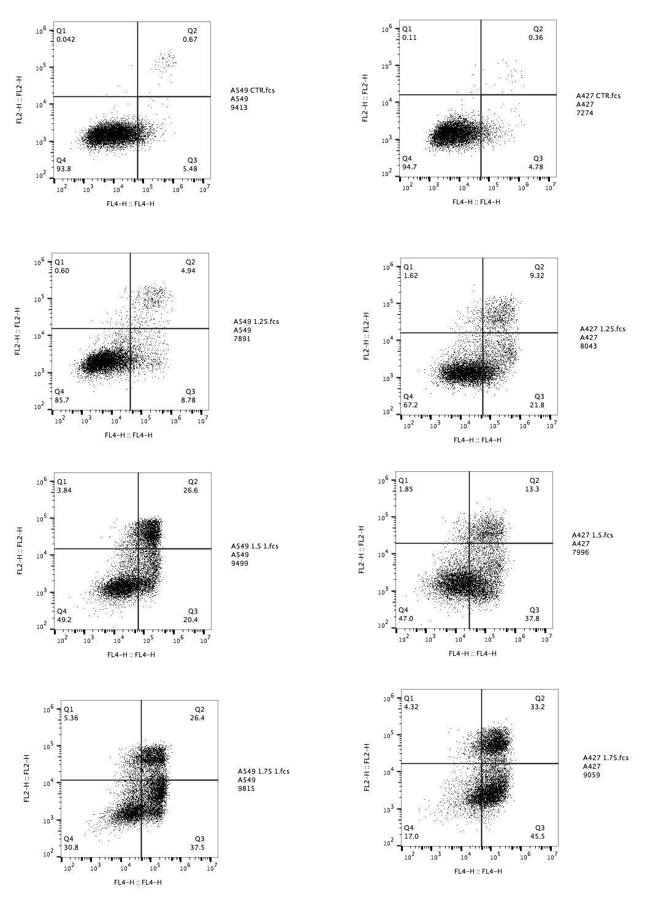

Sup. 2 C
Clonogenic analyses

A549 | # colonies
 | Control | ICRP
 |  | 1.0 U/mL | 1.25 U/mL | 1.5 U/mL
Exp. 1 | 45 | 8 | 2 | 0
 | 44 | 10 | 1 | 1
 | 47 | 9 | 0 | 1
Exp. 2 | 53 | 6 | 6 | 3
 | 47 | 7 | 2 | 2
 | 40 | 5 | 5 | 6
Exp. 3 | 41 | 8 | 3 | 0
 | 51 | 10 | 0 | 0
 | 48 | 5 | 5 | 5
Mean | 46.2 | 7.6 | 2.7 | 2.0
S.D. | 4.3 | 1.9 | 2.2 | 2.2
Clonogenicity | 100% | 3% | 1% | 1%
S.D. | 9% | 1% | 2% | 2%

A427 | # colonies
 | Control | ICRP
 |  | 1.0 U/mL | 1.25 U/mL | 1.5 U/mL
Exp. 1 | 49 | 18 | 4 | 3
 | 57 | 36 | 0 | 1
 | 52 | 7 | 0 | 1
Exp. 2 | 45 | 15 | 1 | 2
 | 36 | 10 | 0 | 0
 | 41 | 11 | 5 | 0
Exp. 3 | 50 | 5 | 0 | 1
 | 38 | 29 | 5 | 1
 | 55 | 14 | 0 | 2
Mean | 47.0 | 16.1 | 1.7 | 1.2
S.D. | 7.4 | 10.3 | 2.3 | 1.0
Clonogenicity | 100% | 7% | 1% | 1%
S.D. | 16% | 1% | 3% | 2%

