Trends in cognitive performance in the periods of pre-2011 vs. post-2011

Presurgical (the complete cohort)
Source SS df MS F Prob>F
------------------------------------------------
Groups 98.7 1 98.721 0.25 0.6188
Error 75122.6 189 397.474
Total 75221.3 190

Postsurgical (the complete cohort)

Source SS df MS F Prob>F
-----------------------------------------------
Groups 91.7 1 91.662 0.2 0.654
Error 69971.6 154 454.361
Total 70063.3 155

IQ/DQ change (the complete cohort)
Source SS df MS F Prob>F
------------------------------------------------
Groups 8 1 7.99 0.08 0.7747
Error 14766.6 152 97.1489
Total 14774.6 153

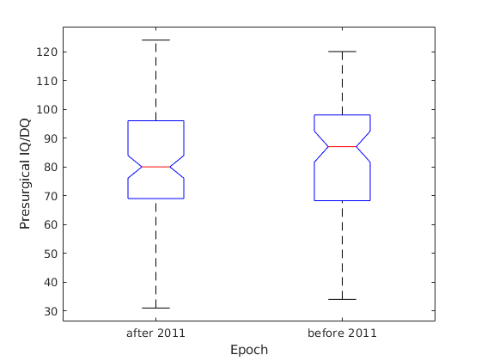
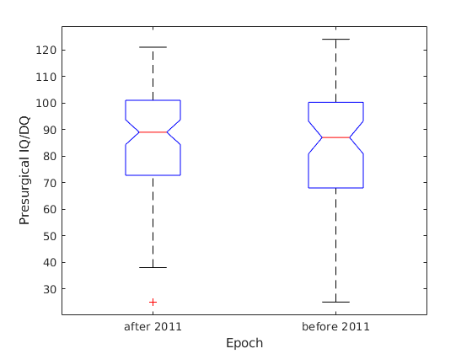
Postsurgical IQ/DQ

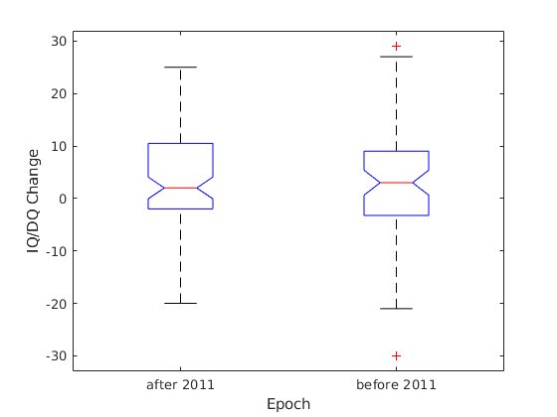
>> summary
TLE 93
XTLE 94
HEMI 16

TLE presurgical
Source SS df MS F Prob>F
------------------------------------------------
Groups 319.97 1 319.965 0.89 0.3472
Error 31165.99 87 358.23
Total 31485.96 88

TLE postsurgical
Source SS df MS F Prob>F
-----------------------------------------------
Groups 18.2 1 18.219 0.05 0.8227
Error 25587.9 71 360.393
Total 25606.1 72

TLE change
Source SS df MS F Prob>F
-----------------------------------------------
Groups 7.8 1 7.8028 0.09 0.7691
Error 6287.47 70 89.8211
Total 6295.28 71
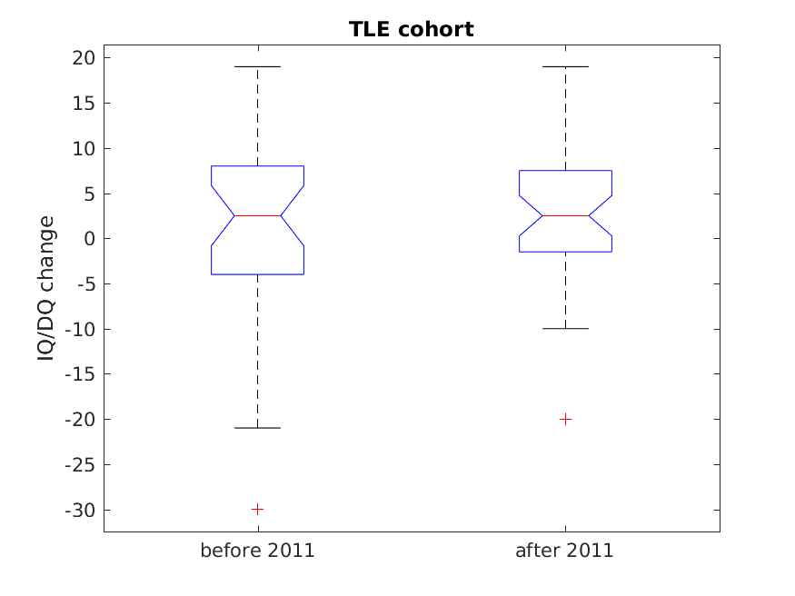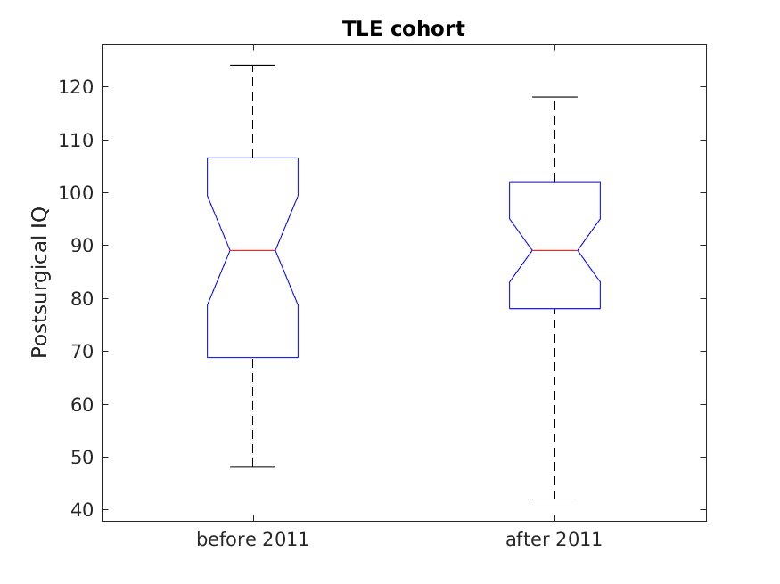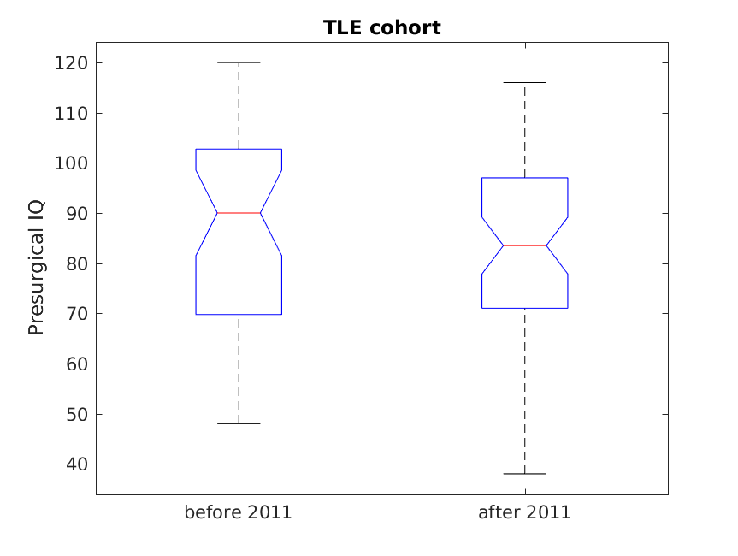 XTLE presurgical
Source SS df MS F Prob>F
-----------------------------------------------
Groups 128.6 1 128.595 0.36 0.5485
Error 30839.5 87 354.476
Total 30968 88

XTLE Postsurgical
Source SS df MS F Prob>F
-----------------------------------------------
Groups 243.4 1 243.388 0.47 0.4969
Error 37586.1 72 522.029
Total 37829.5 73

XTLE IQ/DQ Change
Source SS df MS F Prob>F
-----------------------------------------------
Groups 0.78 1 0.7841 0.01 0.9282
Error 6800.89 71 95.7871
Total 6801.67 72
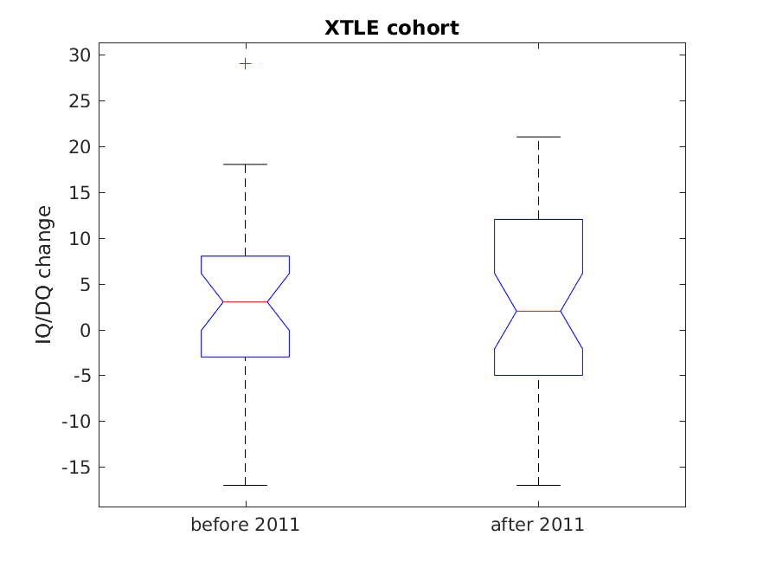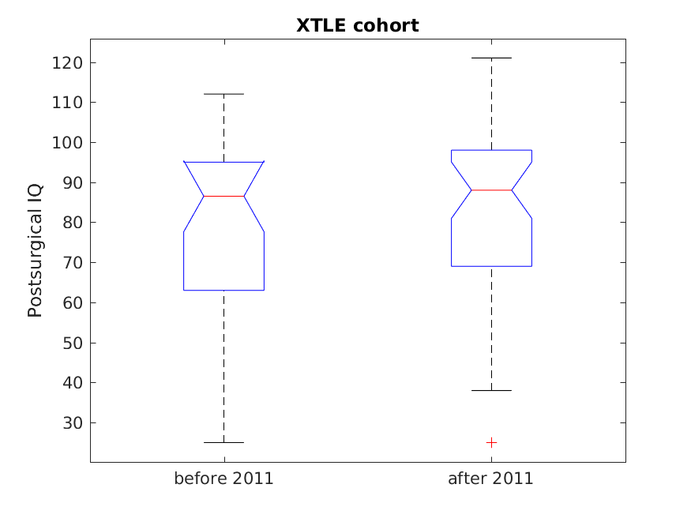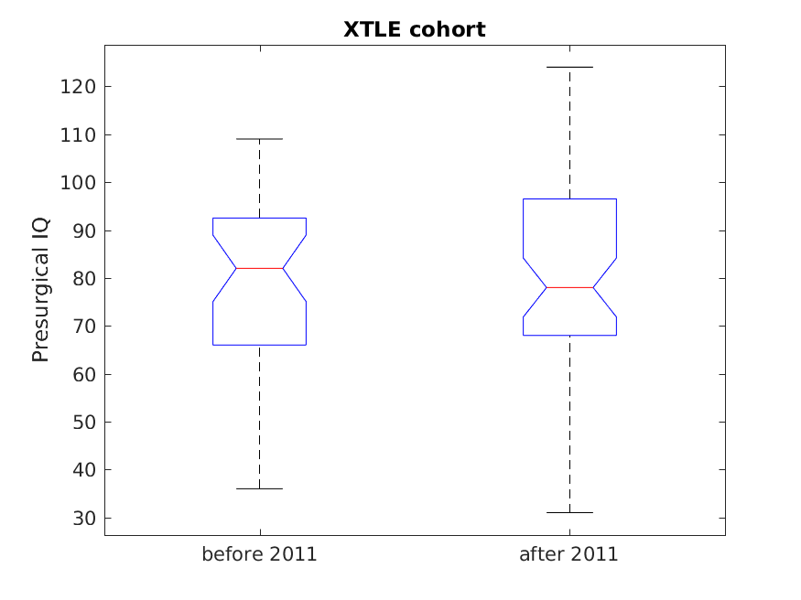
HEMI presurgical
Source SS df MS F Prob>F
-----------------------------------------------
Groups 344.74 1 344.741 0.52 0.4869
Error 7326.18 11 666.017
Total 7670.92 12

HEMI Postsurgical
Source SS df MS F Prob>F
--------------------------------------------
Groups 283.5 1 283.5 0.48 0.5117
Error 4154.5 7 593.5
Total 4438 8

HEMI IQ/DQ Change
Source SS df MS F Prob>F
-----------------------------------------------
Groups 90.865 1 90.8651 1.62 0.2441
Error 393.357 7 56.1939
Total 484.222 8 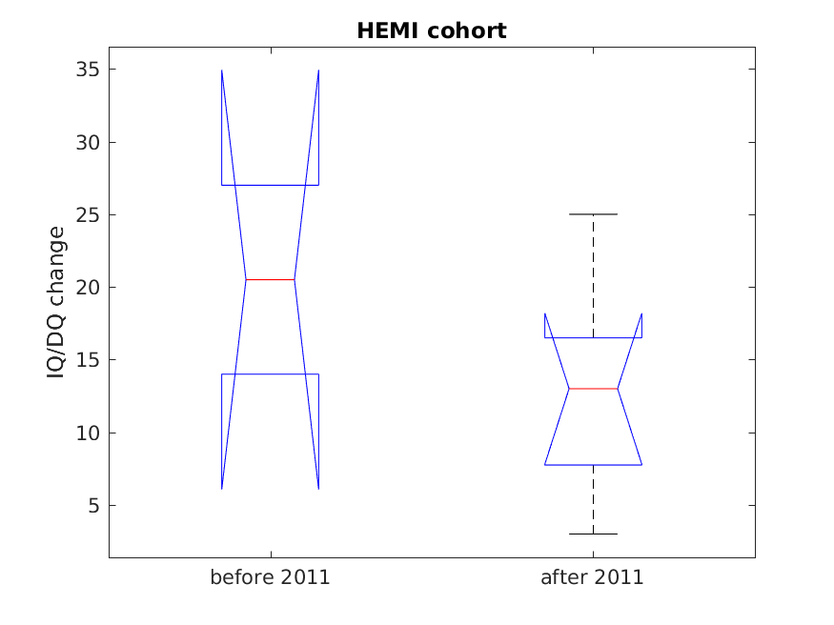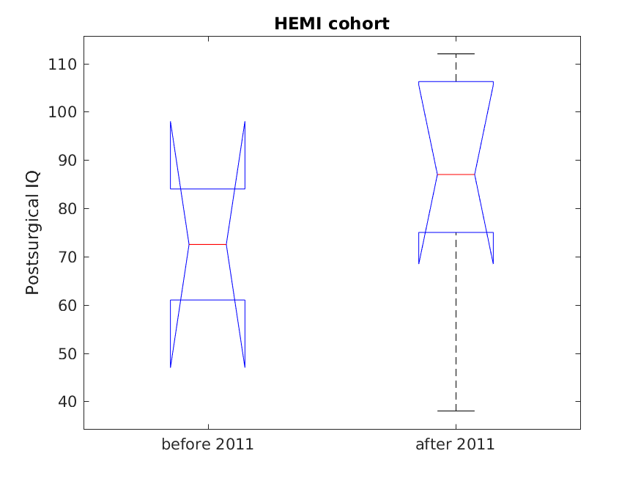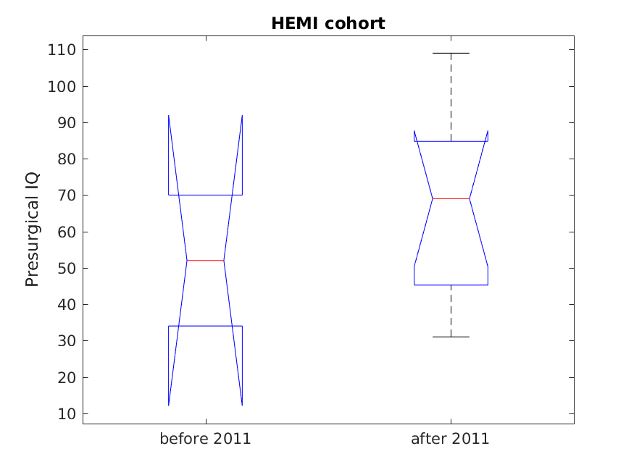
Acquired vs. congenital lesions (comparison between the periods)
>> summary
acquired 19
congenital 153
<undefined> 3

Congenital Presurgical
Source SS df MS F Prob>F
------------------------------------------------
Groups 53.2 1 53.22 0.14 0.7103
Error 54163.4 141 384.138
Total 54216.7 142

Congenital Postsurgical
Source SS df MS F Prob>F
------------------------------------------------
Groups 9.4 1 9.392 0.02 0.8903
Error 56995.7 116 491.342
Total 57005.1 117

Congenital IQ/DQ Change
Source SS df MS F Prob>F
------------------------------------------------
Groups 10 1 10.0188 0.11 0.7428
Error 10556.4 114 92.6003
Total 10566.4 115
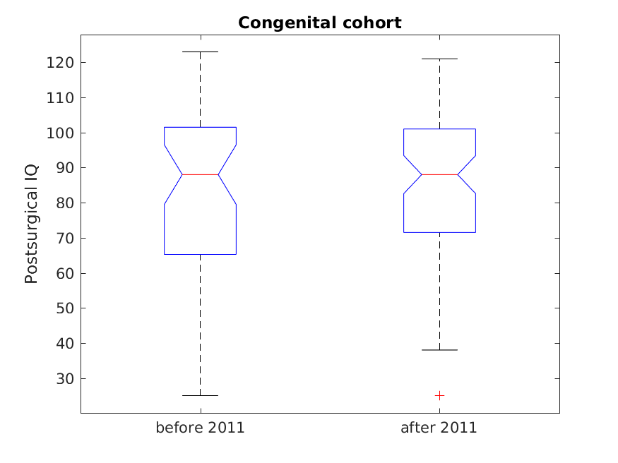
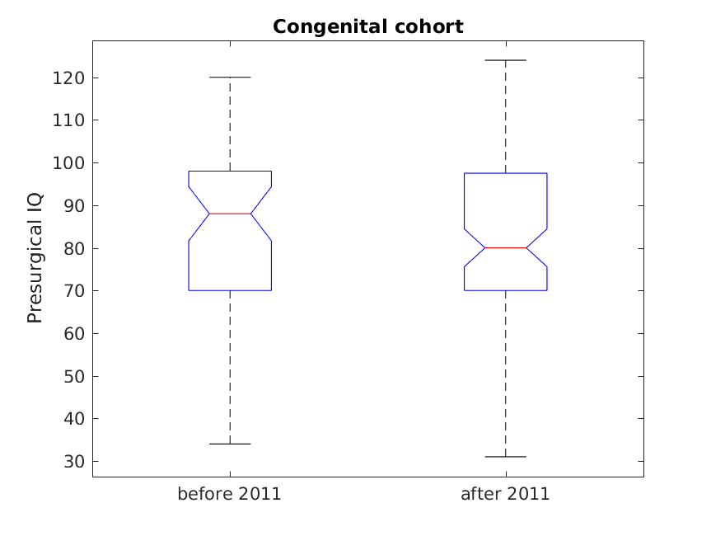

Acquired cohort

Acquired Presurgical
Source SS df MS F Prob>F
----------------------------------------------
Groups 365.76 1 365.76 0.7 0.4154
Error 8371.35 16 523.209
Total 8737.11 17

Acquired Postsurgical
Source SS df MS F Prob>F
-----------------------------------------------
Groups 13.15 1 13.149 0.03 0.8581
Error 4731.21 12 394.267
Total 4744.36 13

Acquired IQ/DQ Change
Source SS df MS F Prob>F
-----------------------------------------------
Groups 56.01 1 56.006 0.49 0.4957
Error 1361.21 12 113.434
Total 1417.21 13
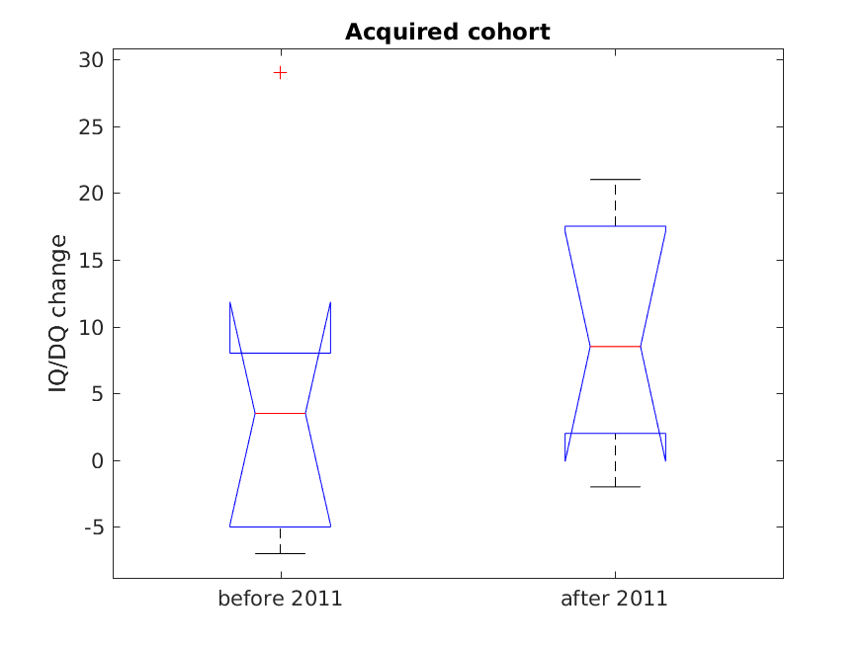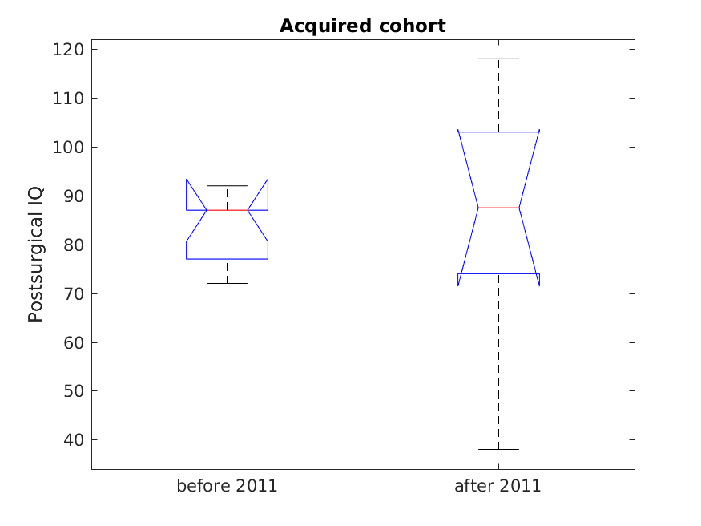Presu
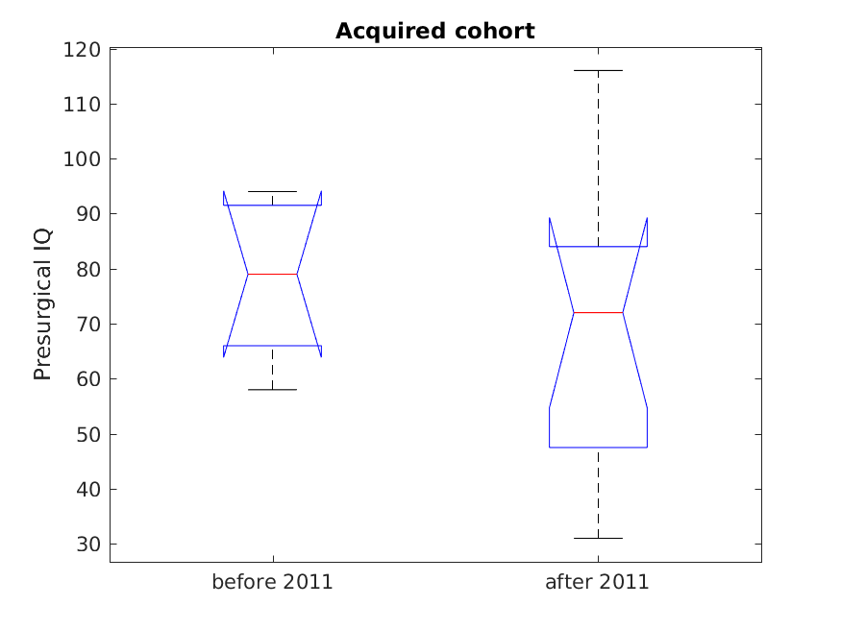
Acquired vs. congenital lesions (over the entire follow-up period)
>> summary
acquired 19
congenital 149
<undefined> 3

Presurgical
Source SS df MS F Prob>F
------------------------------------------------
Groups 1413.8 1 1413.81 3.52 0.0624
Error 62596.9 156 401.26
Total 64010.7 157

Postsurgical
Source SS df MS F Prob>F
------------------------------------------------
Groups 2.5 1 2.489 0.01 0.943
Error 61516.1 127 484.379
Total 61518.6 128

IQ/DQ Change:
Source SS df MS F Prob>F
-----------------------------------------------
Groups 331.2 1 331.17 3.49 0.0643
Error 11877.4 125 95.02
Total 12208.6 126
