Supplementary Material:

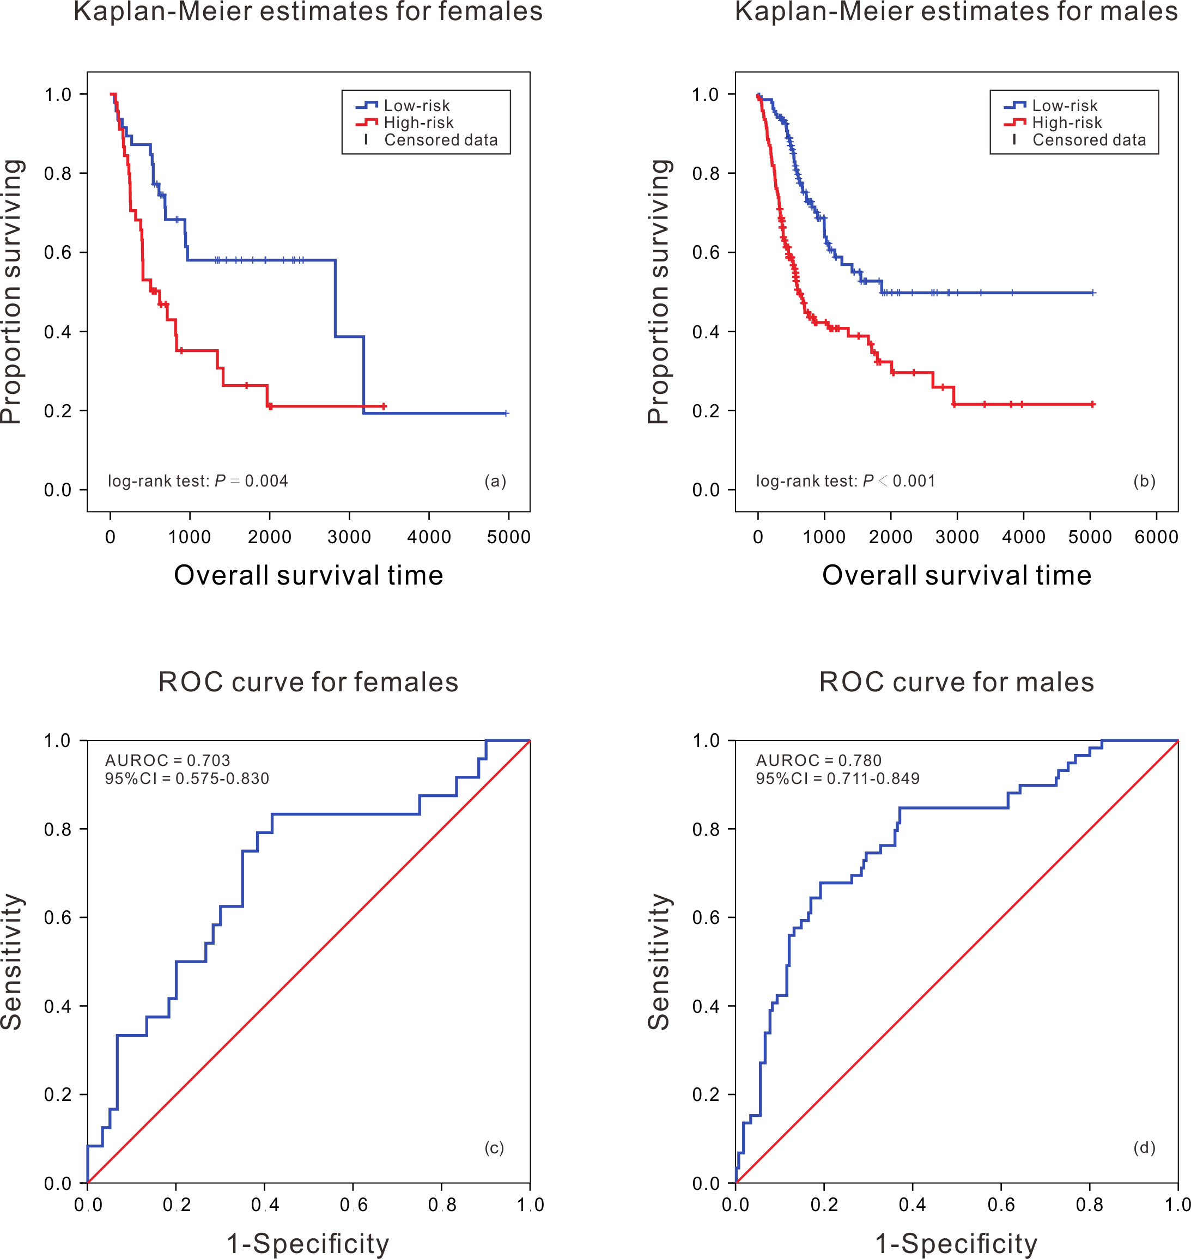

**Figure S1.** Kaplan-Meier analysis of survival difference between high and low risk BLCA patients and ROC curve of survival prediction by RNA prognostic biomarker in different gender groups.

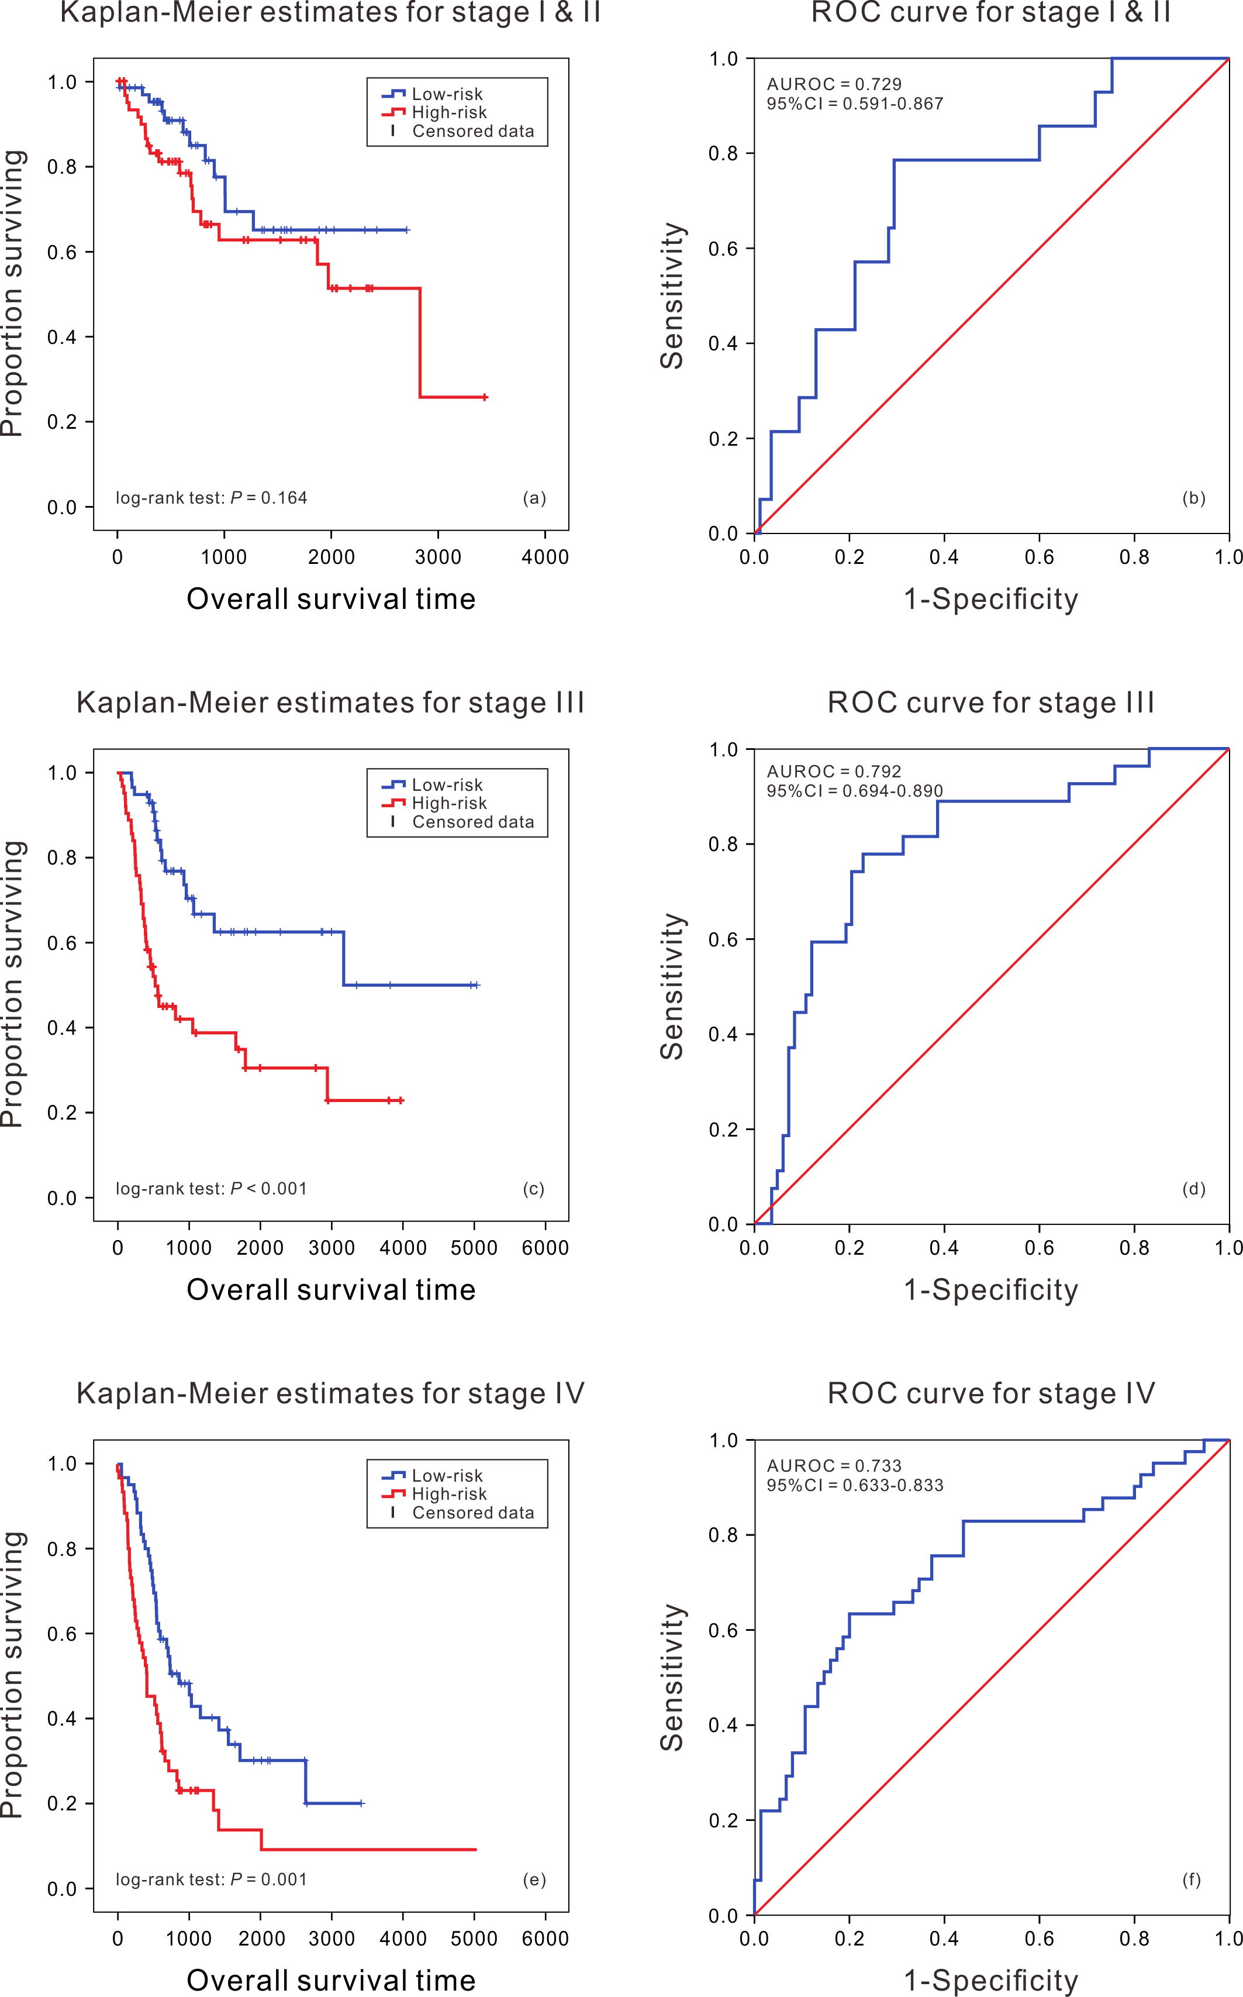

**Figure S2**. Kaplan-Meier analysis of survival difference between high and low risk BLCA patients and ROC curve of survival prediction by RNA prognostic biomarker in different clinical stages.

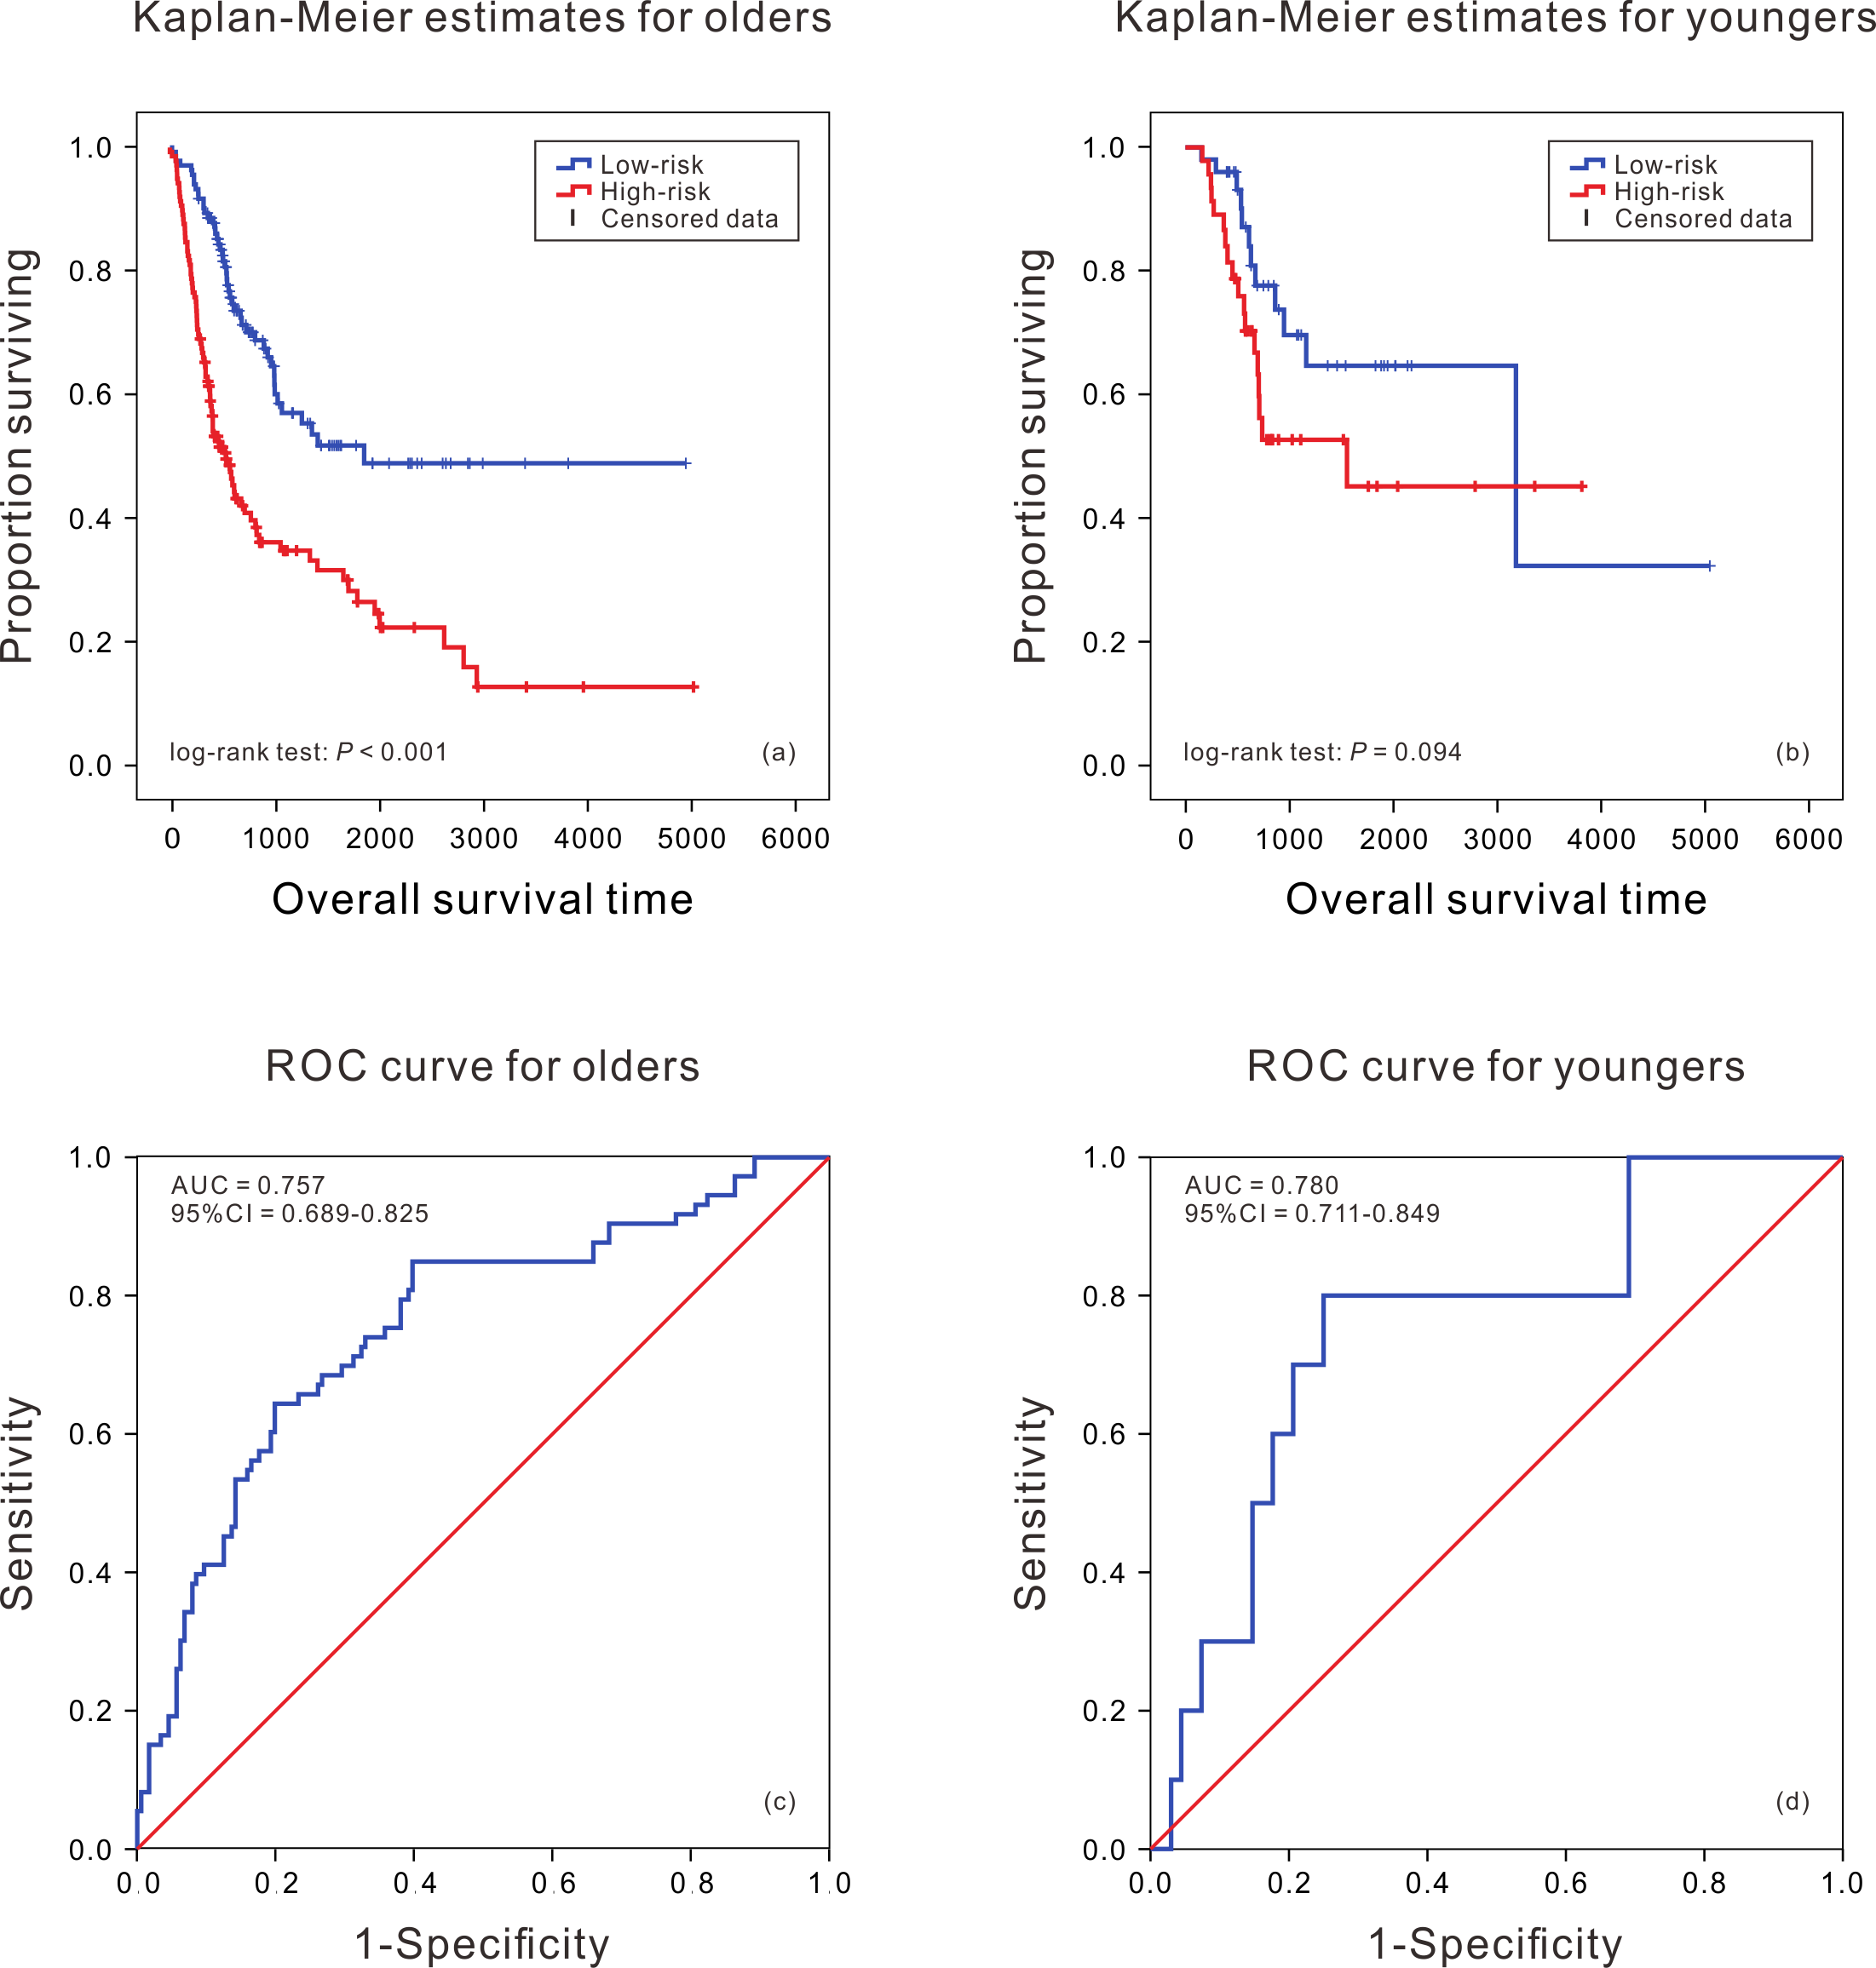

**Figure S3**. Kaplan-Meier analysis of survival difference between high and low risk BLCA patients and ROC curve of survival prediction by RNA prognostic biomarker in different age groups.

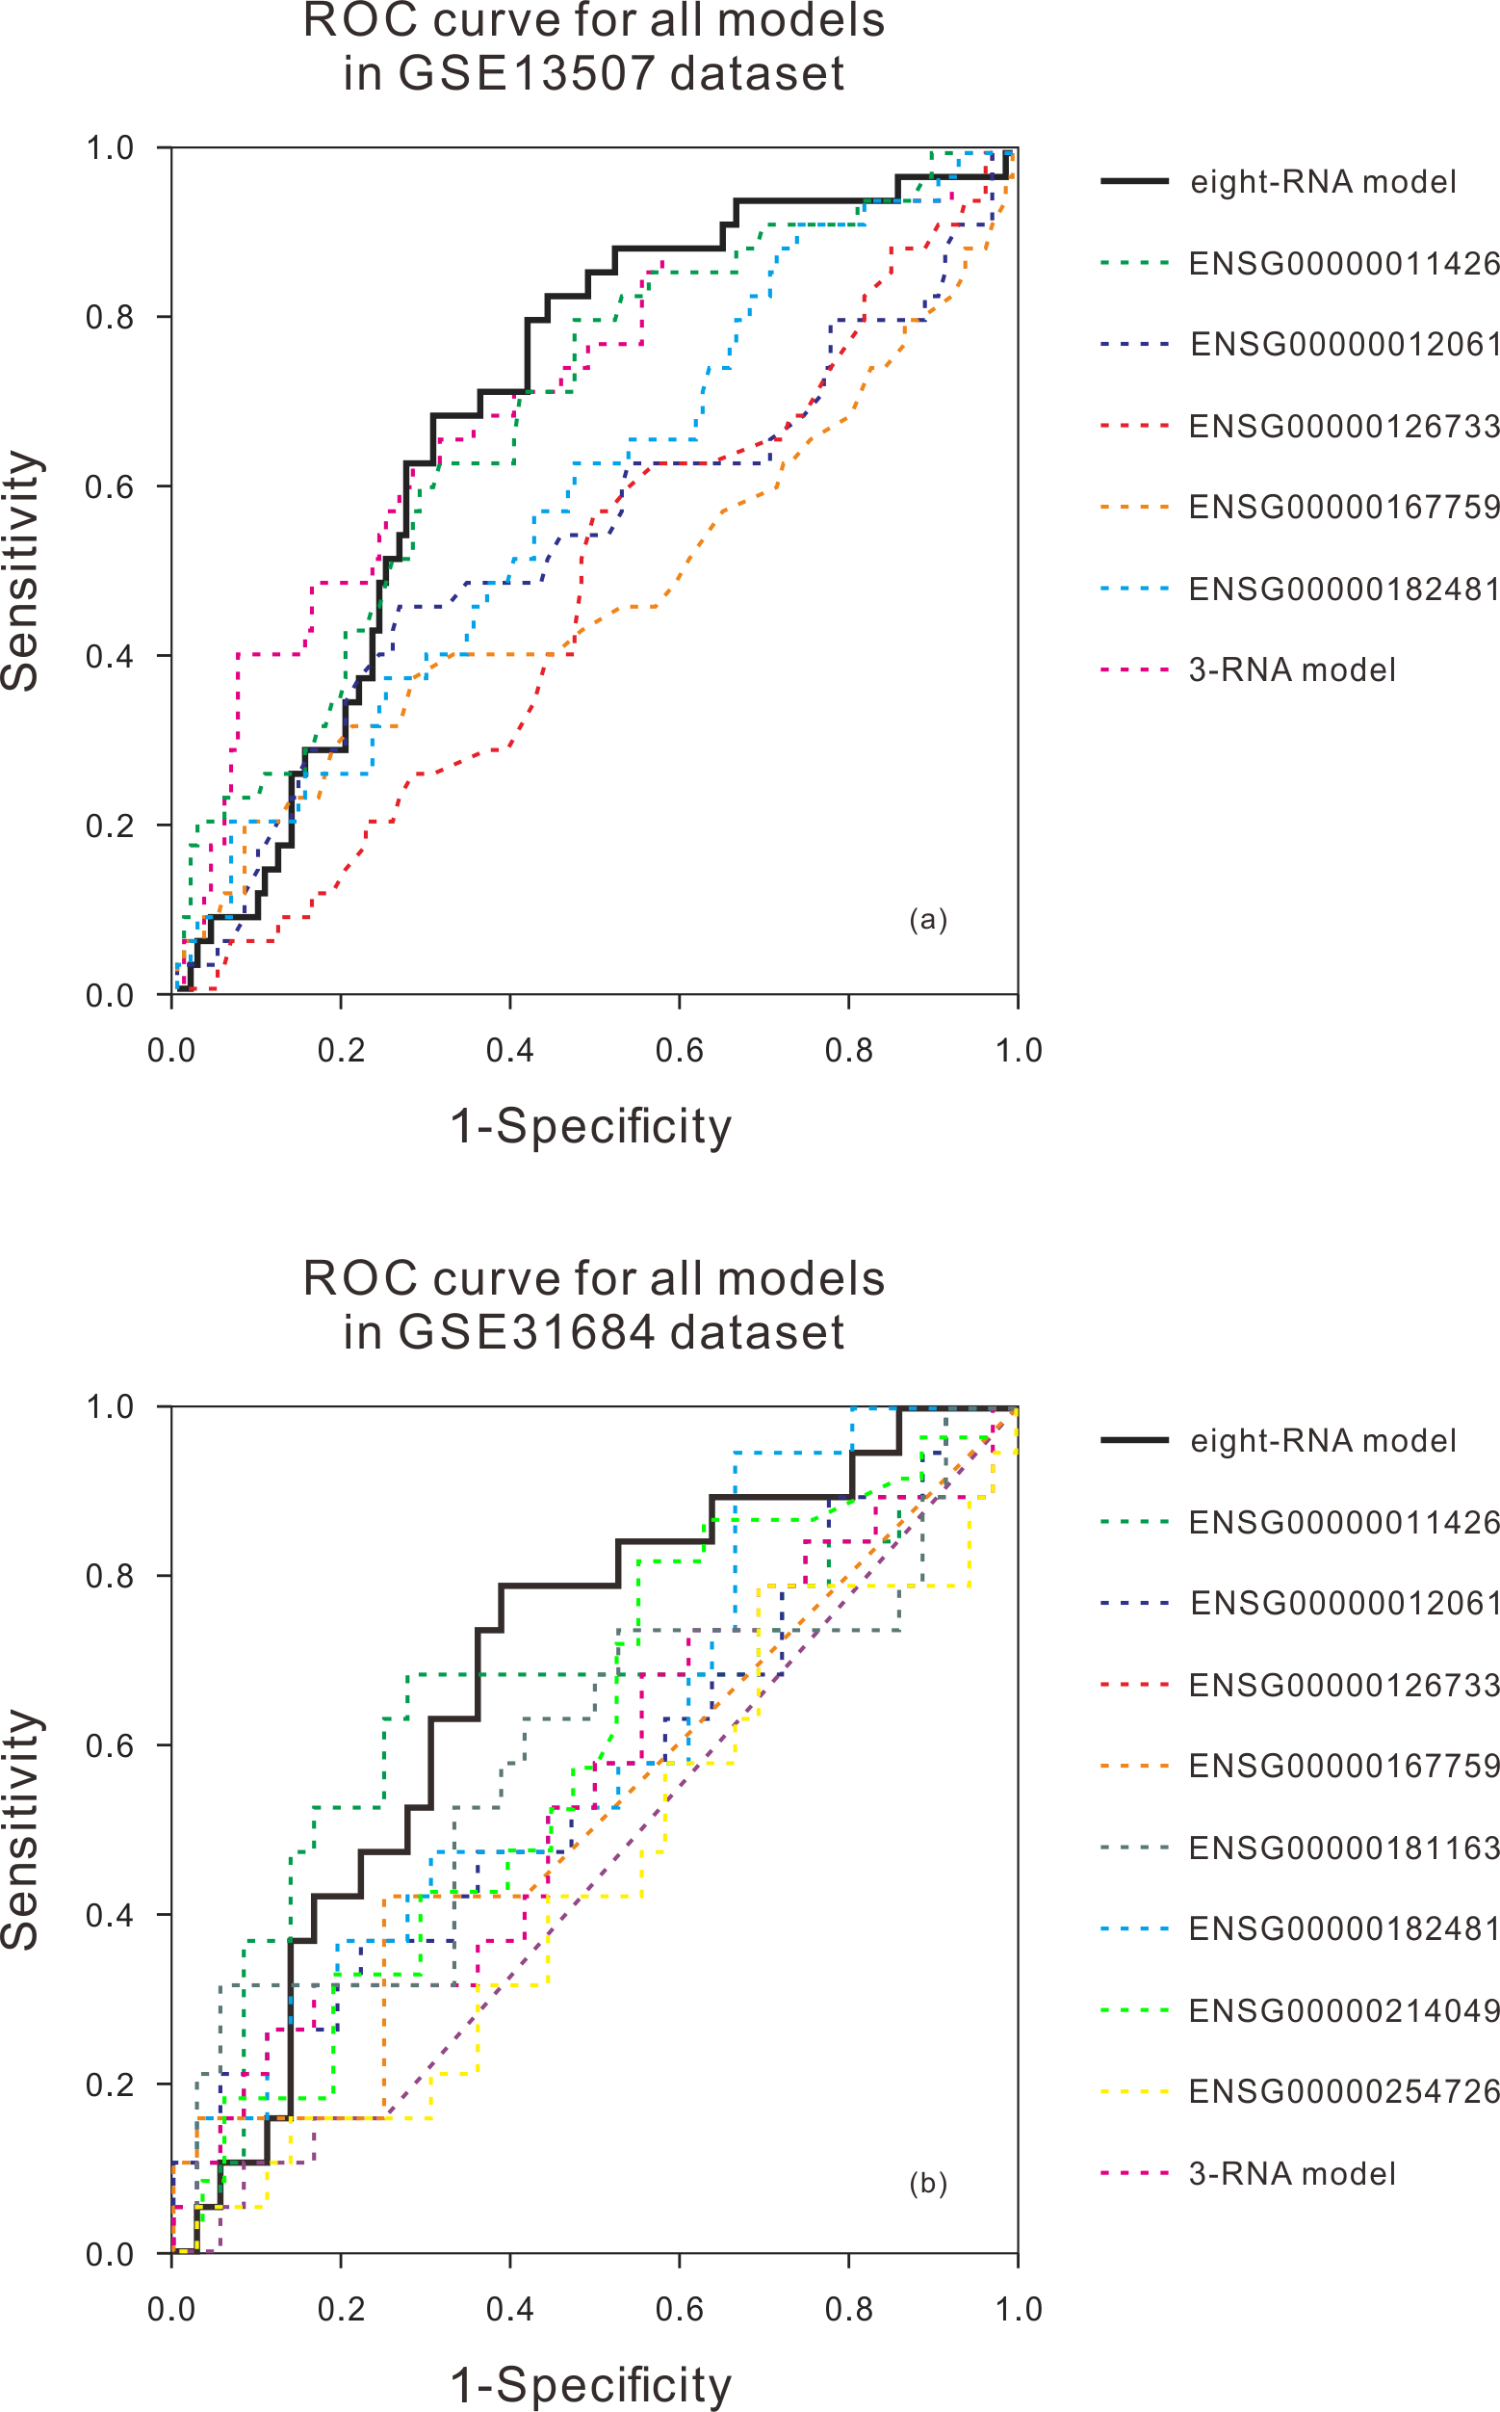

**Figure S4.** The ROC curve of prediction property of RNA prognostic biomarker combination for BLCA in comparison with other known prognostic biomarkers in GSE13507 dataset (a) and GSE31684 dataset (b).

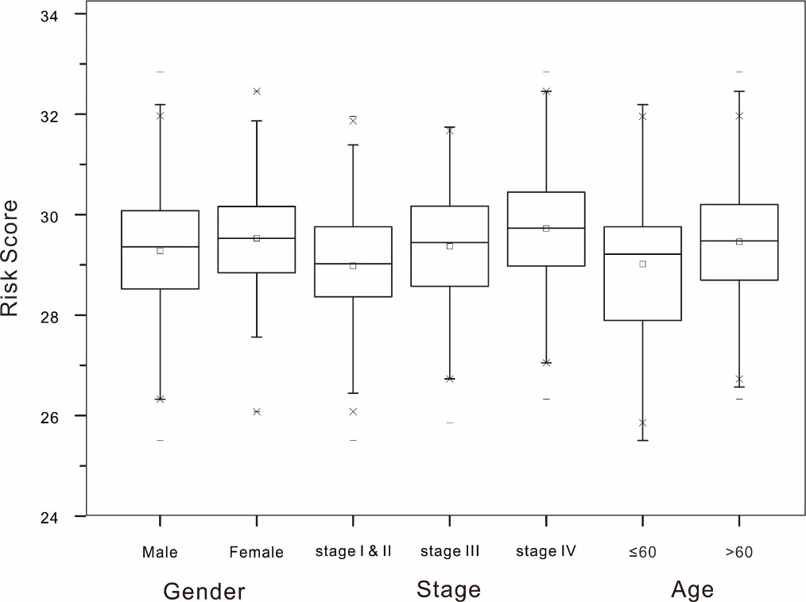

**Figure S5.** The boxplot of risk scores for different genders, cancer stages and ages.