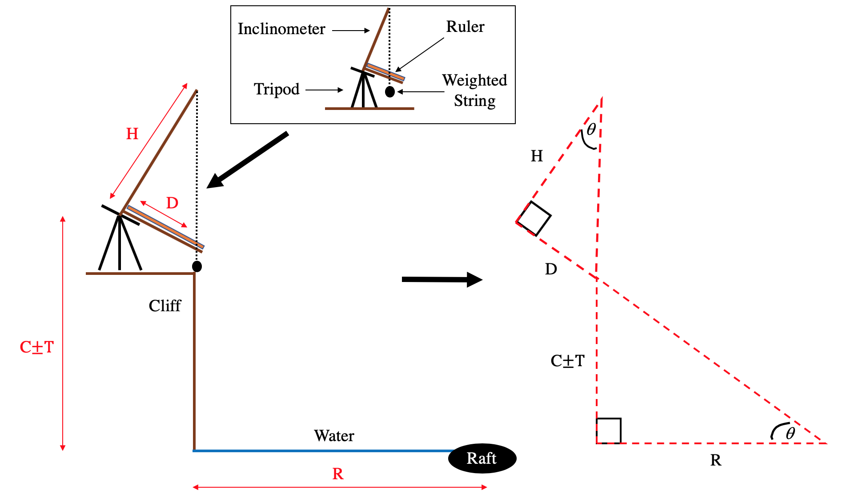

Illustration of equipment and method used to calculate Manx shearwater raft distance from shore. Where C = height of cliff at observation station plus tripod height (Garland Stone: 64.1 m; Skomer Head: 66.7 m; South Haven: 63.7 m; North Haven: 49.0 m), T = tide height relative to mean sea level, D = declination distance, H = height of inclinometer (0.895 m), and R is raft distance.

The inclinometer was mounted to a tripod which allowed it to be tilted and pointed towards a raft of Manx shearwaters. The weighted string then indicated a distance on the ruler which gave declination distance (D).

Because they are similar triangles and $tan= \frac{Opposite}{Adjacent}$ :

$$Large Triangle: tan = \frac{(C±T)}{R}$$

$$Small Triangle: tan = \frac{D}{H}$$

$$tan = \frac{(C±T)}{R} = \frac{D}{H}$$

$$\frac{(C±T)}{R} × R = \frac{D}{H} × R$$

$$\left(C±T\right)× H= \frac{D × R}{H} × H$$

$$\frac{\left(C±T\right) × H}{D}= \frac{D × R}{\text{D}}$$

$$Raft distance \left(R\right)= \frac{\left(C±T\right)}{D} ×H$$

