Fundamental niche unfilling and potential invasion risk of the slider turtle Trachemys scripta

Sayra Espindola, Juan L. Parra, Ella Vázquez-Domínguez
Supplemental Figure S1
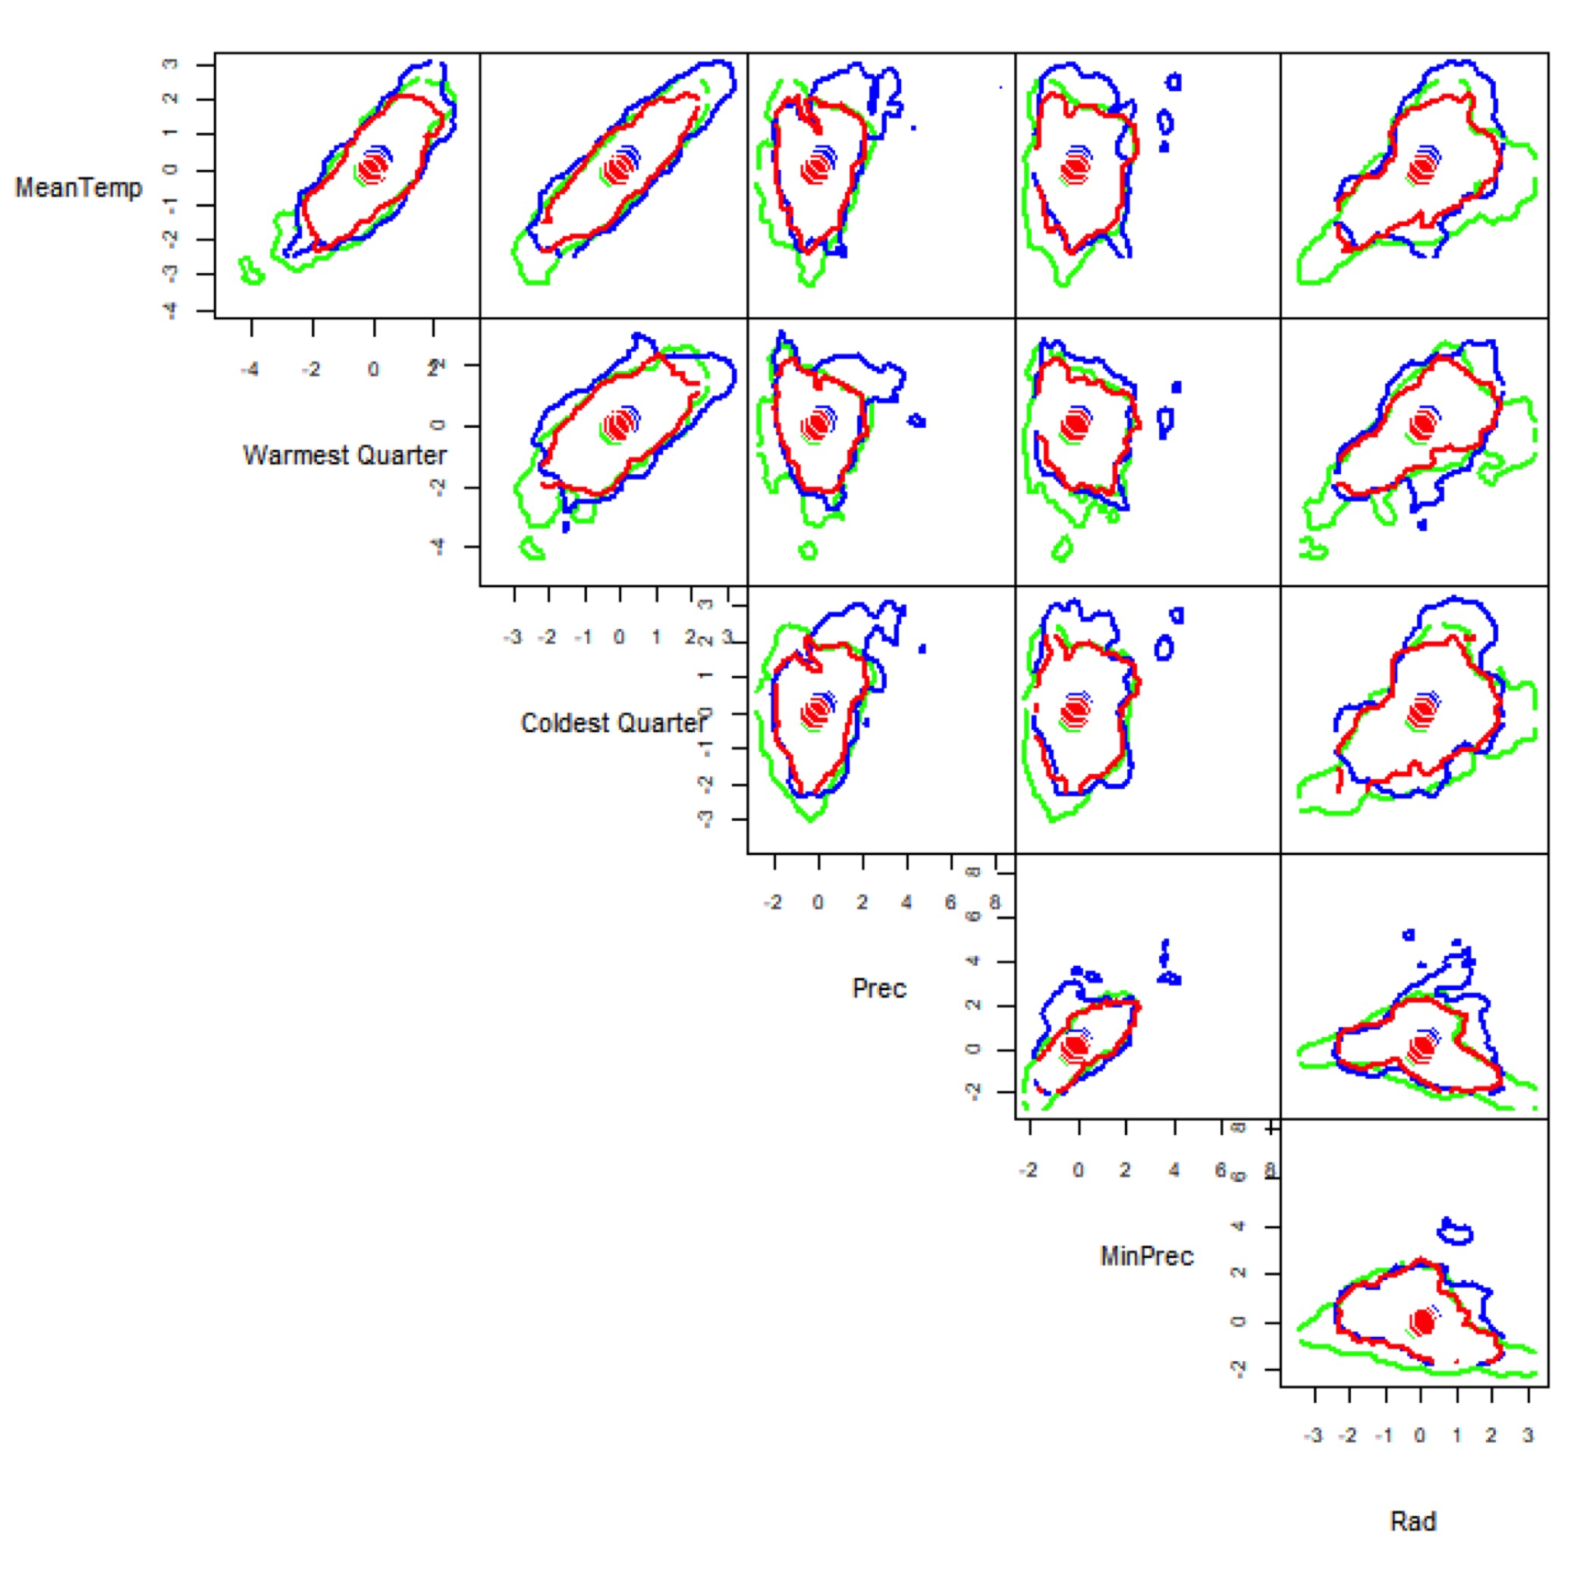
Figure S1. Six-dimensional hypervolumes for native and non-native Trachemys scripta. Estimated six-dimensional hypervolumes for native (green line), non-native (blue line), and intersection (red line) between Trachemys scripta native and non-native niches along the climatic space (Hypervolume package in R; Blonder et al. 2014). Variables were selected on the basis of the slider turtle’s natural history, and z-transformed for the analysis. Contours include 95% of simulated data.

