Table S1. Examples of Pilates exercises.
MESOCYCLE | EXERCISE FOCUSHED ON THE SPINE | EXERCISE FOCUSHED ON THE HIP | EXERCISE FOCUSHED ON THE PECTORAL GIRDLE
FAMILIARIZA-TION PERIOD (WEEKS 1-2) | Neck and dorsal spine flexion | Hip extension | Scapula abduction
 | 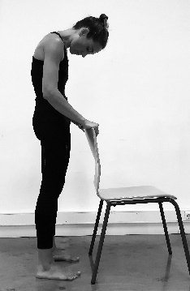 | 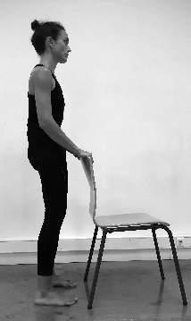 | 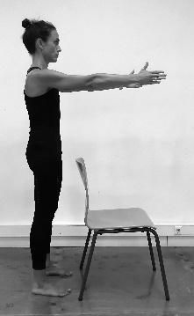
MESOCYCLE 1 (WEEKS 3-6) | Standing spine twist | Standing hip extension | Windmill arms seated on a chair
 | 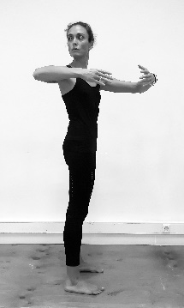 | 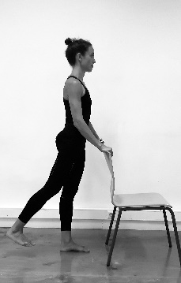 | 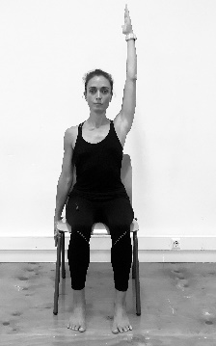
MESOCYCLE 2 (WEEKS 7-10) | Supine curl ups (chi ball) | Side leg lifts | Supine up shoulders  (elastic band)
 | 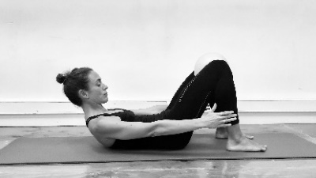 | 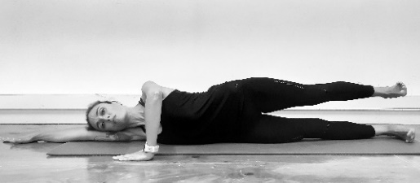 | 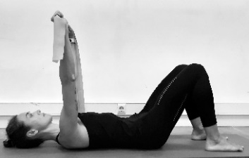
MESOCYCLE 3 (WEEKS 11-14) | The bridge | Side leg lifts (chi ball) | Supine windmill arms  (elastic band)
 | 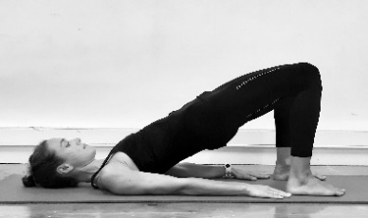 | 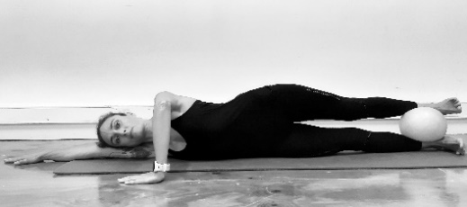 | 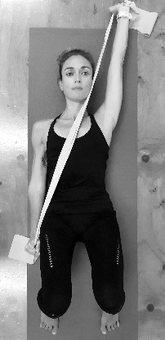
MESOCYCLE 4 (WEEKS 15-18) | Assisted roll up  (elastic band) | Femur arcs and windmill arms  (elastic band) | Curl ups and shoulder abduction (elastic band)
 | 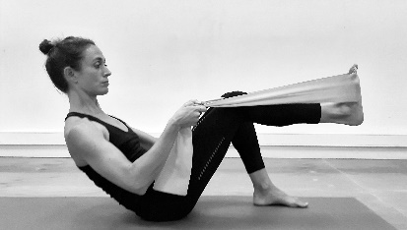 | 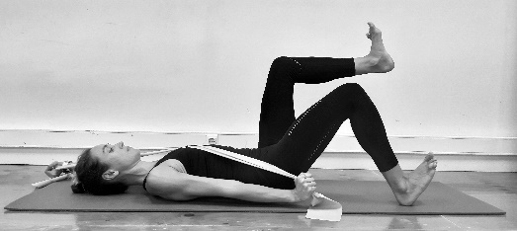 | 