PCR database
- The agarose electrophoresis of GPCR RACE product
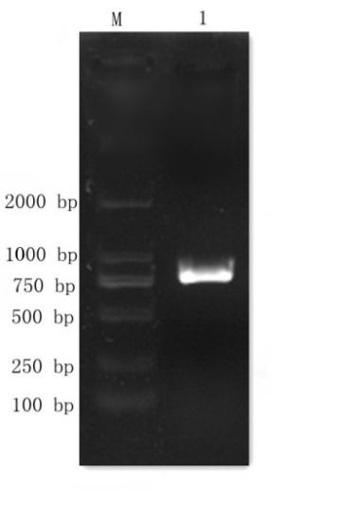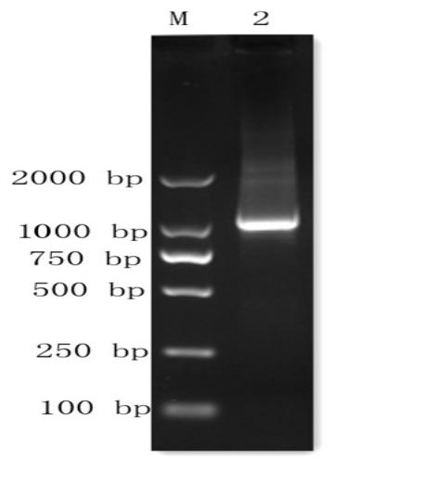
a b
Figure 1 RACE product of GPCR from P. aibuhitensis，a shows the result of 3' RACE，b shows the result of 5' Inner RACE
- The agarose electrophoresis of PKA RACE product

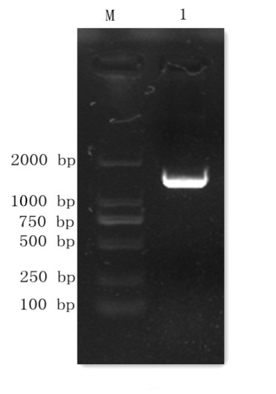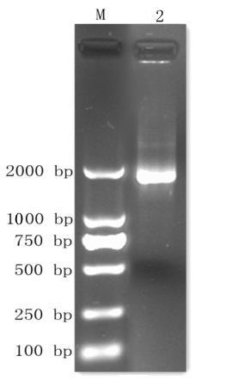
a b
Figure 2 RACE product of PKA from P. aibuhitensis，a shows the result of 3' Inner RACE， b shows the result of 5' RACE

