**Appendix A.**

Community structure

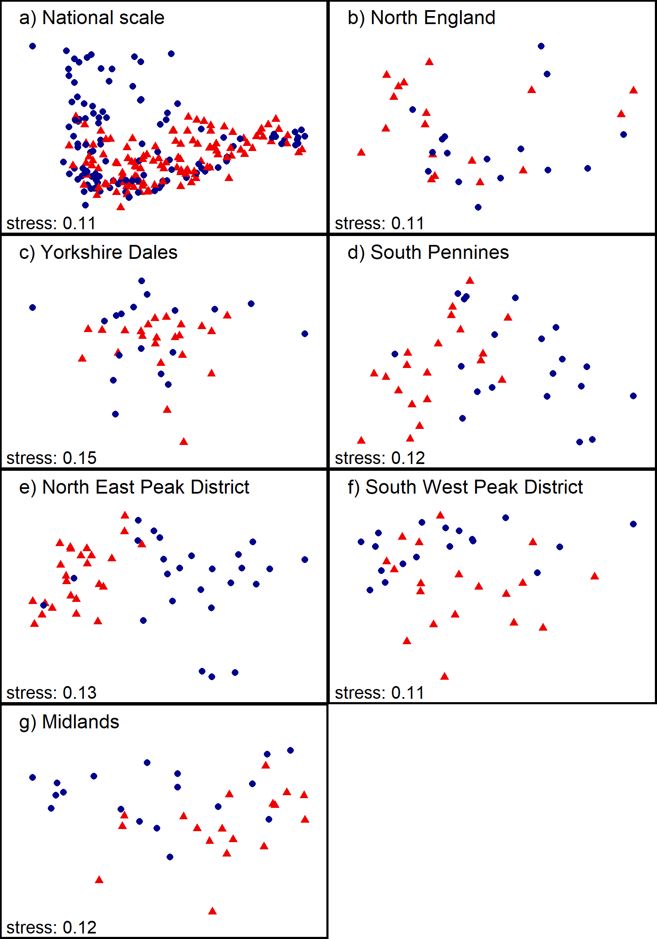  
**Figure S1**. NMDS ordination results including all spring samples on national (panel a) and regional scale (panels b-h), labelled according to *SiteType* (Step 1). Blue dots = control sites, red triangles = downstream sites.

**Table S1**. Results from PERMANOVA testing the significance of *Year*, *DCpair* and *Region* on community structure at control sites for separate spring (S) and autumn (A) samples (Step 3). Significant *p*-values are in bold font; *** = *p* ≤ 0.001; ** = *p* ≤ 0.01; * = *p* ≤ 0.05.

|  |  |  |  |  |  |  |  |  |  |  |
| --- | --- | --- | --- | --- | --- | --- | --- | --- | --- | --- |
| Region | Season | Year |  |  | DCpair |  |  | Region |  |  |
|  |  | pseudo-*F* | *R2* | *p* | pseudo-*F* | *R*2 | *p* | pseudo-*F* | *R*2 | *p* |
| National scale | Spring | 1.02 | 0.03 | 0.409 | 3.90 | 0.614 | **0.001**\*\*\* | 7.34 | 0.25 | **0.001**\*\*\* |
|  | Autumn | 0.96 | 0.03 | 0.502 | 5.44 | 0.681 | **0.001**\*\*\* | 9.82 | 0.30 | **0.001**\*\*\* |
| North England | Spring | 0.79 | 0.17 | 0.725 | 1.54 | 0.360 | 0.058 |  |  |  |
|  | Autumn | 0.79 | 0.16 | 0.724 | 3.24 | 0.541 | **0.001**\*\*\* |  |  |  |
| Yorkshire Dales | Spring | 0.80 | 0.15 | 0.778 | 3.74 | 0.609 | **0.001**\*\*\* |  |  |  |
|  | Autumn | 0.59 | 0.11 | 0.949 | 4.29 | 0.641 | **0.001**\*\*\* |  |  |  |
| South Pennines | Spring | 0.80 | 0.13 | 0.745 | 3.05 | 0.449 | **0.001**\*\*\* |  |  |  |
|  | Autumn | 0.61 | 0.10 | 0.917 | 5.11 | 0.577 | **0.001**\*\*\* |  |  |  |
| North East Peak District | Spring | 1.10 | 0.14 | 0.350 | 2.66 | 0.470 | **0.001**\*\*\* |  |  |  |
|  | Autumn | 1.15 | 0.14 | 0.263 | 3.21 | 0.517 | **0.001**\*\*\* |  |  |  |
| South West Peak District | Spring | 0.77 | 0.14 | 0.776 | 2.30 | 0.489 | **0.003**\*\* |  |  |  |
|  | Autumn | 0.69 | 0.12 | 0.874 | 3.25 | 0.556 | **0.001**\*\*\* |  |  |  |
| Midlands | Spring | 0.46 | 0.09 | 0.990 | 3.48 | 0.517 | **0.001**\*\*\* |  |  |  |
|  | Autumn | 0.65 | 0.11 | 0.948 | 2.58 | 0.408 | **0.001**\*\*\* |  |  |  |

**Table S2**. Results from PERMANOVA testing the significance of *Year*, *DCpair* and *Region* on community structure at downstream sites for separate spring (S) and autumn (A) samples (Step 3). Significant *p*-values are in bold font; *** = *p* ≤ 0.001; ** = *p* ≤ 0.01; * = *p* ≤ 0.05.

|  |  |  |  |  |  |  |  |  |  |  |
| --- | --- | --- | --- | --- | --- | --- | --- | --- | --- | --- |
| Region | Season | Year |  |  | DCpair |  |  | Region |  |  |
|  |  | pseudo-*F* | *R2* | *p* | pseudo-*F* | *R*2 | *p* | pseudo-*F* | *R*2 | *p* |
| National scale | Spring | 1.43 | 0.04 | **0.036**\* | 3.20 | 0.54 | **0.001**\*\*\* | 4.69 | 0.17 | **0.001**\*\*\* |
|  | Autumn | 0.90 | 0.02 | 0.615 | 4.04 | 0.61 | **0.001**\*\*\* | 6.53 | 0.22 | **0.001**\*\*\* |
| North England | Spring | 0.58 | 0.11 | 0.970 | 3.34 | 0.51 | **0.001**\*\*\* |  |  |  |
|  | Autumn | 0.51 | 0.10 | 0.998 | 3.18 | 0.50 | **0.001**\*\*\* |  |  |  |
| Yorkshire Dales | Spring | 0.95 | 0.13 | 0.537 | 2.42 | 0.42 | **0.001**\*\*\* |  |  |  |
|  | Autumn | 0.73 | 0.10 | 0.858 | 3.90 | 0.53 | **0.001**\*\*\* |  |  |  |
| South Pennines | Spring | 0.82 | 0.13 | 0.791 | 2.37 | 0.39 | **0.001**\*\*\* |  |  |  |
|  | Autumn | 0.58 | 0.10 | 0.986 | 3.97 | 0.51 | **0.001**\*\*\* |  |  |  |
| North East Peak District | Spring | 0.92 | 0.12 | 0.584 | 3.01 | 0.50 | **0.001**\*\*\* |  |  |  |
|  | Autumn | 1.40 | 0.17 | 0.092 | 2.02 | 0.40 | **0.001**\*\*\* |  |  |  |
| South West Peak District | Spring | 0.67 | 0.12 | 0.945 | 2.08 | 0.44 | **0.001**\*\*\* |  |  |  |
|  | Autumn | 0.65 | 0.12 | 0.916 | 3.66 | 0.58 | **0.001**\*\*\* |  |  |  |
| Midlands | Spring | 0.60 | 0.12 | 0.978 | 2.65 | 0.45 | **0.001**\*\*\* |  |  |  |
|  | Autumn | 0.84 | 0.17 | 0.665 | 2.15 | 0.44 | **0.011**\* |  |  |  |

Diatom indices

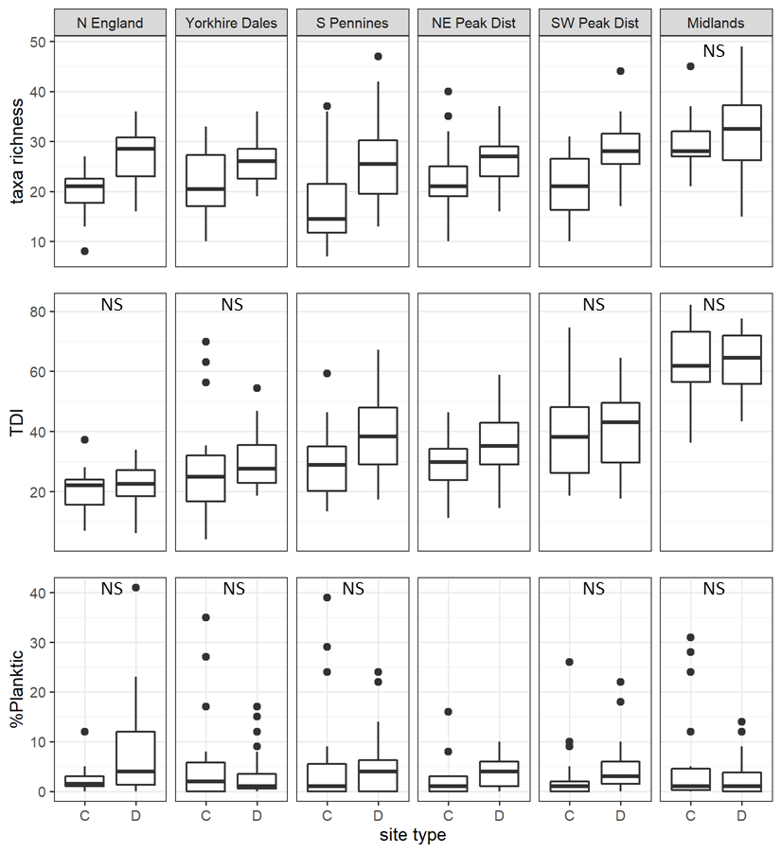  
**Figure S2**. Regional-scale values for taxonomic richness, TDI and *%planktic* calculated on spring samples, per site type (C = control, D = downstream sites). Non-significant Kruskal-Wallis results are indicated with ‘NS’.

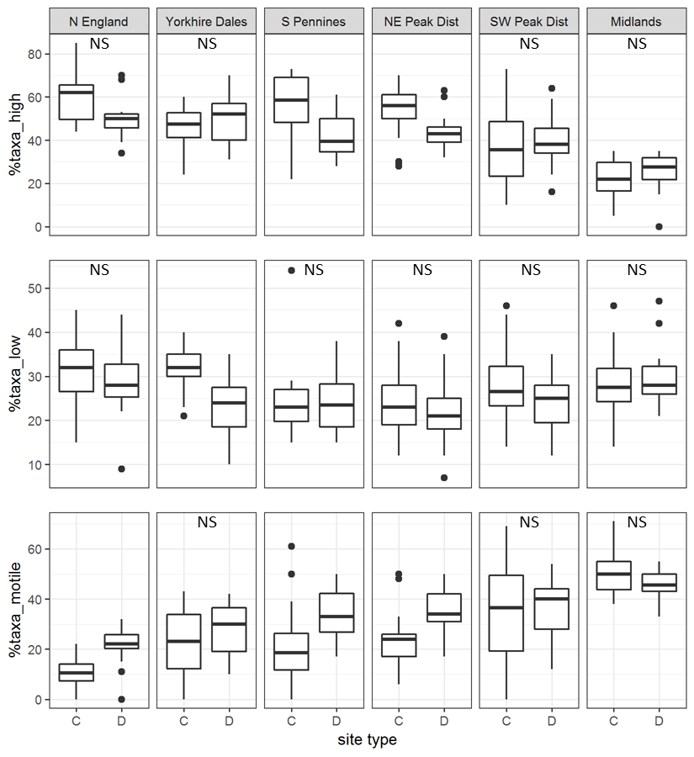  
**Figure S3**. Regional-scale values for percentages of ecological guilds calculated on spring samples, per site type (C = control, D = downstream sites). Non-significant Kruskal-Wallis results are indicated with ‘NS’.

**Table S3**. Mean values for taxonomic richness of the separate ecological guilds (‘Ntaxa_high’ = high-profile guild; ‘Ntaxa_low’ = low-profile guild; ‘Ntaxa_motile’ = motile guild) and results from Kruskal-Wallis testing the significance of variable *SiteType* on these variables for separate spring and autumn samples. C = control sites, D = downstream sites. Significant *p*-values are in bold font; *** = *p* ≤ 0.001; ** = *p* ≤ 0.01; * = *p* ≤ 0.05.

|  |  |  |  |  |  |  |  |  |  |  |
| --- | --- | --- | --- | --- | --- | --- | --- | --- | --- | --- |
| Region | Season | Ntaxa_high | | | Ntaxa_low | | | Ntaxa_motile | | |
|  |  | C | D | p | C | D | p | C | D | p |
| National scale | Spring | 9.3 | 11.3 | **0.001**\*\*\* | 5.9 | 6.7 | **0.017**\* | 6.7 | 9.3 | **0.001**\*\*\* |
|  | Autumn | 9.2 | 12.1 | **0.001**\*\*\* | 6.6 | 8.4 | **0.001**\*\*\* | 8.1 | 12.4 | **0.001**\*\*\* |
| North England | Spring | 11.5 | 13.2 | 0.159 | 6.1 | 7.7 | 0.074 | 2.2 | 5.9 | **0.001**\*\*\* |
|  | Autumn | 10.3 | 11.4 | 0.354 | 5.1 | 8.2 | **0.001**\*\*\* | 3.9 | 10.0 | **0.001**\*\*\* |
| Yorkshire Dales | Spring | 9.3 | 12.6 | **0.002**\*\* | 6.6 | 6.0 | 0.225 | 5.3 | 7.3 | 0.059 |
|  | Autumn | 8.5 | 13.0 | **0.001**\*\*\* | 6.3 | 7.7 | **0.017**\* | 6.5 | 11.9 | **0.001**\*\*\* |
| South Pennines | Spring | 9.1 | 10.9 | 0.197 | 4.2 | 6.1 | **0.005**\*\* | 4.3 | 9.1 | **0.001**\*\*\* |
|  | Autumn | 10.8 | 13.3 | **0.043**\* | 6.2 | 9.3 | **0.001**\*\*\* | 6.4 | 14.4 | **0.001**\*\*\* |
| North East Peak District | Spring | 11.8 | 11.4 | 0.647 | 5.0 | 5.4 | 0.261 | 5.5 | 9.2 | **0.001**\*\*\* |
|  | Autumn | 11.1 | 13.5 | **0.010**\*\* | 4.7 | 7.3 | **0.001**\*\*\* | 5.0 | 12.4 | **0.001**\*\*\* |
| South West Peak District | Spring | 7.1 | 11.2 | **0.001**\*\*\* | 5.9 | 6.7 | 0.213 | 8.2 | 10.4 | 0.196 |
|  | Autumn | 7.8 | 12.9 | **0.001**\*\*\* | 7.4 | 7.7 | 0.813 | 8.1 | 12.8 | 0.059 |
| Midlands | Spring | 6.6 | 8.6 | 0.123 | 8.4 | 9.3 | 0.415 | 14.9 | 14.3 | 0.974 |
|  | Autumn | 6.6 | 7.4 | 0.521 | 10.1 | 10.9 | 0.368 | 18.7 | 13.1 | **0.001**\*\*\* |

**Table S4**. Spearman’s rank correlation coefficients between diatom indices for separate spring and autumn samples.

|  |  |  |  |  |  |  |
| --- | --- | --- | --- | --- | --- | --- |
|  | Ntaxa | %taxa_high | %taxa_low | %taxa_motile | TDI | %planktic |
| *spring* |  |  |  |  |  |  |
| Ntaxa | **XXX** | -0.38 | -0.14 | 0.48 | 0.42 | 0.09 |
| %taxa_high | -0.38 | **XXX** | -0.25 | -0.87 | -0.75 | 0.15 |
| %taxa_low | -0.14 | -0.25 | **XXX** | -0.21 | -0.06 | -0.04 |
| %taxa_motile | 0.48 | -0.87 | -0.21 | **XXX** | 0.79 | -0.13 |
| TDI | 0.42 | -0.75 | -0.06 | 0.79 | **XXX** | -0.17 |
| %planktic | 0.09 | 0.15 | -0.04 | -0.13 | -0.17 | **XXX** |
| *autumn* |  |  |  |  |  |  |
| Ntaxa | **XXX** | -0.51 | -0.27 | 0.66 | 0.51 | 0.19 |
| %taxa_high | -0.51 | **XXX** | -0.28 | -0.87 | -0.79 | 0.13 |
| %taxa_low | -0.27 | -0.28 | **XXX** | -0.17 | 0.13 | -0.20 |
| %taxa_motile | 0.66 | -0.87 | -0.17 | **XXX** | 0.74 | 0.00 |
| TDI | 0.51 | -0.79 | 0.13 | 0.74 | **XXX** | -0.11 |
| %planktic | 0.19 | 0.13 | -0.20 | 0.00 | -0.11 | **XXX** |

Water quality variables

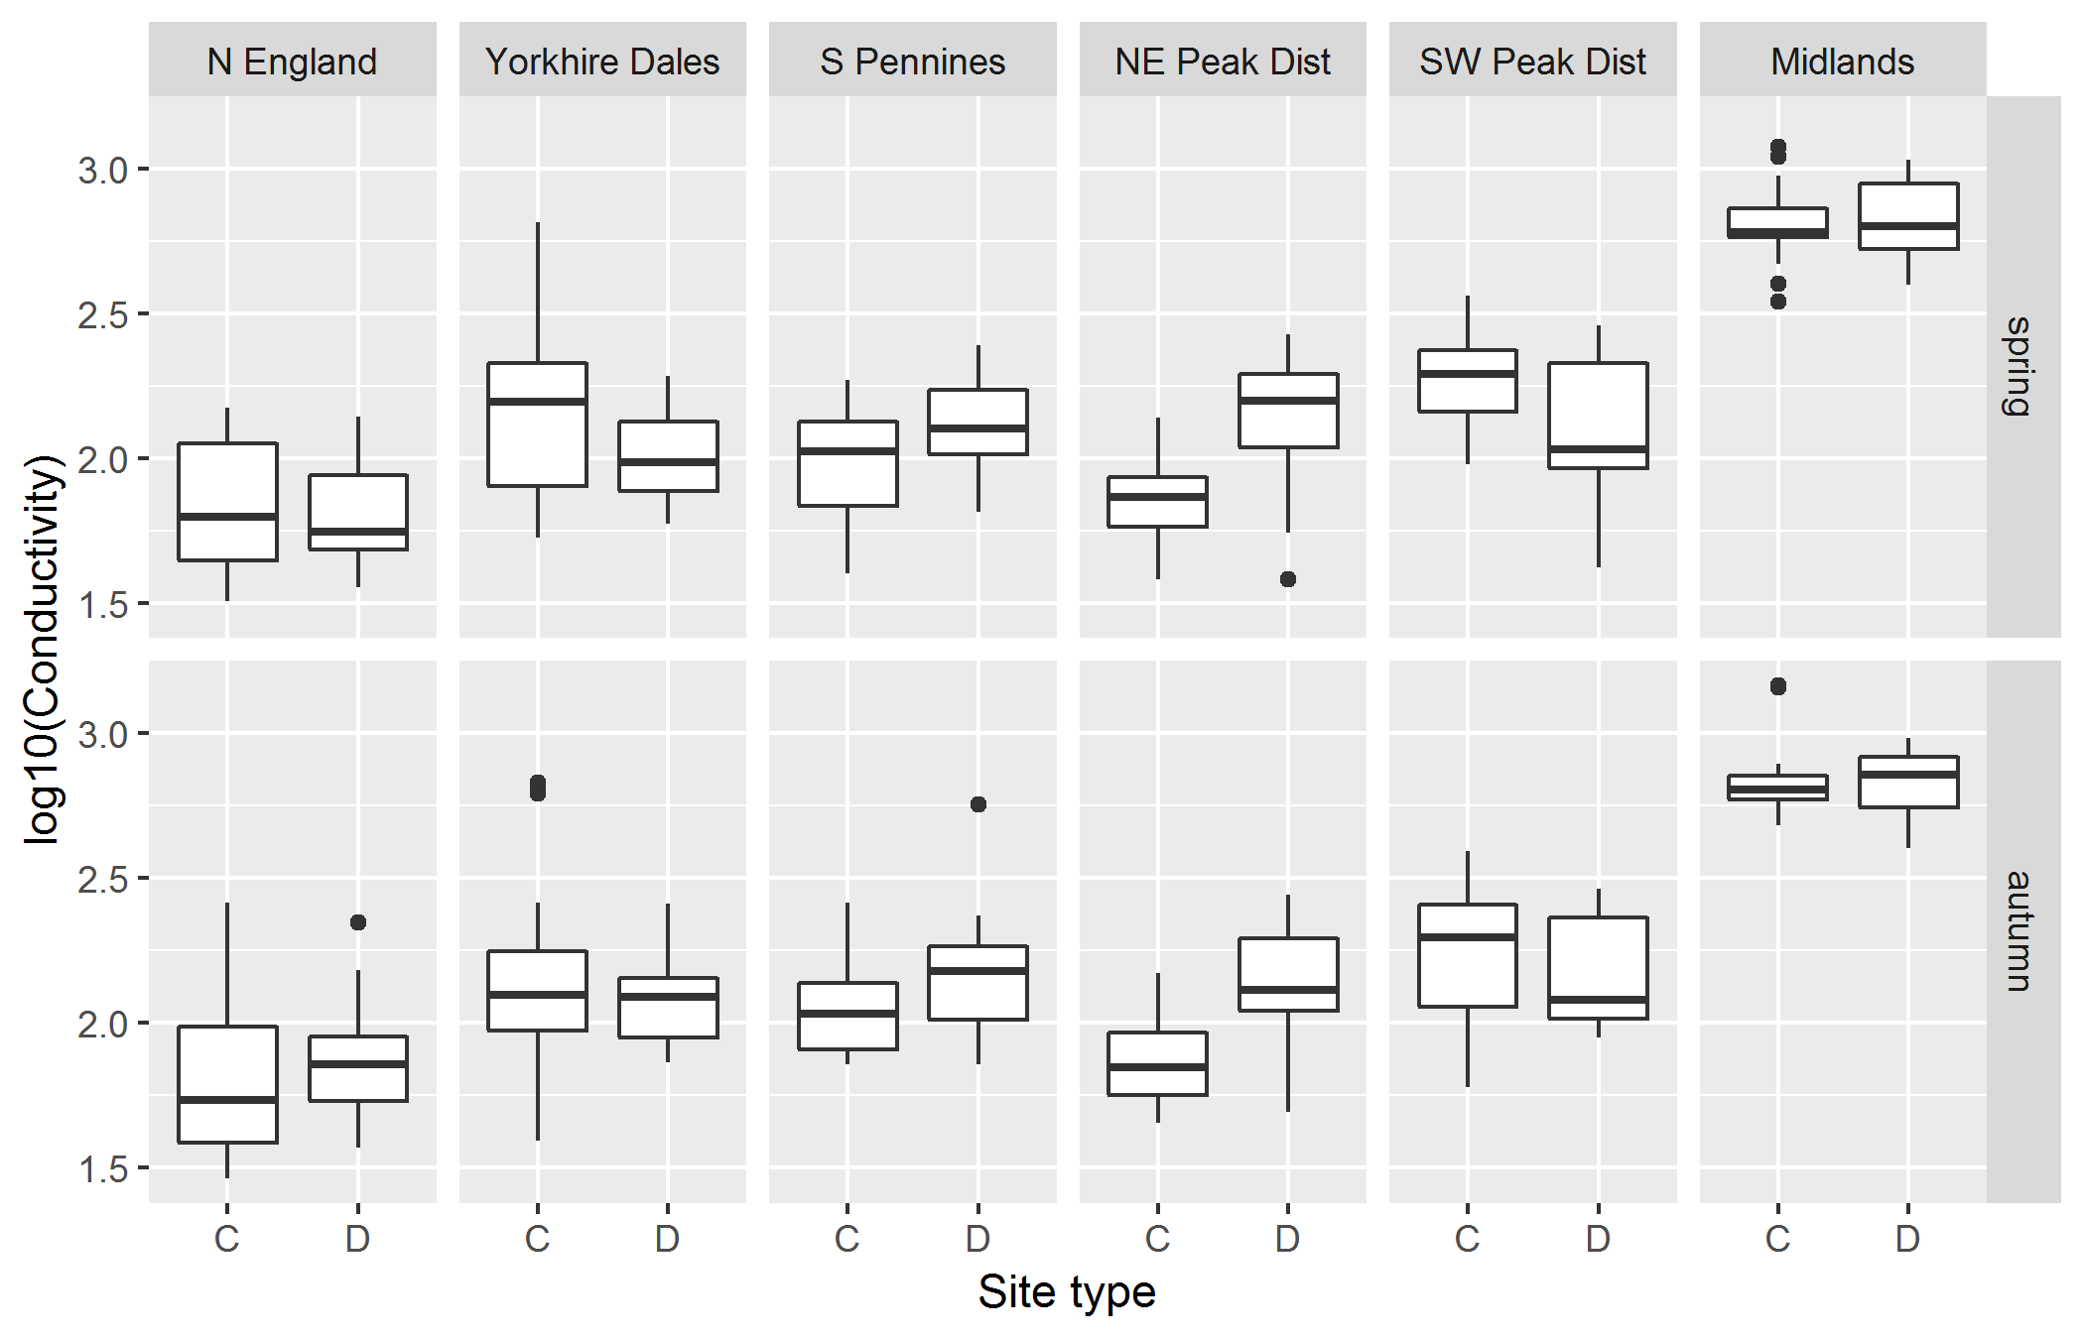  
**Figure S4**. Conductivity values (log-transformed) for spring (top) and autumn samples (bottom), per site type (C = control, D = downstream sites).

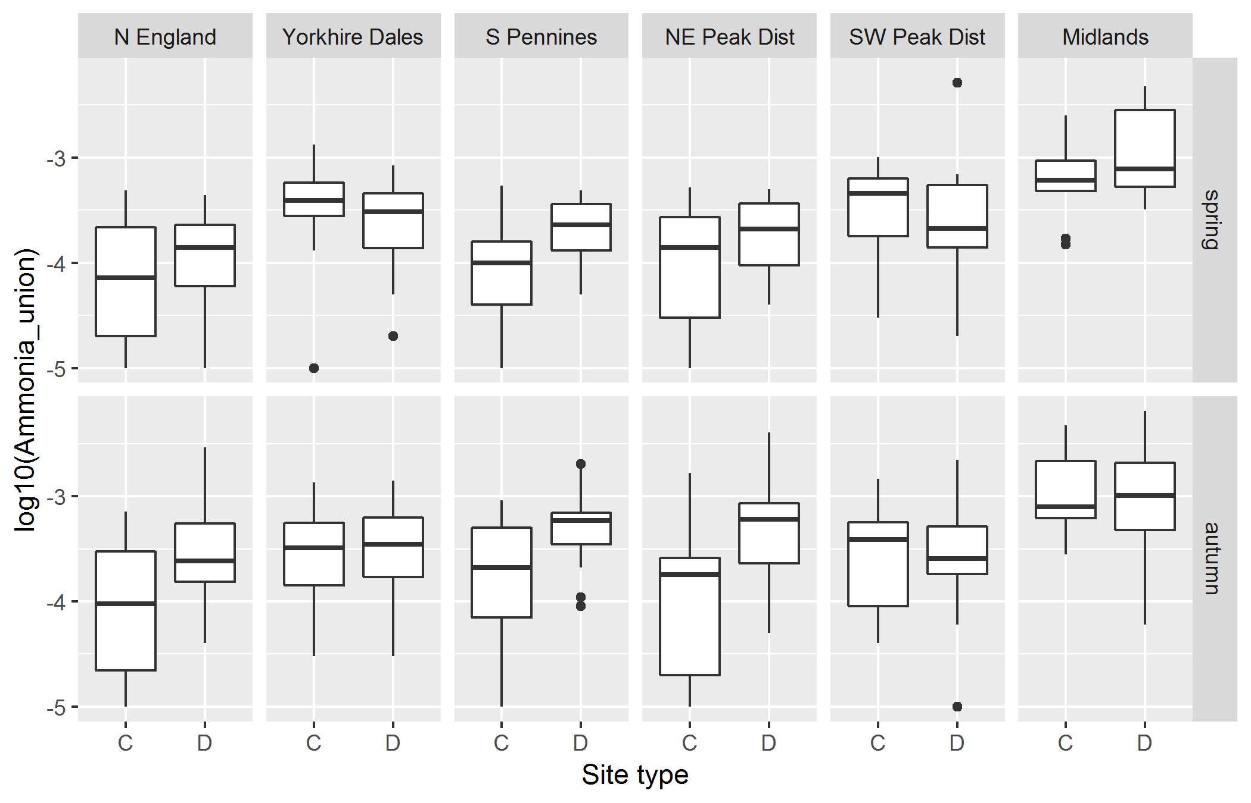  
**Figure S5**. Un-ionised ammonia (NH3; log-transformed) for spring (top) and autumn samples (bottom), per site type (C = control, D = downstream sites).

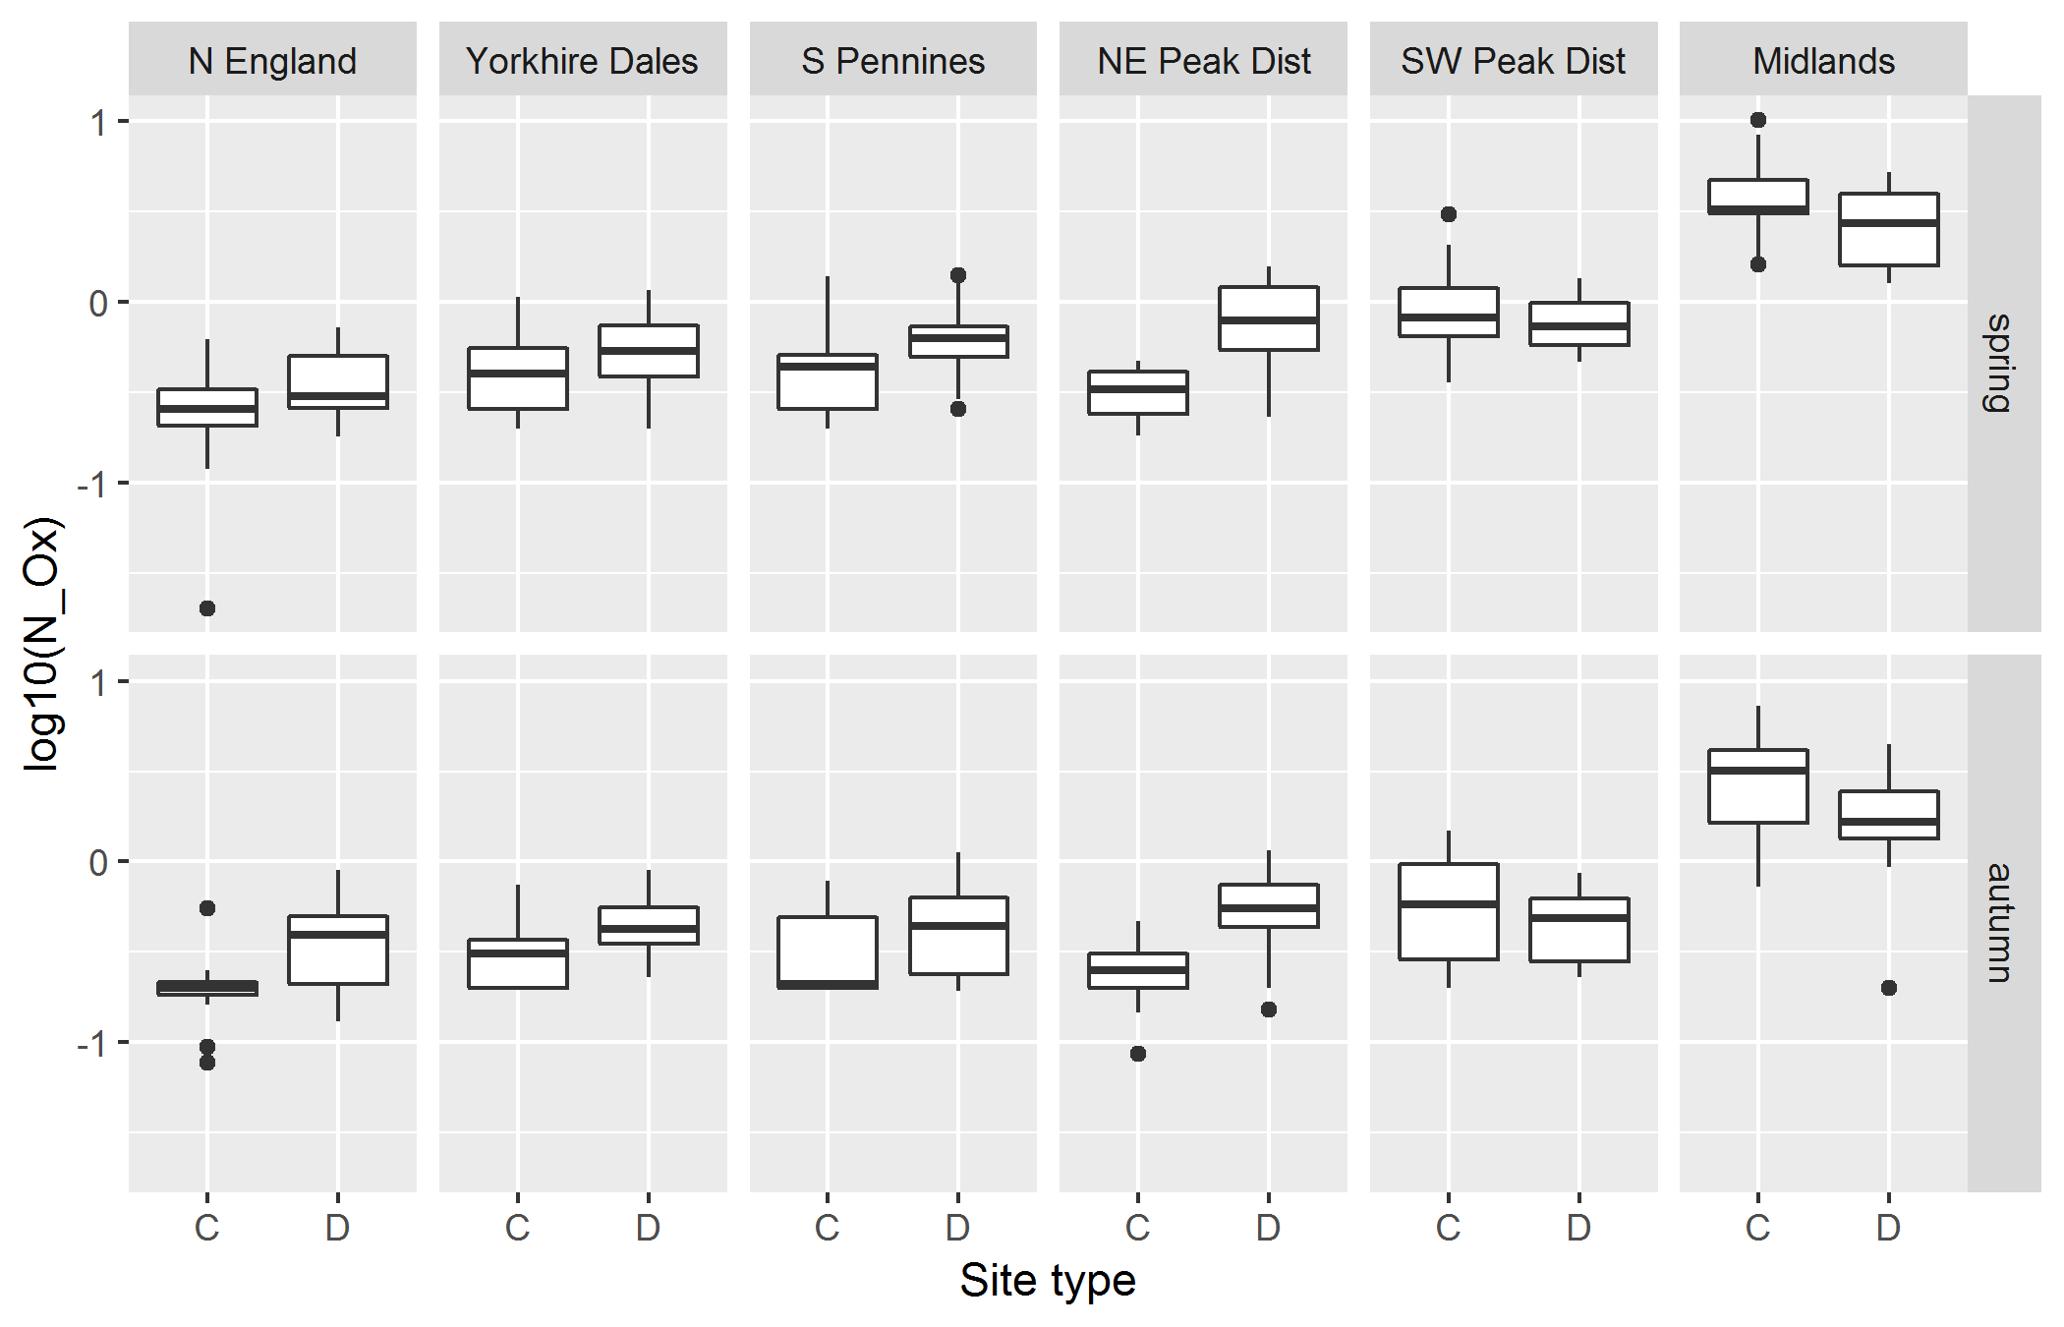  
**Figure S6**. Total oxidised nitrogen (TON; log-transformed) for spring (top) and autumn samples (bottom), per site type (C = control, D = downstream sites).

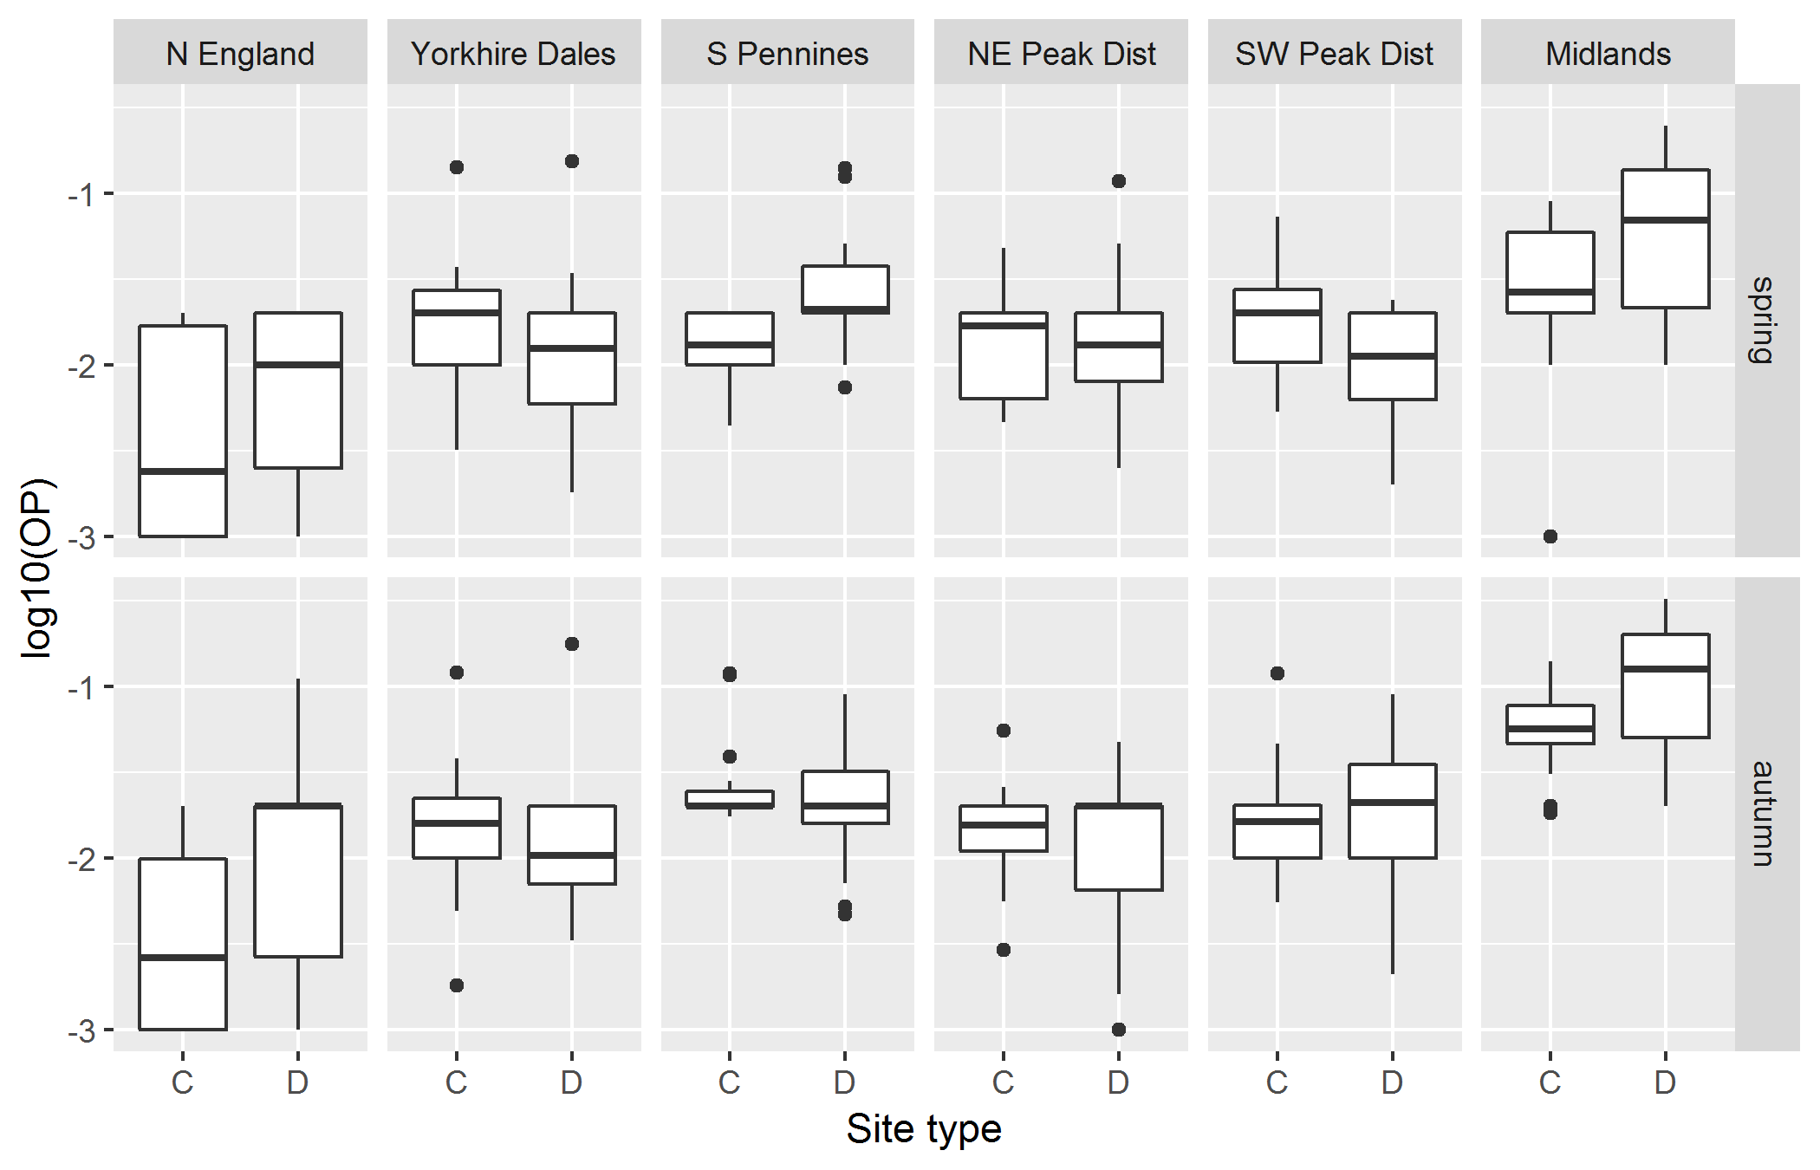  
**Figure S7**. Orthophosphate (OP; log-transformed) for spring (top) and autumn samples (bottom), per site type (C = control, D = downstream sites).

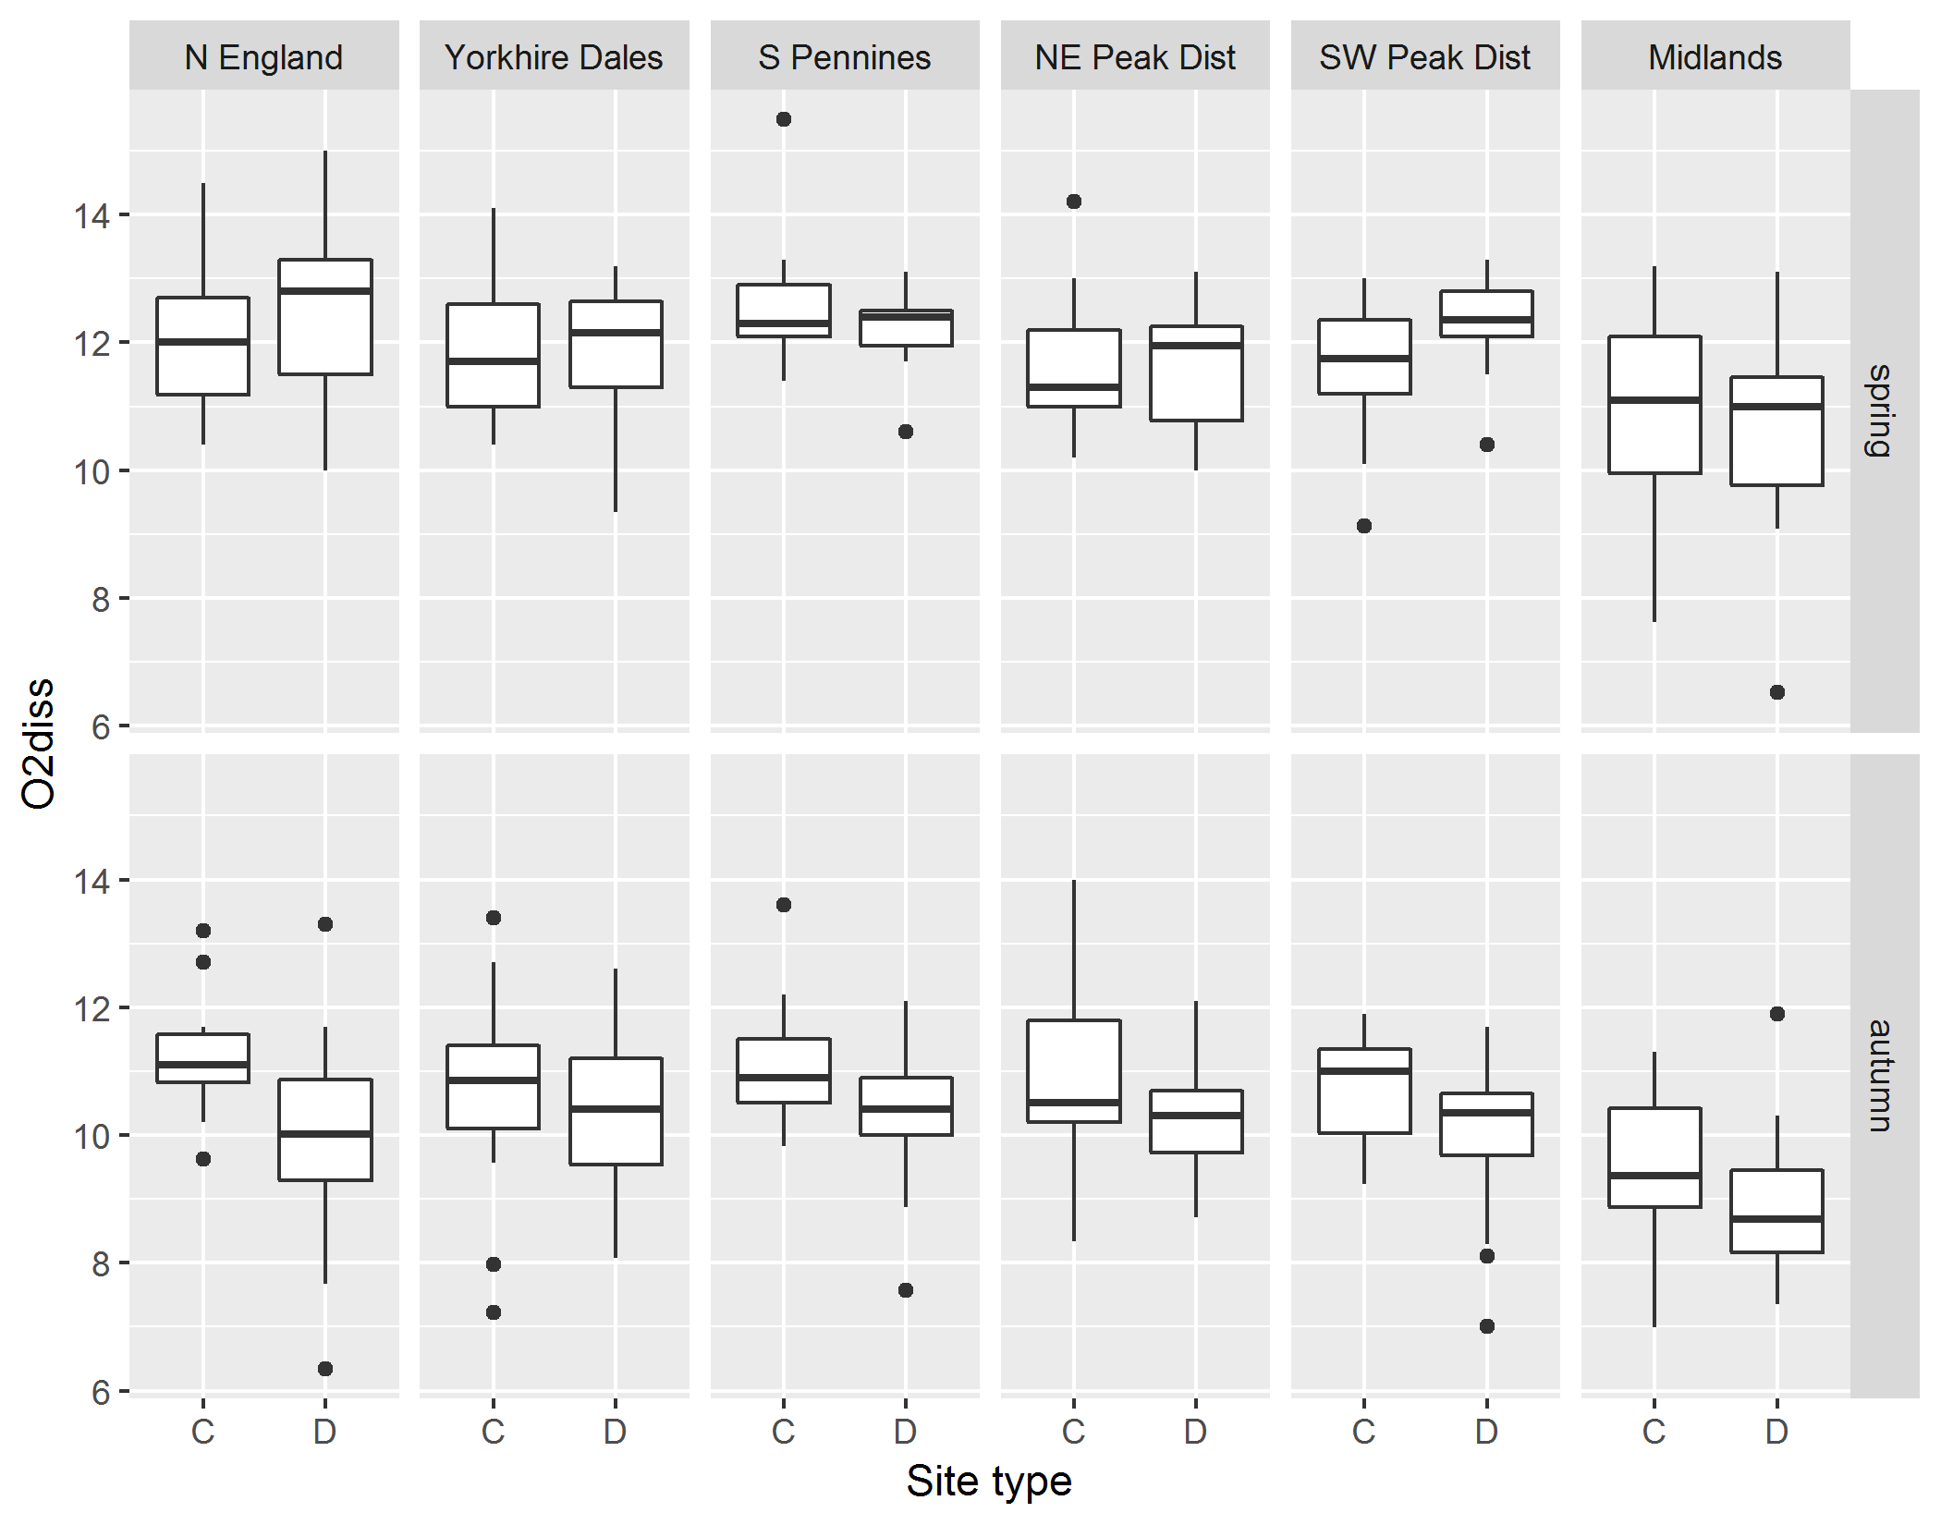  
**Figure S8**. Dissolved oxygen (mg/L) for spring (top) and autumn samples (bottom), per site type (C = control, D = downstream sites).

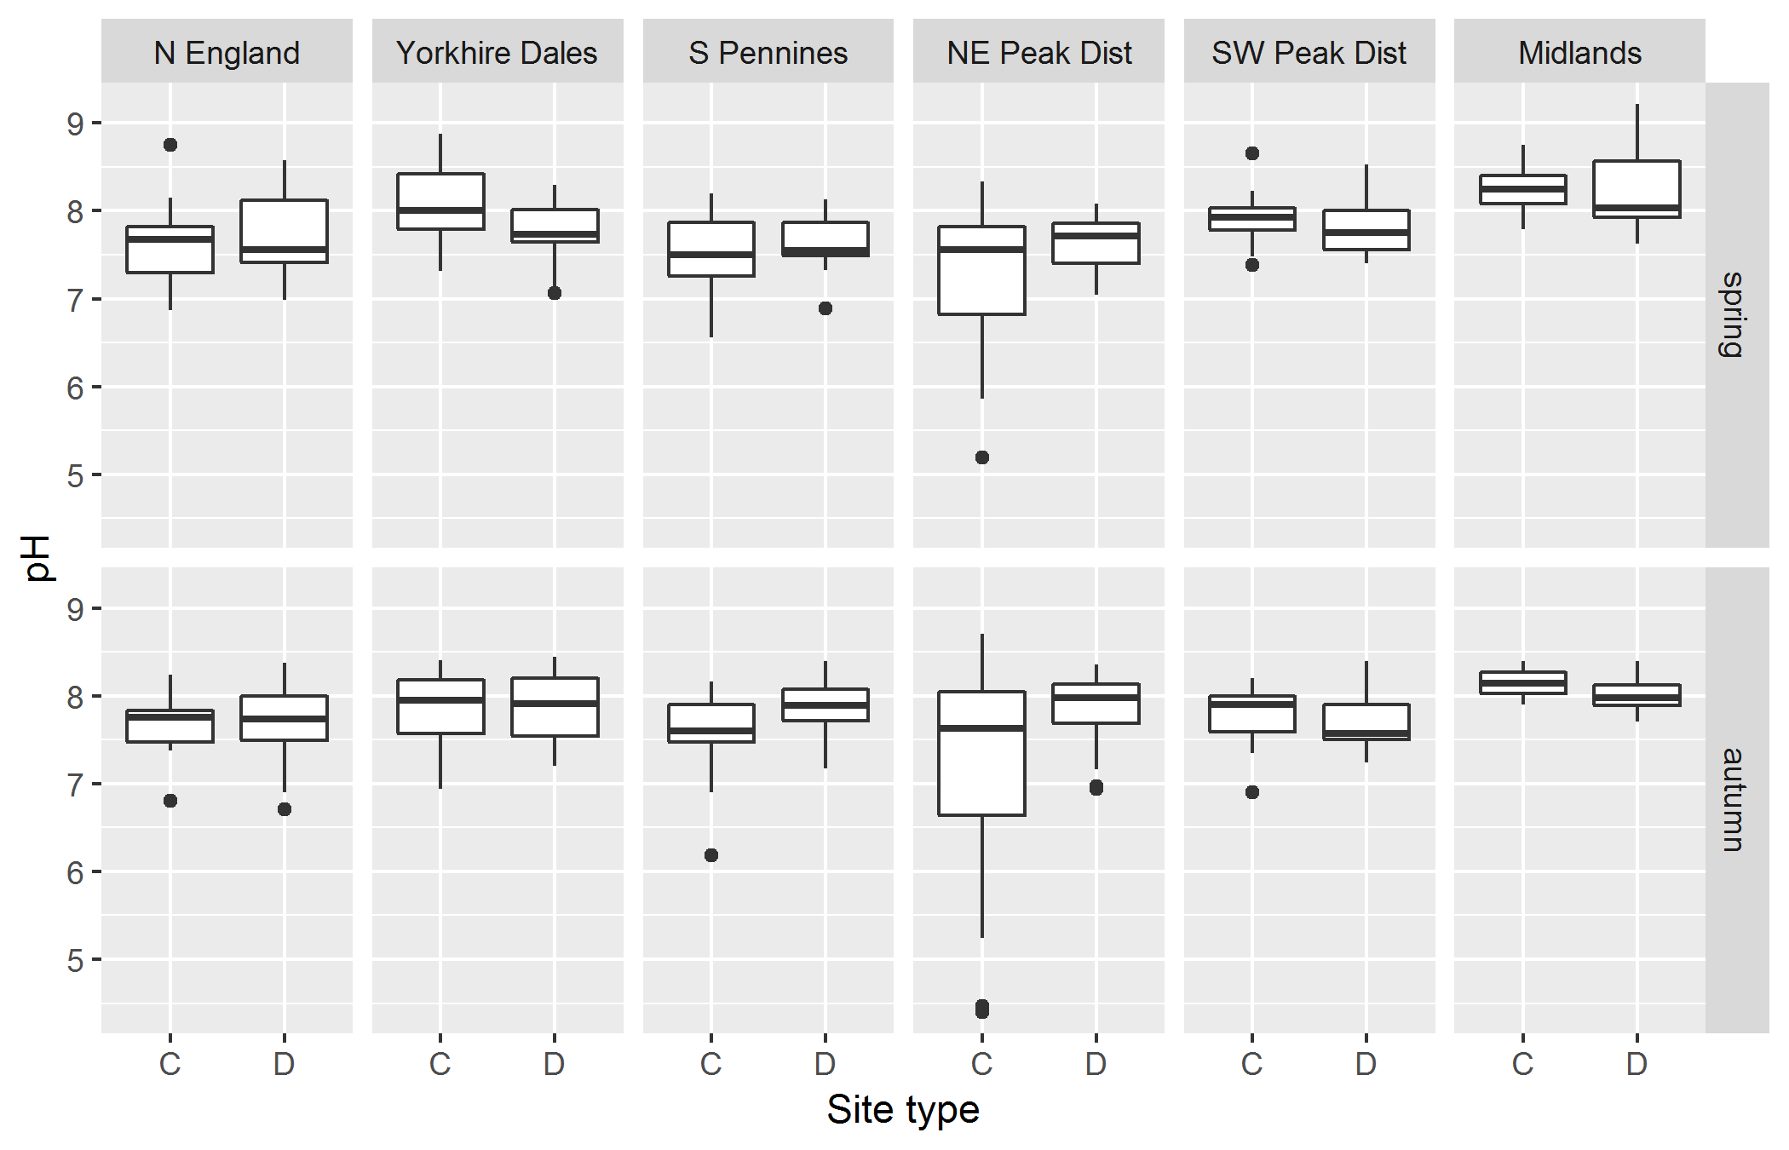  
**Figure S9**. Values of pH for spring (top) and autumn samples (bottom), per site type (C = control, D = downstream sites).

**Table S5**. Results from Kruskal-Wallis testing the significance of variable *SiteType* on water quality variables for separate spring and autumn samples. C = control sites, D = downstream sites. Significant *p*-values are in bold font; *** = *p* ≤ 0.001; ** = *p* ≤ 0.01; * = *p* ≤ 0.05.

|  |  |  |  |  |  |  |  |
| --- | --- | --- | --- | --- | --- | --- | --- |
| Region | Season | Kruskal-Wallis *p*-value | | | | | |
|  |  | **Conductivity** | **TON** | **NH3** | **OP** | **O2** | **pH** |
| National scale | Spring | 0.955 | **0.023**\* | 0.858 | 0.740 | 0.140 | 0.231 |
|  | Autumn | 0.166 | **0.002**\*\* | **0.003**\*\* | 0.967 | **0.001**\*\*\* | 0.638 |
| North England | Spring | 0.904 | 0.248 | 0.421 | 0.213 | 0.199 | 0.886 |
|  | Autumn | 0.254 | **0.006**\*\* | **0.027**\* | **0.048**\* | **0.008**\*\* | 0.805 |
| Yorkshire Dales | Spring | 0.101 | 0.160 | 0.177 | 0.231 | 0.759 | **0.050**\* |
|  | Autumn | 0.738 | **0.004**\*\* | 0.693 | 0.216 | 0.354 | 0.903 |
| South Pennines | Spring | 0.097 | **0.018**\* | **0.032**\* | **0.004**\*\* | 0.405 | 0.345 |
|  | Autumn | 0.096 | **0.036**\* | **0.009**\*\* | 0.685 | 0.053 | **0.030**\* |
| North East Peak District | Spring | **0.001**\*\*\* | **0.001**\*\*\* | 0.095 | 0.653 | 0.927 | 0.291 |
|  | Autumn | **0.001**\*\*\* | **0.001**\*\*\* | **0.001**\*\*\* | 0.648 | 0.183 | 0.055 |
| South West Peak District | Spring | 0.077 | 0.647 | 0.349 | 0.060 | **0.037**\* | 0.492 |
|  | Autumn | 0.420 | 0.384 | 0.776 | 0.515 | **0.041**\* | 0.149 |
| Midlands | Spring | 0.196 | 0.289 | 0.872 | 0.368 | **0.025**\* | 0.936 |
|  | Autumn | 0.153 | 0.877 | 0.942 | 0.943 | 0.153 | 0.352 |

**Table S6**. Spearman’s rank correlation coefficients between diatom indices and water quality variables for separate spring and autumn samples.

|  |  |  |  |  |  |  |
| --- | --- | --- | --- | --- | --- | --- |
|  | Conduc-tivity | TON | NH3 | OP | O2 | pH |
| *spring* |  |  |  |  |  |  |
| Ntaxa | 0.31 | 0.38 | 0.32 | 0.18 | -0.21 | 0.19 |
| %taxa_high | -0.66 | -0.64 | -0.46 | -0.51 | 0.16 | -0.38 |
| %taxa_low | -0.03 | -0.06 | 0.05 | 0.03 | 0.09 | 0.09 |
| %taxa_motile | 0.69 | 0.68 | 0.47 | 0.50 | -0.21 | 0.34 |
| TDI | 0.75 | 0.69 | 0.49 | 0.48 | -0.22 | 0.43 |
| %planktic | -0.05 | -0.04 | 0.08 | -0.08 | 0.00 | -0.04 |
| *autumn* |  |  |  |  |  |  |
| Ntaxa | 0.47 | 0.40 | 0.32 | 0.31 | -0.28 | 0.15 |
| %taxa_high | -0.69 | -0.53 | -0.44 | -0.44 | 0.40 | -0.34 |
| %taxa_low | 0.14 | 0.12 | 0.09 | -0.04 | -0.07 | 0.11 |
| %taxa_motile | 0.65 | 0.47 | 0.43 | 0.47 | -0.38 | 0.32 |
| TDI | 0.78 | 0.62 | 0.52 | 0.51 | -0.36 | 0.33 |
| %planktic | -0.14 | -0.13 | 0.01 | -0.13 | -0.04 | -0.11 |