**Supplemental Materials**

Environmental DNA detection and quantification of invasive red-eared sliders, *Trachemy scripta elegans*, in ponds and the influence of water quality

Aozora Kakuda, Izumi Katano, Rio Souma, Mariko Nagano, Toshifumi Minamoto, and Hideyuki Doi

Table S1A Results of the water quality analysis. Not measured because of sample lost is represented by -

|  |  |  |  |  |  |  |  |  |
| --- | --- | --- | --- | --- | --- | --- | --- | --- |
| Site No. | Chl. *a*（mg/L） | SS (mg/L) | PO₄-P （µmol/L) | NO₃-N （µmol/L） | TP （µmol/L） | TN （µmol/L） | DOM  (abs254nm) | TOM  (abs254nm) |
| 1 | 0.046 | 67.20 | - | - | - | - | - | - |
| 2 | 0.008 | 9.84 | - | - | - | - | - | - |
| 3 | 0.014 | 18.52 | - | - | - | - | - | - |
| 4 | 0.058 | 47.07 | 4.777 | 42.28 | 5.541 | 31.86 | 0.101 | 0.001 |
| 5 | 0.031 | 20.00 | 0.275 | 28.03 | 0.743 | 26.69 | 0.076 | 0.026 |
| 6 | 0.006 | 11.48 | 0.344 | 22.53 | 0.608 | 23.93 | 0.056 | 0.027 |
| 7 | 0.007 | 11.64 | 0.103 | 13.03 | 3.649 | 12.55 | 0.029 | 0.007 |
| 8 | 0.052 | 50.80 | 0.481 | 56.03 | 1.689 | 35.66 | 0.139 | 0.011 |
| 9 | 0.008 | 20.67 | 0.647 | 13.66 | 0.321 | 12.71 | - | - |
| 10 | 0.044 | 37.60 | 0.344 | 37.03 | 1.419 | 30.48 | 0.087 | 0.004 |
| 11 | 0.234 | 200.40 | 1.765 | 115.85 | 3.654 | 132.00 | - | - |
| 12 | 0.026 | 22.93 | 0.206 | 22.28 | 1.216 | 13.93 | 0.053 | 0.000 |
| 13 | 0.005 | 12.90 | 1.718 | 50.53 | 2.703 | 52.90 | 0.037 | 0.002 |
| 14 | 0.022 | 22.55 | 0.309 | 28.03 | 1.014 | 19.10 | 0.069 | 0.002 |
| 15 | 0.026 | 23.40 | 0.241 | 30.53 | 0.743 | 10.83 | 0.076 | 0.000 |
| 16 | 0.006 | 14.76 | 0.241 | 36.28 | 0.946 | 18.76 | 0.093 | 0.009 |
| 17 | 0.025 | 23.25 | 0.309 | 39.03 | 0.878 | 13.93 | 0.101 | 0.000 |
| 18 | 0.054 | 122.53 | 1.203 | 79.03 | 1.149 | 24.97 | 0.205 | 0.020 |
| 19 | 0.003 | 15.64 | 3.162 | 37.78 | 3.243 | 34.28 | 0.069 | 0.011 |
| 20 | 0.007 | 15.72 | 0.893 | 35.78 | 1.486 | 25.66 | 0.066 | 0.004 |
| 21 | 0.031 | 26.30 | 0.756 | 34.78 | 1.216 | 16.69 | 0.089 | 0.004 |
| 22 | 0.014 | 34.45 | 0.447 | 22.03 | 0.473 | 9.10 | 0.055 | 0.007 |
| 23 | 0.025 | 20.05 | 0.241 | 28.78 | 0.946 | 17.72 | 0.069 | 0.003 |
| 24 | 0.007 | 100.35 | 0.447 | 39.53 | 1.419 | 21.52 | 0.100 | 0.004 |
| 25 | 0.035 | 93.80 | 0.412 | 47.78 | 1.014 | 27.03 | 0.117 | 0.017 |
| 26 | 0.006 | 21.25 | 2.096 | 50.53 | 2.703 | 30.48 | 0.126 | 0.009 |
| 27 | 0.000 | 161.85 | 0.378 | 14.03 | 1.216 | 6.34 | 0.031 | -0.001 |
| 28 | 0.040 | 48.70 | 0.275 | 28.28 | 1.554 | 16.69 | 0.059 | 0.006 |
| 29 | 0.052 | 96.05 | 0.447 | 8.78 | 1.014 | 19.45 | 0.021 | 0.010 |
| 30 | 0.058 | 23.60 | 0.034 | 16.03 | 1.149 | 6.69 | 0.042 | 0.006 |
| 31 | -0.005 | 214.85 | 1.856 | 68.78 | 3.311 | 70.14 | 0.049 | 0.002 |
| 32 | 0.048 | 48.50 | 0.756 | 21.03 | 1.959 | 23.24 | 0.036 | 0.001 |
| 33 | 0.007 | 26.80 | 0.447 | 41.53 | 1.149 | 15.31 | 0.098 | 0.016 |
| 34 | 0.046 | 28.53 | 0.275 | 42.53 | 1.014 | 18.07 | 0.102 | 0.000 |
| 35 | 0.023 | 20.95 | 0.172 | 29.53 | 0.541 | 17.03 | 0.061 | 0.001 |
| 36 | 0.020 | 21.90 | 0.123 | 49.48 | 0.576 | 34.00 | 0.058 | 0.001 |
| 37 | 0.223 | 62.13 | 0.798 | 50.48 | 1.186 | 29.56 | 0.121 | 0.005 |
| 38 | 0.013 | 11.20 | 0.061 | 31.48 | 0.373 | 10.30 | 0.074 | 0.002 |
| 39 | 0.001 | 15.25 | 0.061 | 63.48 | 0.237 | 58.81 | 0.036 | 0.013 |
| 40 | -0.001 | 16.95 | 0.245 | 94.98 | 0.203 | 91.41 | 0.027 | 0.005 |
| 41 | 0.025 | 21.35 | 0.184 | 18.48 | 0.203 | 9.19 | 0.039 | 0.007 |
| 42 | 0.124 | 30.27 | 1.471 | 44.39 | 1.410 | 28.07 | - | - |
| 43 | 0.041 | 39.73 | 1.353 | 35.85 | 0.449 | 11.29 | - | - |
| 44 | -0.002 | 16.05 | 0.798 | 34.73 | 0.373 | 19.56 | 0.055 | 0.001 |
| 45 | 0.033 | 46.25 | 0.613 | 19.73 | 0.407 | 14.74 | 0.043 | 0.013 |
| 46 | -0.002 | 26.95 | 1.104 | 70.23 | 2.068 | 108.44 | 0.049 | 0.060 |
| 47 | 0.007 | 55.10 | 1.656 | 55.73 | 1.085 | 35.85 | 0.134 | 0.025 |
| 48 | 0.381 | 61.07 | 5.399 | 77.48 | 5.153 | 41.41 | 0.185 | 0.007 |
| 49 | 0.005 | 15.45 | 0.491 | 28.23 | 0.441 | 6.96 | 0.064 | 0.001 |
| 50 | 0.008 | 127.90 | 1.902 | 32.98 | 0.305 | 28.81 | 0.031 | 0.008 |

Table S1B Continued

|  |  |  |  |  |  |  |  |  |
| --- | --- | --- | --- | --- | --- | --- | --- | --- |
| Site No. | Chl. *a* （mg/L） | SS (mg/L) | PO₄-P （µmol/L) | NO₃-N （µmol/L） | TP （µmol/L） | TN （µmol/L） | DOM  (abs254nm) | TOM  (abs254nm) |
| 51 | -0.001 | 29.10 | 1.166 | 29.48 | 0.271 | 21.78 | 0.042 | 0.006 |
| 52 | -0.001 | 40.45 | 1.104 | 34.48 | 0.305 | 28.07 | 0.047 | 0.010 |
| 53 | 0.006 | 37.80 | 0.613 | 54.48 | 0.475 | 36.59 | 0.065 | 0.003 |
| 54 | 0.008 | 27.45 | 0.798 | 61.48 | 0.644 | 28.44 | 0.115 | 0.002 |
| 55 | 0.001 | 29.70 | 0.429 | 35.23 | 0.407 | 18.81 | 0.083 | 0.014 |
| 56 | 0.252 | 51.93 | 0.613 | 26.48 | 0.508 | 16.22 | 0.057 | 0.002 |
| 57 | 0.045 | 18.93 | 0.245 | 40.98 | 0.441 | 15.11 | 0.097 | 0.001 |
| 58 | 0.040 | 21.15 | 0.368 | 25.73 | 0.576 | 11.41 | 0.060 | 0.008 |
| 59 | 0.162 | 105.00 | 0.307 | 80.48 | 0.915 | 36.22 | 0.197 | 0.016 |
| 60 | 0.045 | 37.67 | 0.429 | 43.98 | 1.322 | 22.15 | 0.103 | 0.005 |
| 61 | 0.088 | 40.33 | 0.307 | 43.48 | 1.186 | 25.48 | 0.103 | -0.001 |
| 62 | 0.044 | 23.90 | 0.061 | 35.48 | 0.746 | 16.22 | 0.076 | 0.000 |
| 63 | 0.057 | 31.10 | 0.245 | 47.73 | 1.153 | 19.19 | 0.110 | 0.000 |
| 64 | 0.105 | 32.95 | 0.613 | 56.73 | 0.508 | 33.63 | 0.142 | 0.019 |
| 65 | 0.882 | 381.71 | 0.429 | 56.23 | 0.746 | 26.96 | 0.135 | 0.002 |
| 66 | 0.014 | 13.10 | 0.368 | 27.48 | 0.339 | 6.59 | 0.066 | 0.000 |
| 67 | 0.043 | 23.50 | 0.184 | 36.23 | 0.441 | 10.67 | 0.084 | 0.001 |
| 68 | 0.138 | 85.10 | 0.060 | 50.38 | 0.780 | 24.10 | 0.121 | -0.001 |
| 69 | 0.089 | 42.15 | 0.357 | 49.87 | 1.064 | 20.31 | 0.104 | 0.001 |
| 70 | 0.064 | 26.05 | 0.298 | 30.13 | 0.780 | 23.07 | 0.065 | 0.009 |
| 71 | 0.017 | 19.53 | 1.412 | 25.37 | 0.897 | 15.93 | - | - |
| 72 | 0.034 | 28.00 | 0.417 | 30.13 | 0.638 | 20.66 | 0.051 | 0.002 |
| 73 | 0.011 | 13.70 | 0.536 | 36.03 | 0.071 | 44.10 | 0.016 | -0.002 |
| 74 | 0.007 | 14.60 | 0.417 | 29.10 | 0.709 | 15.48 | 0.050 | -0.001 |
| 75 | 0.006 | 21.80 | 0.119 | 22.95 | 0.284 | 8.24 | 0.050 | -0.001 |
| 76 | 0.006 | 29.76 | 0.298 | 48.85 | 0.213 | 47.55 | 0.015 | 0.005 |
| 77 | 0.007 | 21.64 | 0.655 | 54.23 | 0.142 | 49.62 | 0.047 | 0.003 |
| 78 | 0.011 | 15.32 | 0.952 | 33.72 | 0.213 | 15.48 | 0.081 | 0.006 |
| 79 | 0.004 | 13.28 | 0.417 | 48.85 | 0.567 | 41.00 | 0.056 | 0.003 |
| 80 | 0.001 | 14.64 | 0.595 | 23.72 | 0.142 | 16.17 | 0.040 | -0.002 |
| 81 | 0.001 | 20.04 | 0.476 | 45.26 | 0.071 | 30.31 | 0.050 | -0.005 |
| 82 | 0.004 | 25.28 | 0.238 | 62.69 | 0.142 | 46.52 | 0.062 | -0.002 |
| 83 | 0.025 | 25.60 | 0.655 | 35.51 | 0.496 | 27.55 | 0.077 | -0.002 |
| 84 | 0.004 | 45.40 | 2.059 | 74.15 | 0.513 | 47.00 | - | - |
| 85 | 0.014 | 44.85 | 2.321 | 43.72 | 2.128 | 185.48 | 0.106 | 0.065 |
| 86 | 0.018 | 65.75 | 2.824 | 41.95 | 1.218 | 201.64 | - | - |
| 87 | 0.016 | 17.48 | 0.893 | 37.82 | 0.213 | 16.52 | 0.090 | 0.003 |
| 88 | 0.006 | 21.12 | 0.774 | 25.51 | 0.355 | 12.72 | 0.057 | 0.001 |
| 89 | 0.012 | 87.60 | 0.893 | 21.92 | 0.426 | 25.83 | 0.033 | 0.001 |
| 90 | 0.002 | 18.04 | 0.595 | 19.36 | 2.128 | 16.52 | 0.032 | -0.002 |
| 91 | 0.006 | 9.88 | 0.765 | 20.24 | 0.385 | 14.14 | - | - |
| 92 | 0.003 | 14.28 | 0.714 | 24.23 | 0.496 | 19.28 | 0.036 | 0.004 |
| 93 | 0.008 | 20.20 | 0.952 | 31.41 | 1.915 | 23.76 | 0.068 | 0.004 |
| 94 | 0.002 | 12.28 | 0.298 | 22.18 | 0.567 | 14.10 | 0.050 | 0.000 |
| 95 | 0.011 | 30.08 | 0.595 | 19.10 | 0.284 | 12.72 | 0.040 | -0.003 |
| 96 | 0.031 | 17.40 | 0.595 | 32.44 | 0.709 | 21.34 | 0.075 | 0.006 |
| 97 | 0.004 | 21.48 | 1.131 | 15.51 | 0.142 | 9.97 | 0.036 | 0.000 |
| 98 | 0.034 | 41.13 | 0.893 | 32.95 | 0.709 | 29.28 | 0.069 | 0.000 |
| 99 | 0.019 | 21.80 | 0.357 | 30.38 | 0.638 | 15.14 | 0.070 | -0.002 |
| 100 | 0.015 | 26.88 | 0.595 | 31.15 | 0.284 | 15.14 | 0.071 | 0.007 |

Table S2 Linear regression slopes with a ± 95% confidence interval, SE, t values, p values, and VIFs for the relationships between the water quality analysis factors and eDNA concentration in the ponds. Turtles represent estimated number of red-eared sliders.

|  |  |  |  |  |  |
| --- | --- | --- | --- | --- | --- |
| Water　quality analysis | slope | SE | *t* value | *p* value | VIF |
| Chl. *a* | -19.410 | 6.073 | -3.196 | 0.019 | 4.391 |
| SS | 0.016 | 0.019 | 0.831 | 0.438 | 6.329 |
| PO₄-P | -0.483 | 0.503 | -0.960 | 0.374 | 8.871 |
| NO₃-N | 0.009 | 0.037 | 0.247 | 0.813 | 49.731 |
| TP | 0.037 | 0.112 | 0.325 | 0.756 | 1.870 |
| TN | -0.0007 | 0.027 | -0.028 | 0.978 | 78.288 |
| DOM | 0.208 | 10.070 | 0.019 | 0.985 | 13.261 |
| TOM | -7.539 | 18.660 | -0.404 | 0.700 | 16.621 |
| Turtles | 0.0004 | 0.00005 | 7.577 | 0.000 | 1.801 |
| Intercept | 8.981 | 0.4172 | 21.528 | 0.000 | - |

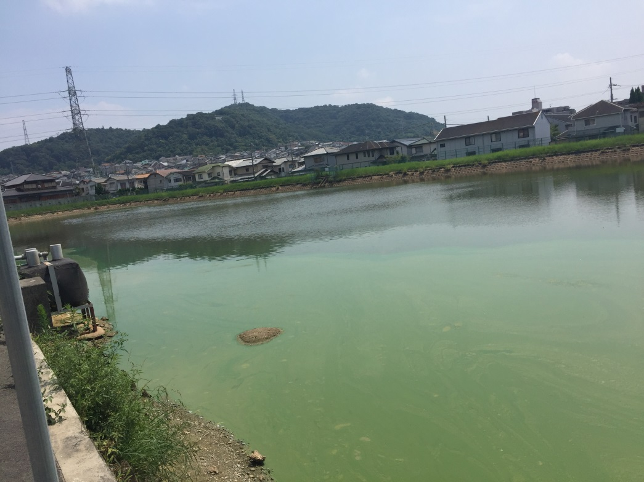

Figure S1 Pond No. 11

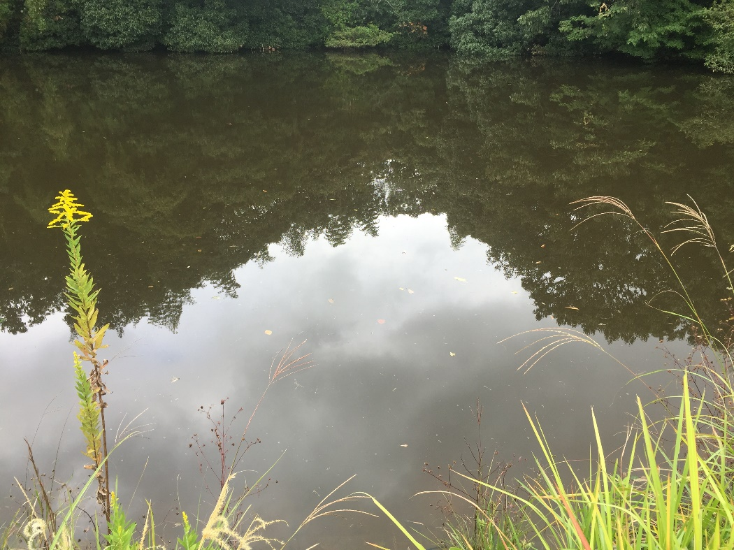

Figure S2 Pond No. 33

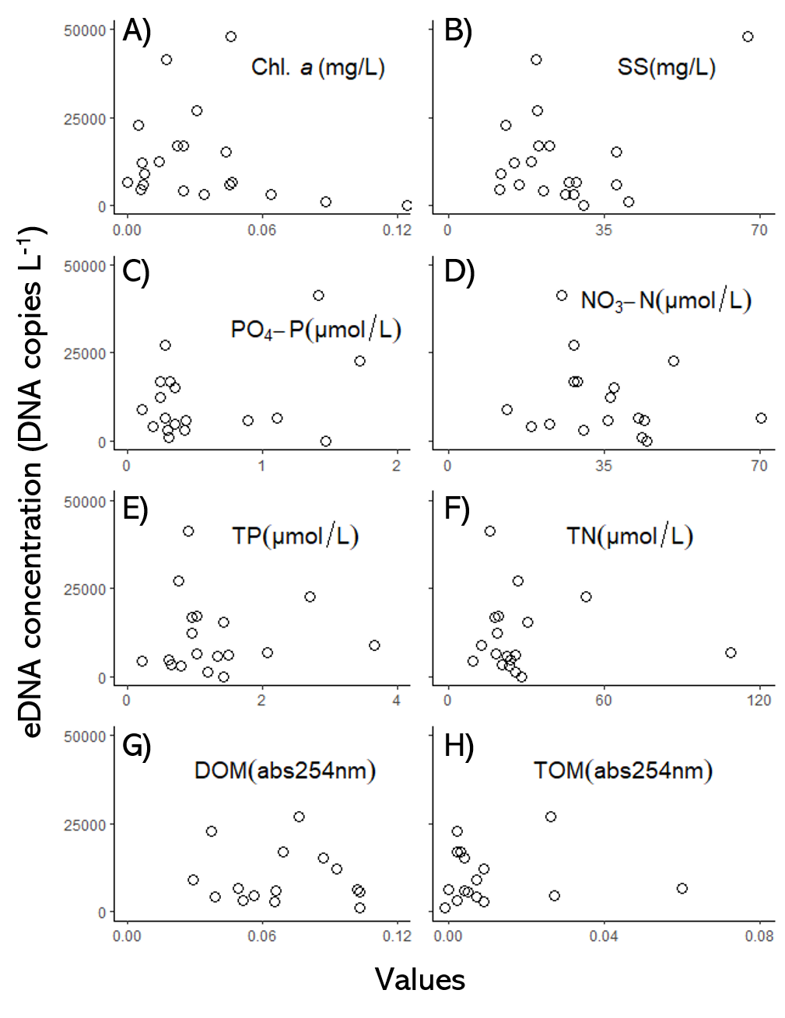

Figure S3 Relationship between each water quality factor and the eDNA concentration of the red-eared slide in the ponds, which is not log-transformed (A: Chl. *a*, B: SS, C: PO4-P, D: NO3-N, E: TP, F: TN, G: DOM, H: TOM).