Icariin can pass the blood-brain barrier
Icariin can pass through the blood-brain barrier and can be detected in rat brain tissue after intragastric administration. Below is the LC-MS result of Icariin (These results are provided by Key Laboratory of Basic Pharmacology and Joint International Research Laboratory of Ethnomedicine of Ministry of Education, Zunyi Medical University, thanks to Dr. Yanliu Lu for his work.)
A substance with a molecular weight of glucuronic acid added to the molecular weight of two icariin was estimated to be a metabolite of icariin in vivo (liver, brain) combined with glucuronic acid.
Icaritin reference standard
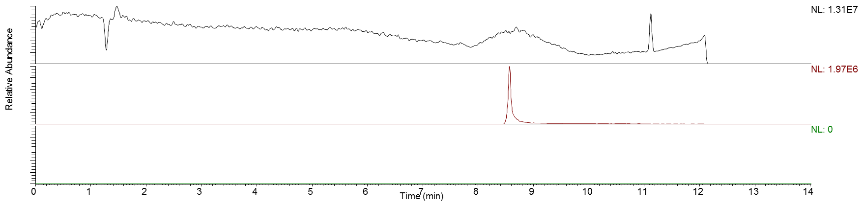
Icaritin
Icaritin + Glu acid
Brain of Control group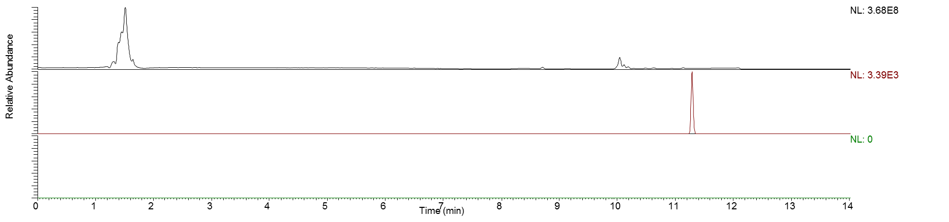
Icaritin + Glu acid
Icaritin
Brain of Treatment group
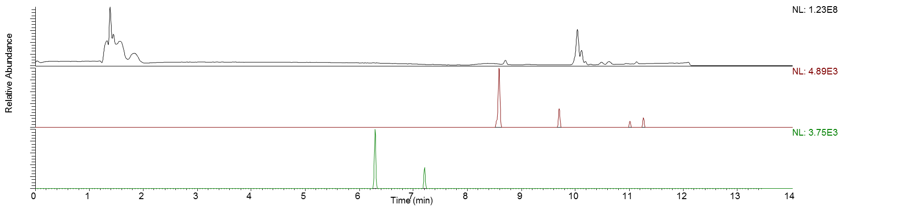
Icaritin
Icaritin + Glu acid

