**Supplemental Table 1.** Specifications of Human Whole Blood Reference Material from the Institut National de Santé Publique du Québec (INSPQ)

|  |  |  |  |
| --- | --- | --- | --- |
| **Whole Blood SRM Identification Number** | **Cu Assigned Concentration (μg/L)** | **Se Assigned Concentration (μg/L)** | **Zn Assigned Concentration (μg/L)** |
| QM-B-Q1313 | 2236.8 | 411.4 | 5812.3 |
| QM-B-Q1314 | 3094.7 | 290.6 | 7911.0 |
| QM-B-Q1404 | 3857.2 | 568.6 | 7126.4 |
| QM-B-Q1505 | 813.4 | 172.2 | 6335.3 |
| QM-B-Q1506 | 3037.5 | 226.7 | 10853.1 |
| QMEQAS-10B-09 | 2220.0 | 357.0 | 12400.0 |
| QMEQAS-09B-05 | 2710.0 | 188.0 | 12200.0 |

**Supplemental Table 2.** Variables that were tested to optimize the TXRF-based method to quantify the target essential elements in dried bloodspots.

|  |  |
| --- | --- |
| **Variable** | **Test Conditions** |
| Acid Extraction | Concentrated HCl |
| Concentrated HNO3 |
| Incubation | Room Temperature Overnight |
| Microwave Digestion |
| IsoTemp at 55°C for 1 hour |
| IsoTemp at 55°C for 1.5 hours |
| Centrifuge | 15 min, 12000 rpm |
| 12 min, 15000 rpm |
| Internal Standard | Gallium (various levels) |
| Multi-element |
| PVA | 1% Polyvinyl Alcohol |
| 0.5% Polyvinyl Alcohol |
| No Polyvinyl Alcohol |
| Serva | Serva |
| No Serva |
| Drying Method | Room temperature |
| Hot plate |
| Vacuum Desiccator |
| Lab oven |

**Supplemental Table 3.** Technical specification of the TXRF spectrometer S2 PICOFOX

|  |  |
| --- | --- |
| **Technical Specification** | **Properties** |
| X-ray tube | Mo target, microfocus, 50 kV, 0.75 mA |
| Element range | Al to Y, Pd to U |
| Optics | Multilayer monochromator, 17.5 keV |
| Detector | Si drift chamber, 30 mm2; <160 eV resolution at Mn Kα |
| Sample station | Cassette changer for 25 samples |
| Size, weight | 600 x 300 x 450 mm, 37 kg |
| Power consumption | 150 W |

**Supplemental Figure 1.** Representative photo of the quartz sample carrier disc with a dried bloodspot extract.

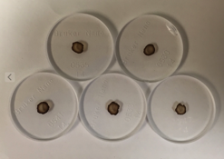

**Supplemental Figure 2.** Representative TXRF spectra.

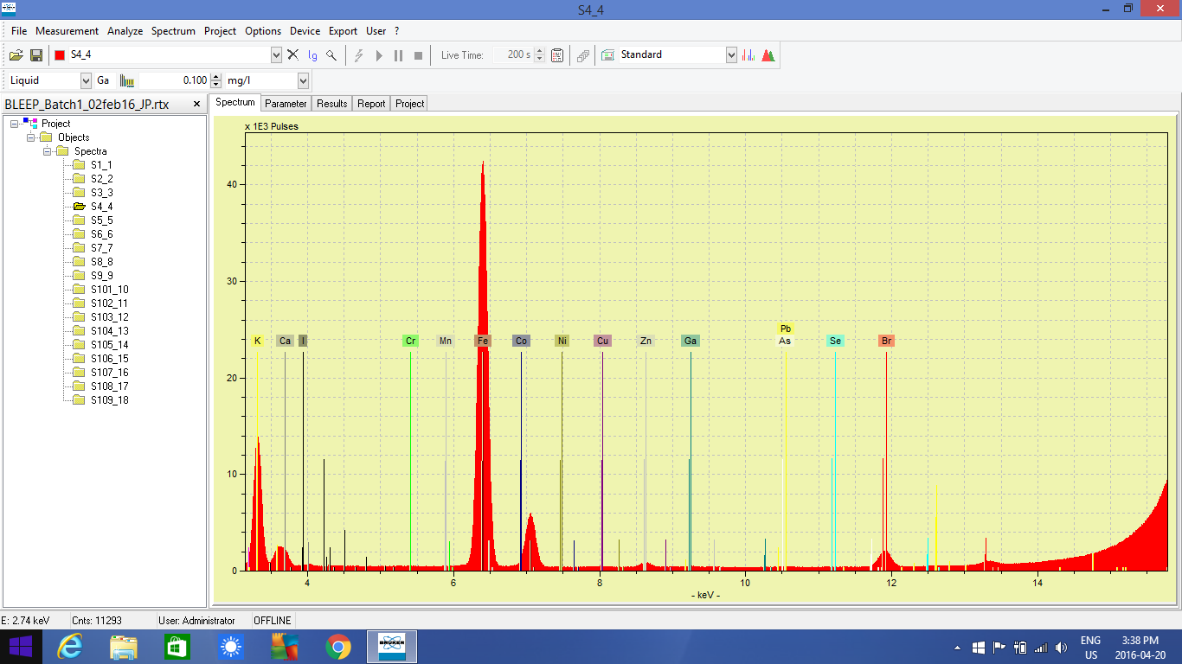

**Supplemental Figure 3.** Linear regression relating Cu levels measured in the dried bloodspot using TXRF versus the assigned concentration of Cu in the whole blood SRM. Each point is an average of 3 independent samples. y=0.99x – 7.2, R2 = 0.98. Average recovery of all measurements is 102.3 ± 5.9 %.

**Supplemental Figure 4.** Linear regression relating Se levels measured in the dried bloodspot using TXRF versus the assigned concentration of Se in the whole blood SRM. Each point is an average of 3 independent samples. Y = 1.2 X + 9.6, R2 = 0.975. Average recovery of all measurements is 100.9 ± 8.6 %.

**Supplemental Figure 5.** Linear regression relating Zn levels measured in the dried bloodspot using TXRF versus the assigned concentration of Zn in the whole blood SRM. Each point is an average of 3 independent samples. y=1.05x – 585.5, R2 = 0.975, Average recovery: 102.3 ± 5.6 %

**Supplemental Figure 6.** Plot of %RPD for copper (Cu) concentration of duplicate DBS samples run in a given batch (n=30) as a measure of intra-assay precision. The %RPD values ranged from 0.76% to 39.56%.

**Supplemental Figure 7.** Plot of %RPD for selenium (Se) concentration of duplicate DBS samples run in a given batch (n=35) as a measure of intra-assay precision. The %RPD values ranged from 0.14% to 53.17%.

**Supplemental Figure 8.** Plot of %RPD for zinc (Zn) concentration of duplicate DBS samples run in a given batch (n=36) as a measure of intra-assay precision. The %RPD values ranged from 00.44% to 70.5%.

**Supplemental Figure 9.** Histogram of of copper (A), selenium (B), and zinc (C) measurements taken in newborn dried blood spots from the Michigan BioTrust for Health program.

