******************************************
Gaussian 16: AS64L-G16RevA.03 25-Dec-2016
17-Jul-2019
******************************************
---------------------------------------
#t TD(nst=1) B3LYP/6-31+G(d,p) opt freq
---------------------------------------
------------------
Anthralin, S1 (Cs)
------------------
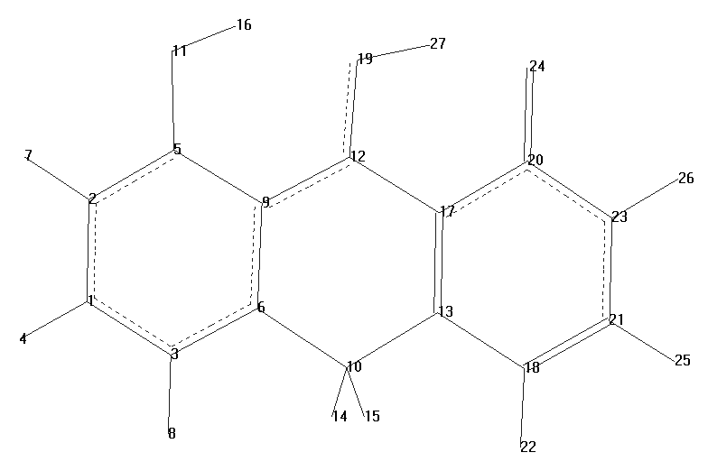
Item Value Threshold Converged?
Maximum Force 0.000060 0.000450 YES
RMS Force 0.000013 0.000300 YES
Maximum Displacement 0.000361 0.001800 YES
RMS Displacement 0.000066 0.001200 YES
Optimization completed.

Standard orientation:
---------------------------------------------------------------------
Center Atomic Atomic Coordinates (Angstroms)
Number Number Type X Y Z
---------------------------------------------------------------------
1 6 0 -3.732525 -1.106763 0.000000
2 6 0 -3.703045 0.296408 0.000000
3 6 0 -2.538769 -1.840282 0.000000
4 1 0 -4.686589 -1.623724 0.000000
5 6 0 -2.494228 0.974540 0.000000
6 6 0 -1.306871 -1.200280 0.000000
7 1 0 -4.617835 0.879597 0.000000
8 1 0 -2.575712 -2.926953 0.000000
9 6 0 -1.244060 0.243961 0.000000
10 6 0 -0.039814 -2.013087 0.000000
11 8 0 -2.527499 2.327853 0.000000
12 6 0 0.000000 0.877277 0.000000
13 6 0 1.251175 -1.259094 0.000000
14 1 0 -0.019662 -2.693351 0.868719
15 1 0 -0.019662 -2.693351 -0.868719
16 1 0 -1.615878 2.677288 0.000000
17 6 0 1.277469 0.112385 0.000000
18 6 0 2.486704 -2.027747 0.000000
19 8 0 0.109403 2.209087 0.000000
20 6 0 2.528626 0.821144 0.000000
21 6 0 3.695665 -1.370640 0.000000
22 1 0 2.430465 -3.111429 0.000000
23 6 0 3.732237 0.039387 0.000000
24 8 0 2.565827 2.106176 0.000000
25 1 0 4.625406 -1.931436 0.000000
26 1 0 4.673876 0.578525 0.000000
27 1 0 1.148366 2.416652 0.000000
---------------------------------------------------------------------

373 basis functions, 614 primitive gaussians, 373 cartesian basis functions
59 alpha electrons 59 beta electrons

SCF Done: E(RB3LYP) = -765.237136974 A.U. after 1 cycles
NFock= 1 Conv=0.43D-08 -V/T= 2.0096

Excitation energies and oscillator strengths:

Excited State 1: Singlet-A' 1.9564 eV 633.74 nm f=0.0707 <S**2>=0.000
59 -> 60 0.70619
Total Energy, E(TD-HF/TD-DFT) = -765.165240883

Full mass-weighted force constant matrix:
Low frequencies --- -3.6407 -2.3044 0.0004 0.0009 0.0011 1.1231
Low frequencies --- 37.6888 73.2218 98.6882

Harmonic frequencies (cm**-1), IR intensities (KM/Mole), reduced masses (AMU),
force constants (mDyne/A), and normal coordinates:
1 2 3
A" A" A"
Frequencies -- 37.6875 73.2218 98.6881
Red. masses -- 4.9183 6.8542 6.0407
Frc consts -- 0.0041 0.0217 0.0347
IR Inten -- 0.6398 0.6889 0.1197
Atom AN X Y Z X Y Z X Y Z
1 6 0.00 0.00 -0.21 -0.00 -0.00 -0.11 -0.00 -0.00 0.15
2 6 0.00 -0.00 -0.15 -0.00 0.00 0.07 -0.00 0.00 0.08
3 6 0.00 0.00 -0.10 -0.00 -0.00 -0.18 -0.00 -0.00 0.05
4 1 0.00 0.00 -0.33 -0.00 -0.00 -0.17 -0.00 -0.00 0.28
5 6 0.00 -0.00 -0.01 -0.00 0.00 0.13 -0.00 0.00 -0.05
6 6 0.00 0.00 0.04 -0.00 -0.00 -0.11 -0.00 -0.00 -0.08
7 1 0.00 0.00 -0.23 -0.00 -0.00 0.18 -0.00 -0.00 0.12
8 1 0.00 0.00 -0.13 -0.00 -0.00 -0.27 -0.00 -0.00 0.08
9 6 0.00 0.00 0.07 -0.00 0.00 -0.03 -0.00 0.00 -0.07
10 6 0.00 -0.00 0.23 -0.00 0.00 -0.08 -0.00 0.00 -0.22
11 8 0.00 -0.00 0.03 -0.00 0.00 0.37 -0.00 0.00 -0.20
12 6 0.00 0.00 0.14 -0.00 -0.00 -0.10 -0.00 -0.00 0.04
13 6 0.00 -0.00 0.10 -0.00 0.00 0.02 -0.00 0.00 -0.04
14 1 -0.01 0.19 0.39 -0.05 -0.04 -0.11 -0.04 -0.23 -0.40
15 1 0.01 -0.19 0.39 0.05 0.04 -0.11 0.04 0.23 -0.40
16 1 0.00 -0.00 0.12 -0.00 0.00 0.28 -0.00 0.00 -0.10
17 6 -0.00 0.00 0.05 0.00 -0.00 -0.09 0.00 -0.00 -0.02
18 6 0.00 -0.00 0.05 -0.00 0.00 0.20 -0.00 0.00 0.03
19 8 -0.00 0.00 0.26 0.00 -0.00 -0.12 0.00 -0.00 0.38
20 6 -0.00 -0.00 -0.10 0.00 -0.00 -0.10 0.00 -0.00 -0.05
21 6 0.00 -0.00 -0.09 -0.00 0.00 0.26 -0.00 0.00 0.14
22 1 0.00 -0.00 0.11 -0.00 0.00 0.28 -0.00 0.00 -0.00
23 6 -0.00 0.00 -0.16 0.00 -0.00 0.10 0.00 -0.00 0.11
24 8 -0.00 -0.00 -0.19 0.00 0.00 -0.27 0.00 0.00 -0.24
25 1 0.00 0.00 -0.14 -0.00 -0.00 0.41 -0.00 -0.00 0.24
26 1 -0.00 0.00 -0.28 0.00 -0.00 0.13 0.00 -0.00 0.14
27 1 -0.00 0.00 0.08 0.00 -0.00 -0.21 0.00 -0.00 0.12

- - - - - - -

Temperature 298.150 Kelvin. Pressure 1.00000 Atm.
Zero-point correction= 0.203218 (Hartree/Particle)
Thermal correction to Energy= 0.216004
Thermal correction to Enthalpy= 0.216949
Thermal correction to Gibbs Free Energy= 0.163849
Sum of electronic and zero-point Energies= -764.962023
Sum of electronic and thermal Energies= -764.949237
Sum of electronic and thermal Enthalpies= -764.948292
Sum of electronic and thermal Free Energies= -765.001392

Normal termination of Gaussian 16

