S.I. Titration curves of RAL-LTR32 at A) 5ºC, B) 15ºC and C) 25ºC
A.
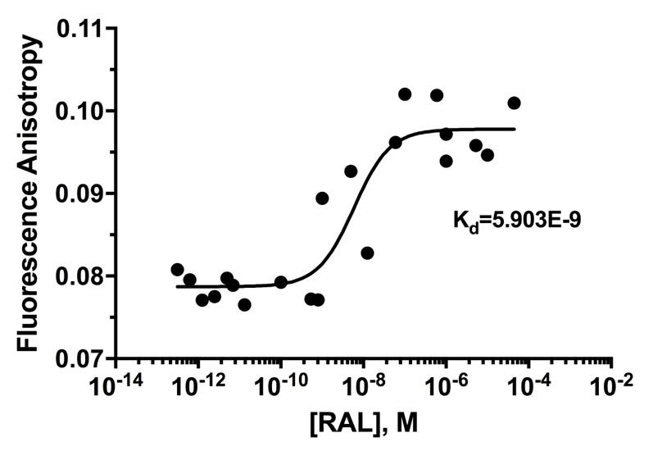
S.I.A. Titration curve of LTR32 at 8 nM by increasing concentrations of RAL (from 10 -13 to 10 -6) at 5ºC. Values of Kd yielded by treatment of the RAL-LTR32 titration curve is inserted on the graph.

B.
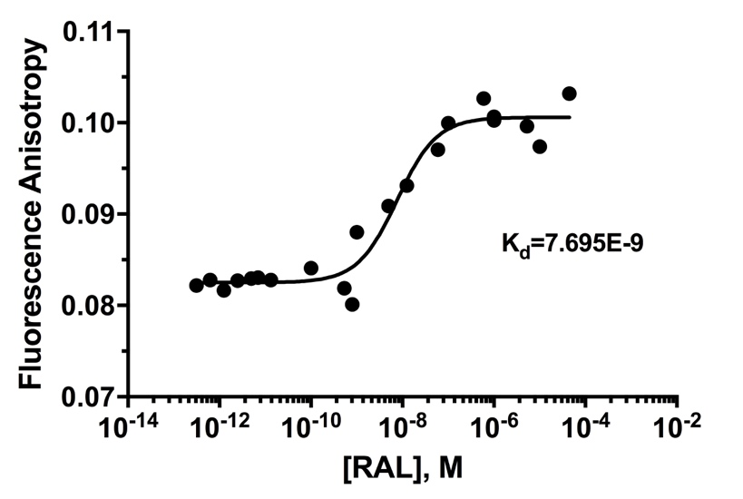
S.I.B. Titration curve of LTR32 at 8 nM by increasing concentrations of RAL (from 10 -13 to 10 -6) at 15ºC. Values of Kd yielded by treatment of the RAL-LTR32 titration curve is inserted on the graph.

C.
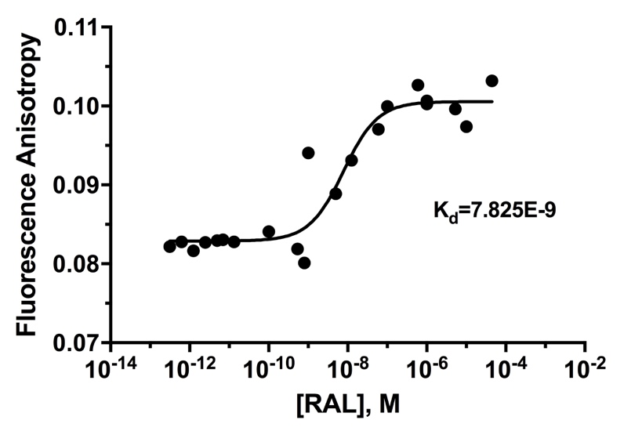
S.I.C. Titration curve of LTR32 at 8 nM by increasing concentrations of RAL (from 10 -13 to 10 -6) at 25ºC. Values of Kd yielded by treatment of the RAL-LTR32 titration curve is inserted on the graph.

