S.II. Titration curves of EVG-LTR32 at A) 5ºC, B) 15ºC and C) 25ºC
A.
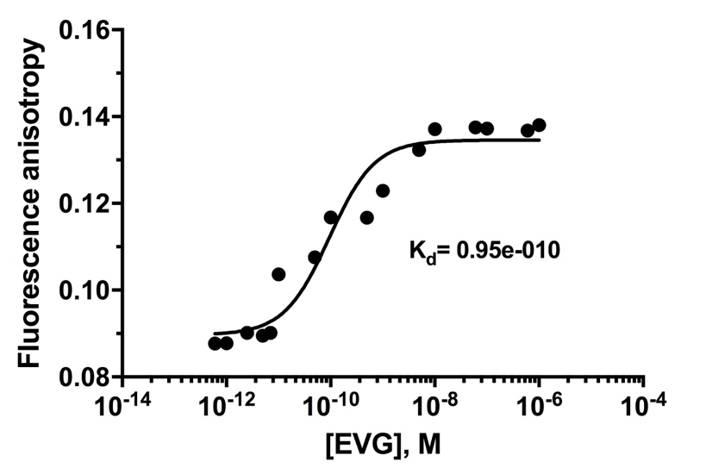
S.II.A. This titration curve was reported in El Khoury et al. [22] and was added to this study for completeness sake. Titration curve of LTR32 at 8 nM by increasing concentrations of EVG (from 10 -13 to 10 -6) at 5ºC. Values of Kd yielded by treatment of the EVG-LTR32 titration curve is inserted on the graph.
B.

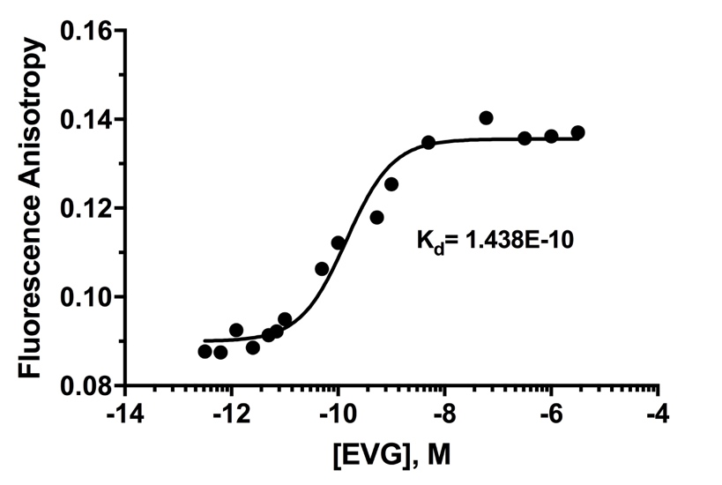
S.II.B. Titration curve of LTR32 at 8 nM by increasing concentrations of EVG (from 10-13 to 10 -6) at 15ºC. Values of Kd yielded by treatment of the EVG-LTR32 titration curve is inserted on the graph.

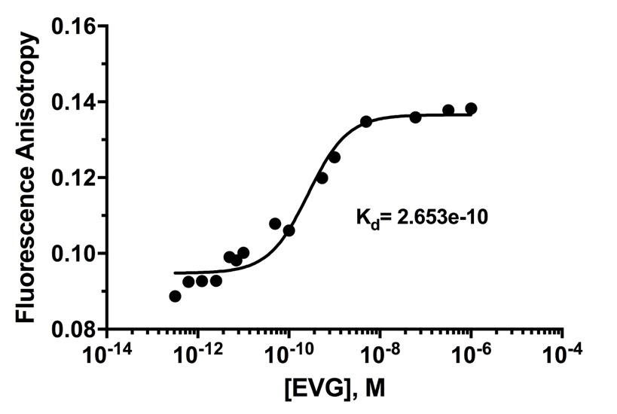
S.II.C. Titration curve of LTR32 at 8 nM by increasing concentrations of EVG (from 10 -13 to 10 -6) at 25ºC. Values of Kd yielded by treatment of the EVG-LTR32 titration curve is inserted on the graph.

