S.III. Titration curves of DTG-LTR32 at A) 5ºC, B) 15ºC and C) 25ºC
A.
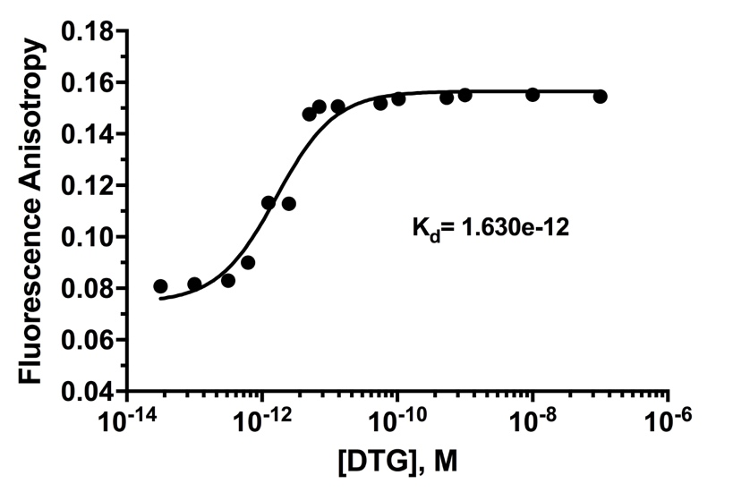
S.III.A. This titration curve was reported in El Khoury et al. [32] and was added to this study for completeness sake. Titration curve of LTR32 at 8 nM by increasing concentrations of DTG (from 10 -13 to 10 -6) at 5ºC. Values of Kd yielded by treatment of the DTG-LTR32 titration curve is inserted on the graph.
B.
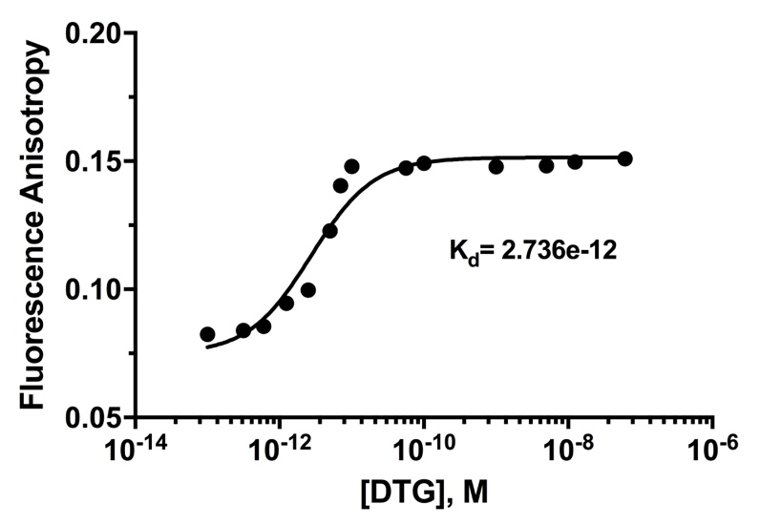
S.III.B. Titration curve of LTR32 at 8 nM by increasing concentrations of DTG (from 10 -13 to 10 -6) at 15ºC. Values of Kd yielded by treatment of the DTG-LTR32 titration curve is inserted on the graph.
C.
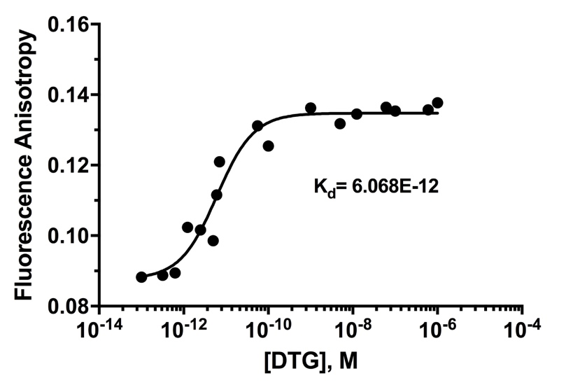
S.III.C. Titration curve of LTR32 at 8 nM by increasing concentrations of DTG (from 10 -13 to 10 -6) at 25ºC. Values of Kd yielded by treatment of the DTG-LTR32 titration curve is inserted on the graph.

